
Lesson 3 – Worksheet
 | Activity 1: Applying action words  Complete the following activity individually.

Study the cartoon below and answer the following questions.
Exam-writing skills
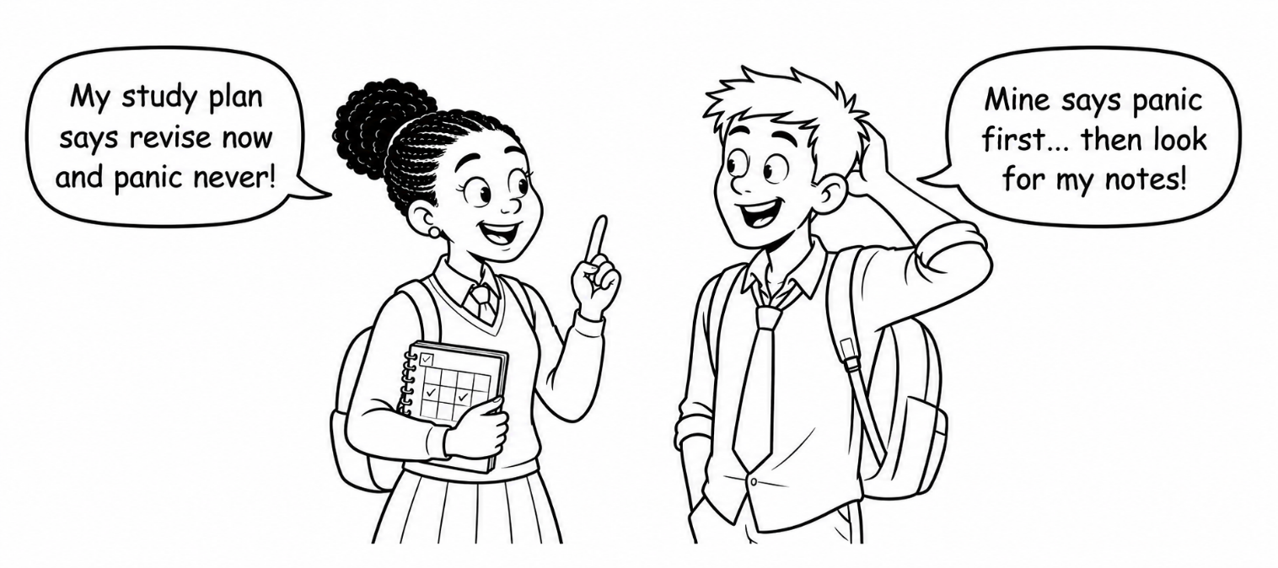
[Created by Teenactiv, 1 July 2026]

1. State TWO examination-writing skills. (2 × 1) (2)
__________________________________________________________________________________________________________________________________________________________________

2. Explain how time management can help learners during an examination. (1 × 2) (2)
__________________________________________________________________________________________________________________________________________________________________
__________________________________________________________________________________________________________________________________________________________________

3. Evaluate the effectiveness of completing past papers when preparing for
an examination. (1 × 4) (4)
__________________________________________________________________________________________________________________________________________________________________
__________________________________________________________________________________________________________________________________________________________________
[Total: 8]
Activity 2: Completing a Personal Development Plan
Complete the following activity in pairs.

Read the incomplete personal development plan below.

Plan element | Example
Long-term goal | I want to become a lawyer.
Short-term study goal | I want to pass Grade 11 and improve my English and History results.
Actions | - Follow my study plan consistently  - Revise English and History three times per week  - Complete past examination questions
Timeframe | - Identify a realistic period in which the learner could work towards the short-term study goal.  _______________________________________________________________  _______________________________________________________________
Obstacles and solutions | - Identify possible obstacles and explain how the learner could overcome them.  _______________________________________________________________  _______________________________________________________________  _______________________________________________________________  _______________________________________________________________  _______________________________________________________________  _______________________________________________________________  _______________________________________________________________  _______________________________________________________________
Monitoring | - Explain how the learner could monitor their progress and make adjustments when necessary.  _______________________________________________________________  _______________________________________________________________  _______________________________________________________________  _______________________________________________________________  _______________________________________________________________  _______________________________________________________________  _______________________________________________________________  _______________________________________________________________

Activity 3: Developing a Personal Development Plan
Complete the following activity individually.

1. Choose ONE area in which you would like to develop.

☐ Study ☐ Health ☐ Fitness

2. Complete the personal development plan below.
Plan element | My personal development plan
Long-term goal | What would you like to improve?  _________________________________________________________________
Short-term goal | What is your short-term and/or long-term goal?  _________________________________________________________________  _________________________________________________________________
Actions | What steps will you take to achieve your goal?  _________________________________________________________________  _________________________________________________________________  _________________________________________________________________  _________________________________________________________________
Timeframe | By when would you like to achieve your goal?  _________________________________________________________________
Obstacles and solutions | What could make it difficult to achieve your goal?  _________________________________________________________________  _________________________________________________________________  _________________________________________________________________  _________________________________________________________________  How could you overcome these obstacles?  _________________________________________________________________  _________________________________________________________________  _________________________________________________________________  _________________________________________________________________
Monitoring | How will you review your progress and make adjustments?  _________________________________________________________________  _________________________________________________________________

3. Why is this goal important to you?
__________________________________________________________________________________________________________________________________________________________________

