
Lesson 4 – Worksheet MEMO
 | Activity 1: Determine Revision and Consolidation Activities  Complete the following activity in pairs.

Read each scenario. Decide whether the learner is mainly using revision, consolidation or both.
 | Scenario |  | Revision, consolidation or both?
 | - A learner closes their notes and writes down all the key points they can remember about a topic. |  | Revision
 | - A learner uses their notes to create a comparison table that shows how two concepts are connected. |  | Consolidation
 | - A learner completes a past examination paper without looking at their notes to test what they remember. |  | Revision
 | - A learner marks a past examination paper, reviews their mistakes and writes improved answers. |  | Consolidation
 | - A learner completes practice questions, identifies gaps, revises the difficult content and then applies it to new questions. |  | Both
Activity 2: Revision and Consolidation
Complete the following activity individually.

Study the statistics below and answer the following questions.
Many learners still choose lower-impact revision methods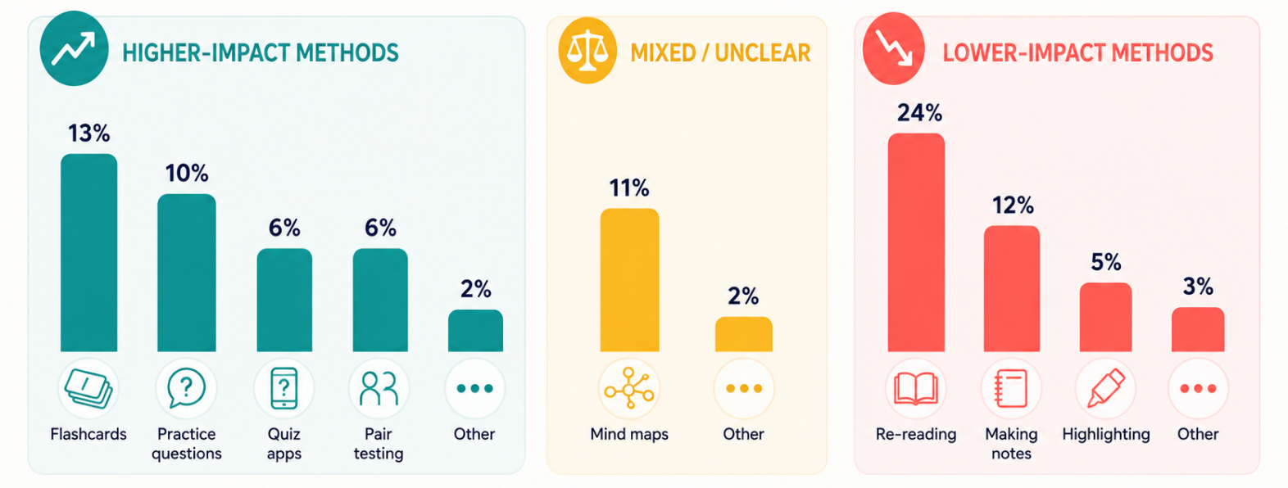
[Adapted from https://examstudyexpert.com/student-revision-data/ Accessed: 3 August 2026]

1. State TWO reasons why revision can help learners feel more prepared for
an assessment. (2 × 1) (2)

It can help learners...
- remember important facts/concepts/skills before the assessment. (🗸)
- identify the topics/sections they still need to practise. (🗸)
- feel more confident because they know what work they have covered. (🗸)
- reduce stress because they have prepared before the assessment. (🗸)
- manage their study time more effectively. (🗸)
- become familiar with the content that may be assessed. (🗸)

Any TWO of the above for ONE mark each

2. Describe ONE action a learner can take after realising that they still do not understand
a topic during revision. (1 × 2) (2)

Learners can...
- ask a teacher/tutor/classmate to explain the topic again, (🗸) and use the explanation to clear up the misunderstanding. (🗸)
- return to their textbook/class notes/summaries, (🗸) and study the relevant explanations/examples using an appropriate study method. (🗸)
- watch a reliable educational video about the topic, (🗸) and compare the explanation with the information in their learning materials. (🗸)
- complete additional practice questions on the topic, (🗸) and use their mistakes to identify the content that still requires attention. (🗸)
- write down specific questions about what they do not understand, (🗸) and ask a teacher/ classmate for focused assistance. (🗸)
- use a different study strategy, such as a mind map/worked example, (🗸) and reorganise the information in a way that is easier to understand. (🗸)

Any ONE of the above for TWO marks
(i.e. ONE mark for statement and ONE mark for elaborator)

3. Discuss ONE benefit of completing practice questions as part of revision. (1 × 2) (2)

It could...
- help learners test whether they understand the work, (🗸) which could reveal whether they can apply the content without referring to their notes. (🗸)
- help learners identify mistakes/weak areas, (🗸) which could guide them towards topics that require further revision. (🗸)
- familiarise learners with the format/assessment questions, (🗸) which could help them answer similar questions more confidently. (🗸)
- help learners practise time management, (🗸) which could improve the way they allocate time to different questions during an assessment. (🗸)
- help learners apply action words/mark allocations correctly, (🗸) which could improve the structure/depth of their answers. (🗸)
- improve learners’ confidence before an assessment, (🗸) which could reassure them that they are able to answer questions correctly. (🗸)

Any ONE of the above for TWO marks
(i.e. ONE mark for statement and ONE mark for qualifier/explanation)

4. Recommend ONE way in which learners can avoid leaving revision until the last minute.
In your answer, also indicate how the recommendation may help them prepare
more effectively. (1 × 3) (3)

Learners can...
- revise small sections of work every week, (🗸) which could spread the workload over a longer period, (🗸) thereby preventing rushed preparation shortly before the assessment. (🗸)
- create a revision timetable before the examination period begins, (🗸) which could ensure that enough time is allocated to each subject/topic, (🗸) thereby helping them manage their workload more effectively. (🗸)
- complete short revision sessions regularly, (🗸) which could make revision part of their normal weekly routine, (🗸) thereby helping them remember the work more consistently. (🗸)
- divide large topics into smaller sections, (🗸) which could make the content feel more manageable, (🗸) thereby helping them remain motivated/complete the work gradually. (🗸)
- record assessment dates/deadlines in a diary/calendar, (🗸) which could remind them when they need to begin revising, (🗸) thereby allowing them to plan ahead/avoid last-minute preparation. (🗸)
- set weekly revision goals for each subject, (🗸) which could give them a clear focus for each revision session, (🗸) thereby helping them cover the required content before the assessment. (🗸)

Any ONE of the above for THREE marks
(i.e. ONE mark for statement, ONE mark for qualifier/explanation and ONE mark for outcome)

[Total: 9]

Activity 3: Practical Application of Revision and Consolidation
Complete the following activity individually.

Revision and consolidation are connected processes. You may move between them as you test your knowledge, identify gaps and strengthen your understanding.

Follow these steps to start preparing for an upcoming examination.

1. Choose what to revise
a. Which subject did you choose?
b. Which specific topic will you revise?
c. What key concepts, facts, definitions, formulas, processes or skills do you need to know?
d. Which notes, textbook sections, activities or assessment guidelines will you use?

2. Revise actively
Choose and apply at least ONE active revision method.
a. Which revision method did you use?
b. What were you able to remember or complete without looking at your notes?
c. Which information did you forget, misunderstand or answer incorrectly?

3. Address gaps and consolidate your learning
a. What did you do to address the gaps you identified?
b. Which consolidation method did you use?
c. What do you understand better after consolidating the topic?

4. Apply and review
a. Which practice questions did you complete without looking at your notes?
b. How did you check or mark your answers?
c. Which mistakes did you correct or improve?
d. Which content still requires further revision or consolidation?

→ Learners will have personal responses to this activity.

