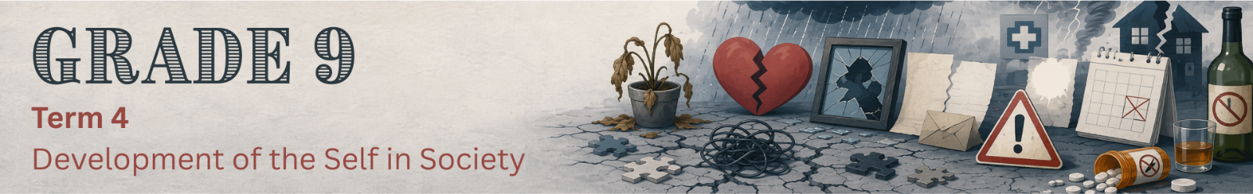

Content Summary

Lesson 1
Challenging situations
A challenging situation is a difficult circumstance that requires a person to use problem-solving skills, make careful decisions or cope with pressure.

Throughout life, every person will encounter challenging situations that affect them both emotionally and physically.
- Physically: Changes in sleep, appetite or energy levels.
- Emotionally: Feelings of being overwhelmed, numbness or intense sadness.

These challenging situations are unavoidable. They may differ in how serious they are, how long they last and how they affect each person.

Examples
- Losing a dear friend or family member to death.
- Parents getting divorced.
- Being diagnosed with a serious illness.
- Being constantly bullied at school.
- Experiencing domestic violence.
- Being in a car accident and seriously injured.
- Being the victim of a crime such as a robbery.

Challenging situations can cause difficult emotions, such as sadness, anger, frustration or shock. It is important to recognise these feelings and find healthy ways to express and cope with them.

Emotional triggers
Certain reminders, such as a sound, smell, image, story, place, person, or situation, of a past challenging situation may bring these emotions back suddenly. These reminders are known as emotional triggers.

Feeling triggered is a normal response, but we can learn healthy strategies to manage our emotions instead of becoming completely overwhelmed.

For example, if you hear someone telling a story about losing a parent and you have also lost a parent, that story may trigger your own grief, causing you to feel suddenly overwhelmed with sadness even though the event happened long ago.

Strategies to deal with emotional triggers
A trigger could occur anywhere at any time. When a trigger occurs, you can use the following strategies to regain control of your emotional state.
- Breathe slowly and deeply.
- Step aside to a quiet place.
- Remind yourself: This is just a memory; I am safe right now.
- Use a grounding technique (e.g. touching a textured object, counting things you see).
- Listen to music, an audiobook or a podcast.
- Do an activity you enjoy, like drawing, journaling or reading.
- Create a ‘comfort box’ with photos, letters, quotes or objects that calm you.
- Write down positive affirmations (“I am safe, I am not alone”).
- Talk to a trusted family member or friend.

Effects of challenging situations
Challenging situations can have emotional and psychological effects. Let's take a closer look at what this entails.

Trauma
Trauma is a person's emotional or physical response to an event that is frightening, dangerous or deeply upsetting. Trauma can affect people in different ways, and not everyone will respond to the same event in the same manner.

Physical trauma
Physical trauma refers to injuries to the body caused by an accident, violence or another harmful event. These injuries can usually be seen and often require medical treatment, such as broken bones, burns, cuts, bruises or wounds.

Many physical injuries heal over time with the correct medical care. However, recovering from a physical injury may also involve dealing with emotional challenges such as fear, frustration or anxiety.

Emotional trauma
Emotional trauma occurs when a person experiences an event that is so frightening, distressing or overwhelming that it has a lasting effect on their emotional well-being.

A person experiencing emotional trauma may:
  - struggle to trust others
  - feel anxious or fearful
  - experience nightmares or flashbacks
  - become withdrawn from family and friends
  - have difficulty concentrating at school
  - become easily startled or irritable.

These reactions are normal after traumatic experiences. With the right support and, where necessary, professional help, many people recover and learn healthy ways to manage their emotions.

Depression
Depression is a medical illness, not simply feeling sad. It is characterised by persistent sadness and a complete loss of interest in activities that you normally enjoy, accompanied by an inability to carry out daily activities.

The difference between sadness and depression
Sadness: Everyone feels sad at certain times. You might feel sad if you fail a test, fight with a friend or lose someone you love. That sadness is a normal emotional response, and it usually fades with time or when circumstances improve.

Depression is fundamentally different. It is a medical condition that affects your entire mind and body. When you are depressed, the sadness does not lift when good things happen. It persists regardless of circumstances.
Depression can make you feel:
  - tired all the time, even after a full night's sleep
  - like you have no energy or motivation
  - unable to enjoy things you normally like
  - empty or numb, not just sad
  - stuck in negative thoughts that don't go away.

It is normal to experience brief periods of intense sadness or low mood after trauma or during grief, but if it persists for more than two weeks, it is essential to seek professional help from a doctor or mental health practitioner.

Grief
Grief is the normal, natural emotional response to a major loss. It is most associated with the death of a loved one, but it can also be felt by a person living with a serious, long-term illness or a terminal diagnosis.

Grief is not a single emotion; it is a complex mixture of feelings:
- Great sadness: A deep, aching sorrow that comes in waves.
- Anger: Feeling angry at the situation, at the person who died for "leaving" you, or at the world for being unfair.
- Guilt: Wondering if you could have done something differently or feeling guilty for moments when you feel okay.
- Despair: A sense of hopelessness about the future without the person or thing you have lost.

Grief is not something you "get over"; rather, you learn to live with it over time. The intensity of grief typically lessens gradually, but it may resurface at unexpected moments (e.g. anniversaries, birthdays, holidays).

Loss
Loss refers to the harm or distress that comes from losing something or someone significant. While it often refers to the death of a person (a parent, sibling, friend or other loved one), loss can also include the end of a relationship, the loss of a home, the loss of health or the loss of a way of life. Loss is the event itself, while grief is the emotional response to that event.

Crisis
A crisis is a sudden, unexpected event that negatively impacts your life, emotions, behaviour, and health. Unlike ongoing challenges, a crisis tends to strike suddenly and demands an immediate response. For example, failing Grade 9 is a crisis. It is a single event that may create immediate negative consequences, such as shame, fear of returning to school, anger at yourself, and worry about the future.

Other examples of crises include the death of a loved one, a serious accident, a natural disaster (such as a fire or flood), a family suddenly losing their home or income, or experiencing violence.

Although a crisis can feel impossible to overcome, it is usually temporary. Support from family, friends, teachers and healthcare professionals can help people recover and develop healthy ways of coping.

Lesson 2
In this lesson, we will investigate the causes of depression, grief, loss, trauma and crisis in more detail. Understanding what may cause these experiences can help us respond to ourselves and others with greater empathy.

Key terms
Cause: Something that contributes to an experience or condition developing.
Risk factor: Something that increases the possibility that a person may experience a particular problem. A risk factor does not mean that the problem will definitely occur.

Causes of depression
Depression usually does not have one simple cause. It can develop through a combination of biological, psychological and social factors.
Risk factor | Explanation and examples
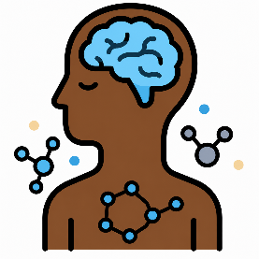  Biological and health-related factors | Some people may be more vulnerable to depression because of factors connected to their bodies or health. Factors may include:  - A family history of depression or other mental health conditions  - Changes in brain functioning or body chemicals  - Hormonal changes during adolescence  - A serious or long-term physical illness, accompanied by chronic pain  - Certain medicines or medical treatments  Having one of these risk factors does not mean that a person will definitely develop depression.
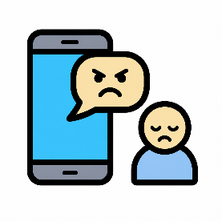  Difficult or painful experiences | Stressful life experiences can increase the risk of depression, particularly when several difficulties occur at the same time or continue for a long period.  Examples include:  - The death of a family member or friend  - Family conflict, separation or divorce  - Abuse, neglect or exposure to violence  - Bullying or cyberbullying  - Academic pressure or repeated failure  - Unemployment or financial difficulties in the family  Difficult experiences during childhood and adolescence can have lasting effects on a person’s health and emotional well-being. However, supportive relationships with caregivers, teachers, friends and community members can help protect young people
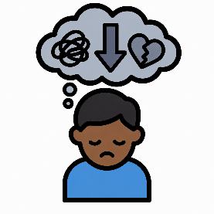  Negative thoughts and low self-esteem | A person who constantly thinks negatively about themselves or their future may become more vulnerable to depression. For example, a learner may begin to believe:  - "I am not good enough."  - "Nothing will ever improve."  - "Nobody cares about me."  - "I always fail."  These thoughts may develop after repeated criticism, rejection, bullying, failure or comparison with others.
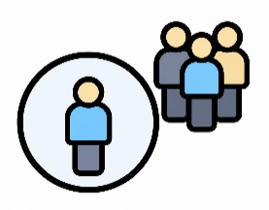  Social pressure and isolation | Teenagers often want to feel accepted and included. Depression may be linked to experiences such as:  - Feeling lonely or socially isolated  - Struggling to make friends  - Comparing one’s appearance or lifestyle with people online  - Not feeling accepted by family or peers  - Carrying adult responsibilities at a young age

Causes of grief and loss
Remember, grief is a natural response to loss. Grief is not exclusively caused by death. A teenager can grieve the end of a friendship, the loss of a family home, a parent's remarriage, the disappearance of a pet, or the loss of their health. Any significant loss can trigger the grieving process.

Common causes of crises in teenagers
Academic failure  Many learners feel under pressure to perform well at school. Failing a test or receiving poor marks can make you feel disappointed, anxious or hopeless.  Remember, one poor result does not define who you are. The most important step is to ask for help early, improve your study habits and keep trying. | Family problems  Conflict at home, divorce, financial difficulties or illness in the family can have a big impact on your emotional well-being. These situations may make you feel worried, angry or confused.  It is important to remember that adult problems are not your responsibility, and talking to a trusted adult can help you manage your feelings. | Bullying and violence  Bullying, whether it happens at school, online or in your community, can affect your confidence and mental health.  Nobody deserves to be bullied. If you are being bullied, tell a trusted adult, seek support from friends and family, and remember that you do not have to face it alone.

Causes of trauma
Experiencing loss or crises can cause trauma. During a traumatic event, a person may feel that their life, safety or well-being, or the safety of someone else, was threatened. Traumatic events include:
  - Physical, emotional or sexual abuse
  - Neglect
  - Domestic or community violence
  - A serious accident
  - A natural disaster, such as a flood or fire

Not everyone who experiences a potentially traumatic event develops lasting mental health difficulties.

The impact of difficult situations
A difficult situation can affect both your emotions and your body.
- Emotionally, you may feel overwhelmed, anxious, sad, angry or helpless.
- Physically, you may experience headaches, tiredness, difficulty sleeping, changes in appetite or trouble concentrating.
These are normal stress responses. Looking after your mental health can also help protect your physical health. Healthy coping strategies and support from someone you trust can help you recover
Lesson 3
Coping techniques
Everyone experiences stress and difficult emotions, but the choices we make during these times can have a lasting effect on our well-being. Coping techniques are actions people use to manage stress, difficult emotions and challenging situations. People use different techniques to cope with depression, grief, loss, trauma or crisis.

Healthy coping techniques
Healthy coping techniques help people respond positively and support their emotional well-being. They may include crying, talking about your feelings with a friend or counsellor, exercising, journaling, praying, or engaging in creative expression.

Counterproductive coping techniques
Counterproductive techniques refer to actions or behaviours that have the opposite effect to what was intended. These techniques avoid the underlying problem or attempt to numb the pain. They may provide temporary relief but may make the situation worse or create additional problems.

Drug abuse
Some teenagers may use drugs to escape emotional pain. However, when the drugs wear off, the original problem remains unresolved. Drug abuse may lead to additional problems such as addiction, health problems, financial difficulties, legal consequences and damaged relationships.

Alcohol abuse
Like drugs, alcohol may temporarily numb emotional pain, but it can worsen low mood and impair judgement. This may lead to risky behaviour, including unsafe decisions, aggression, unprotected sex, driving under the influence or self-harm.

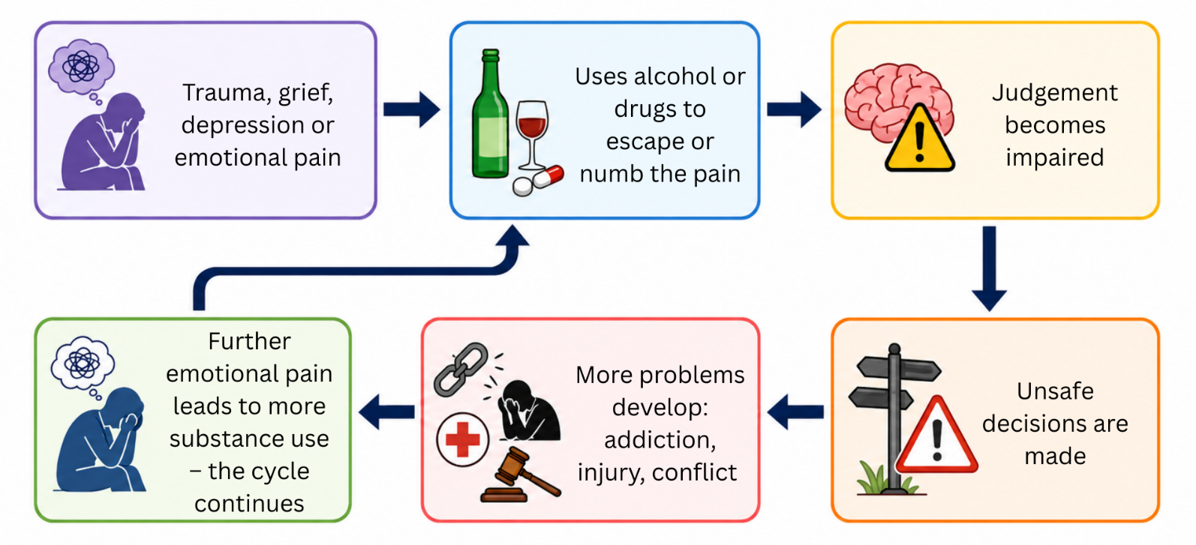
Figure 1: The vicious cycle of alcohol and drug abuse

Fighting and aggression
Some teenagers express emotional pain through anger or physical aggression. Fighting may cause injury, disciplinary or legal consequences and damaged relationships.

Self-harm
Some teenagers deliberately injure themselves to cope with emotional pain or feel a sense of control. Self-harm is dangerous, may cause serious injury and does not address the underlying problem.

Suicidal thoughts
A person experiencing overwhelming emotional pain may believe that there is no way forward. Suicidal thoughts require immediate support. If you or someone you know is having suicidal thoughts, it is critical to tell a trusted adult immediately and contact a crisis helpline.

Social media misuse
Social media can be a good way to stay connected during a difficult time; however, excessive social media use may become a way of avoiding difficult emotions.

Reasons teenagers may use social media | Possible effects of excessive social media use
- To distract themselves from pain  - To seek validation through likes and comments  - To cyberbully others as an outlet for their own pain | - Increased stress and anxiety  - Lower self-esteem and confidence  - Feelings of loneliness or exclusion  - Disrupted sleep, schoolwork and face-to-face relationships

Healthy tip: Use social media in moderation, take regular breaks and make time for offline activities, exercise, hobbies and relationships, especially if you are dealing with a challenging situation.

Barriers to getting help
Although support is available, some teenagers avoid seeking help. Common barriers include:
- Lack of knowledge: Teenagers may not recognise that they are experiencing a mental health difficulty or may believe that they should manage it alone.
- Financial constraints: Some families may not be able to afford private mental healthcare, while public services may have long waiting periods.
- Fear of stigma: Teenagers may fear judgement from friends, family or community members. They may believe that seeking help is a sign of weakness.

How to help someone in a difficult situation
If a friend or family member seems unusually sad, withdrawn or different from their usual self, your support may make a positive difference. Remember that you cannot solve the situation for them, but you can help them access the support they need.

- Listen with kindness and without judgement.  - Show patience and understanding.  - Avoid forcing the person to talk. | - Encourage them to speak to a trusted adult or healthcare professional.  - Continue including and supporting them.

Always tell a trusted adult if someone speaks about self-harm or suicide. Getting help quickly could save their life.

