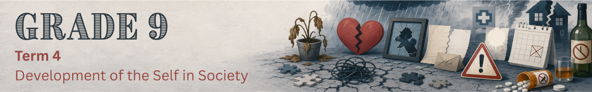

Lesson 3 – Worksheet MEMO
 | Activity 1: Coping with Challenging Situations  Complete the following activity individually.

1. Choose a description from Column B that matches an item in Column A. Write only the letter (A–F) next to the question numbers (1.1 to 1.5) provided below.

Column A |  | Column B
1.1 | Vicious cycle | A. | A strategy used to manage stress, difficult emotions or challenging situations.
1.2 | Coping technique | B. | An action that has the opposite of the desired effect and makes a situation worse.
1.3 | Counterproductive | C. | A repeated pattern in which problems cause one another to become worse.
1.4 | Crisis | D. | An event that increases the likelihood of developing a problem, such as depression.
1.5 | Risk factor | E. | A situation that feels overwhelming and difficult to cope with.
 |  | F. | The ability to recover from challenges and adapt positively after difficult experiences.
(5 × 1) (5)
Term | 1.1 | 1.2 | 1.3 | 1.4 | 1.5
Answer | C () | A () | B () | E () | D ()

2. Study the cartoon below and answer the following questions.

Counterproductive coping techniques
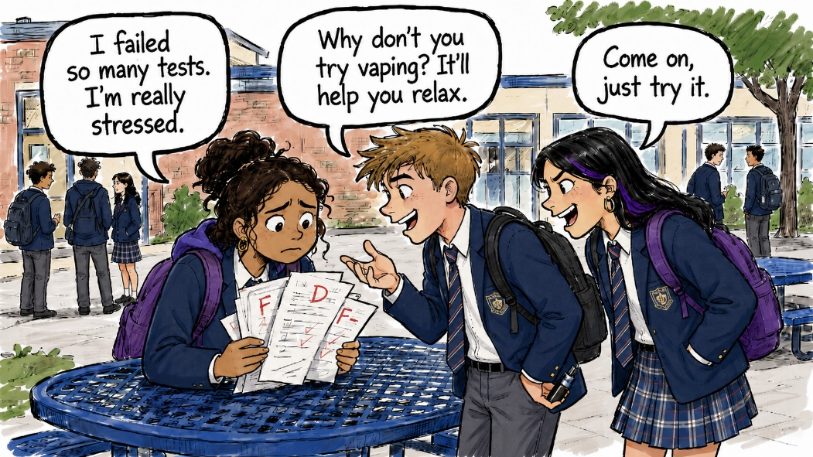
[Created by Teenactiv, 24 July 2026]

2.1 State TWO reasons why learners may experience stress when they are struggling
academically. (2 × 1) (2)

They might…
- fear disappointing their parents/caregivers. (🗸)
- feel embarrassed about poor marks. (🗸)
- worry that they will fail the grade. (🗸)
- feel overwhelmed by the amount of work they need to catch up. (🗸)
- feel pressure to perform as well as their peers. (🗸)
- lose confidence in their ability to succeed. (🗸)
- worry about their future subject choices/career options. (🗸)
- feel anxious before tests or examinations. (🗸)

Any TWO of the above for ONE mark each

2.2 Describe how peer pressure could influence learners to use vaping as a coping technique. (1 × 2) (2)

Possible answers may include:
- Friends may encourage learners to vape by saying it will help them relax, (🗸) making vaping seem like a normal/acceptable way to deal with stress. (🗸)
- Learners may fear being rejected/mocked by their peers, (🗸) causing them to use vaping to fit in even if they know it is harmful. (🗸)
- Peers may make vaping look harmless/popular, (🗸) which could influence learners to copy the behaviour as a way of coping with pressure. (🗸)
- Learners may allow their friends’ opinions to influence their choices, (🗸) causing them to choose vaping instead of a healthier coping technique. (🗸)

Any ONE of the above for TWO marks
(i.e. ONE mark for statement and ONE mark for qualifier/explanation)

2.3 Explain why vaping is a counterproductive way of coping with stress. (1 × 2) (2)

Vaping…
- may provide temporary relief from stress, (🗸) but it does not solve the real problem causing the stress. (🗸)
- can become a harmful habit, (🗸) which may make it harder for learners to cope with future challenges in healthy ways. (🗸)
- may negatively affect a learner’s health/concentration, (🗸) which could make their school stress even worse. (🗸)
- creates more problems than it solves, (🗸) because it may lead to addiction/conflict with parents/disciplinary consequences at school. (🗸)

Any ONE of the above for TWO marks
(i.e. ONE mark for statement and ONE mark for qualifier/explanation)

2.4 Recommend ONE healthy coping technique learners could use when they feel stressed
by school. In your answer, also indicate how this technique could help them improve
their schoolwork. (1 × 3) (3)

Learners could…
- speak to a trusted adult/teacher/school counsellor about their stress, (🗸) which could help them feel supported/less overwhelmed, (🗸) thereby helping them make a plan to improve their schoolwork. (🗸)
- create a realistic study timetable, (🗸) which could help them manage their workload/reduce last-minute stress, (🗸) thereby making it easier to prepare properly for tests/assignments. (🗸)
- ask a teacher/classmate for help with work they do not understand, (🗸) which could help them deal with the cause of their academic stress, (🗸) thereby improving their understanding/performance. (🗸)
- practise relaxation techniques such as deep breathing before studying/writing tests, (🗸) which could help them calm down/think more clearly, (🗸) thereby improving their concentration/ability to complete school tasks. (🗸)
- break schoolwork into smaller, manageable tasks, (🗸) which could make the work feel less overwhelming, (🗸) thereby helping them complete tasks more consistently/improve their academic progress. (🗸)

Any ONE of the above for THREE marks
(i.e. ONE mark for statement, ONE mark for qualifer/explanation and ONE mark for outcome)
[Total: 9]
Activity 2: Reflection
Complete the following activity individually.

Think about how you usually respond when you feel stressed, upset or overwhelmed.

1. Circle the option that best describes what you are most likely to do.

a. |  | Keep everything to myself | e. |  | Do something active or creative
b. |  | Distract myself online | f. |  | Pause and calm myself down
c. |  | Become angry or argue | g. |  | Something else: _________________________
d. |  | Talk to someone I trust

2. Place a checkmark next to your answer.
Does this response:
☐ help me deal with the problem in a healthy way?
☐ provide temporary relief without solving the problem?
☐ make the situation worse?

3. Complete your coping plan.
Next time I face a difficult situation, I can: _______________________________________________
_________________________________________________________________________________

→ Learners will have personal responses to this activity.

