
Lesson 3 – Worksheet MEMO
 | Activity 1: Applying action words  Complete the following activity individually.

Study the cartoon below and answer the following questions.
Exam-writing skills
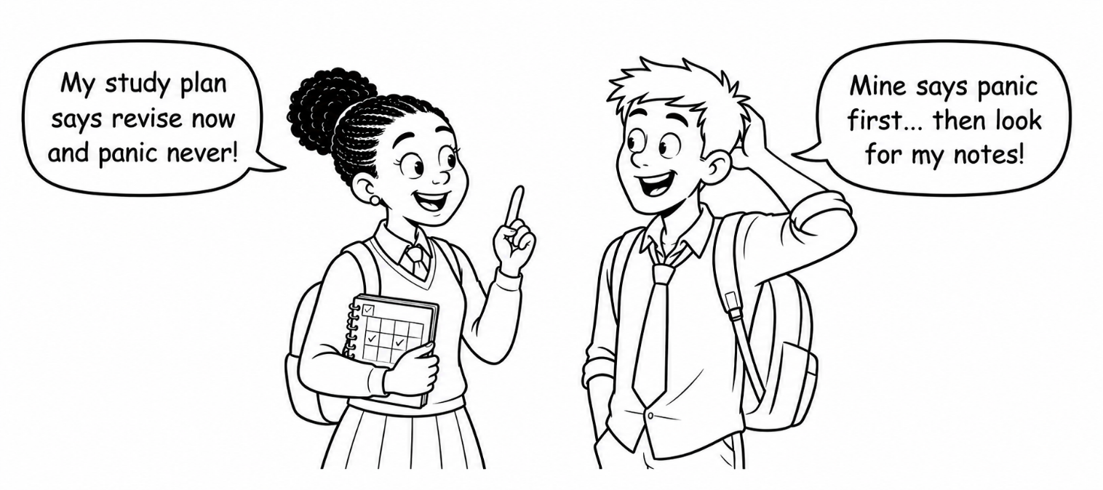
[Created by Teenactiv, 1 July 2026]

1. State TWO examination-writing skills. (2 × 1) (2)
Possible responses could include:
- Reading the examination instructions carefully. (🗸)
- Analysing each question before answering it. (🗸)
- Identifying the content, context and action word in questions. (🗸)
- Using the mark allocation to determine how much information is required. (🗸)
- Managing time according to the marks allocated to each question. (🗸)
- Attempting every question. (🗸)
- Using the correct numbering. (🗸)
- Writing legibly. (🗸)
- Presenting longer answers in paragraphs. (🗸)
- Keeping answers relevant to the question. (🗸)
- Managing stress during the examination. (🗸)
- Checking answers before submitting the examination paper. (🗸)
Any TWO of the above for ONE mark each

2. Explain how time management can help learners during an examination. (1 × 2) (2)

Possible answers may include the following:
- Allocating enough time to each question (🗸) could prevent learners from leaving questions unanswered. (🗸)
- Dividing their time according to the marks available (🗸) could help learners complete all sections of the examination paper. (🗸)
- Avoiding spending too much time on one question (🗸) can allow learners to attempt the remaining questions. (🗸)
- Leaving time at the end of the examination to check their work (🗸) could help learners identify and correct obvious errors. (🗸)
- Working at a suitable pace throughout the examination (🗸) could reduce the need to rush through the final questions. (🗸)
Any ONE of the above for TWO marks
(i.e. ONE mark for statement and ONE mark for qualifier/explanation)

3. Evaluate the effectiveness of completing past papers when preparing for
an examination. (1 × 4) (4)

Possible responses could include:
- Completing past papers could familiarise learners with the examination format/types of questions, (🗸) which may help them answer questions more confidently and effectively; (🗸) however, past papers may be less effective if learners do not correct their answers, (🗸) because they may continue making the same mistakes. (🗸)
- Past papers could help learners practise applying action words/following mark allocations, (🗸) which may improve the structure/depth of their answers; (🗸) however, relying only on past papers may result in incomplete preparation, (🗸) as learners may neglect content that has not appeared in previous papers. (🗸)
- Completing past papers under timed conditions could improve time management, (🗸) because learners practise completing questions within the available examination time; (🗸) however, timed practice may be less useful when learners do not yet understand the content, (🗸) as they may practise answering questions incorrectly. (🗸)
- Past papers could help learners identify topics that require additional revision, (🗸) allowing them to focus their preparation on areas of weakness; (🗸) however, simply memorising previous answers may not prepare them adequately, (🗸) because examination questions may present the content in a different context. (🗸)
- Past papers could increase learners’ confidence before an examination, (🗸) as they become more familiar with the level/style of questioning; (🗸) however, learners may become overconfident if they perform well on familiar questions, (🗸) which could cause them to underestimate the need for thorough content revision. (🗸)
Any ONE of the above for FOUR marks
(To be awarded the full FOUR marks for the EVALUATION, learners must: give a positive statement, (🗸) qualify it, (🗸) give an opposing statement, (🗸) and qualify it. (🗸) [Total: 8]
Activity 2: Completing a Personal Development Plan
Complete the following activity in pairs.

Read the incomplete personal development plan below.

Plan element | Example
Long-term goal | I want to become a lawyer.
Short-term study goal | I want to pass Grade 11 and improve my English and History results.
Actions | - Follow my study plan consistently  - Revise English and History three times per week  - Complete past examination questions
Timeframe | - Identify a realistic period in which the learner could work towards the short-term study goal.  The learner will work towards passing Grade 11 and improving their English and History results by the end of the Grade 11 academic year.
Obstacles and solutions | - Identify possible obstacles and explain how the learner could overcome them.
  Possible obstacle | Possible solution
  The learner may struggle to understand some English or History content. | The learner could ask the teacher for help, attend extra lessons or study with a classmate.
  The learner may procrastinate or fail to follow the study plan. | The learner could set reminders, divide work into smaller tasks and follow a weekly timetable.
  Extracurricular activities or family responsibilities may reduce study time. | The learner could plan study periods around existing commitments and prioritise urgent tasks.
  The learner may become distracted by their cellphone or social media. | The learner could switch off notifications or place the cellphone in another room while studying.
  The learner may lose motivation after receiving a poor result. | The learner could identify where marks were lost, ask for feedback and adjust the study strategy.
  The learner may not have access to enough study resources. | The learner could use school resources, borrow materials or ask the teacher for suitable practice questions.
Monitoring | - Explain how the learner could monitor their progress and make adjustments when necessary.  - Record English and History marks after each assessment and compare them with previous results.  - Check weekly whether the planned study sessions and activities were completed.  - Review incorrect answers in tests and identify topics that require further revision.

Activity 3: Developing a Personal Development Plan
Complete the following activity individually.

1. Choose ONE area in which you would like to develop.

☐ Study ☐ Health ☐ Fitness

2. Complete the personal development plan below.
Plan element | My personal development plan
Long-term goal | What would you like to improve?  _________________________________________________________________
Short-term goal | What is your short-term and/or long-term goal?  _________________________________________________________________  _________________________________________________________________
Actions | What steps will you take to achieve your goal?  _________________________________________________________________  _________________________________________________________________  _________________________________________________________________  _________________________________________________________________
Timeframe | By when would you like to achieve your goal?  _________________________________________________________________
Obstacles and solutions | What could make it difficult to achieve your goal?  _________________________________________________________________  _________________________________________________________________  _________________________________________________________________  _________________________________________________________________  How could you overcome these obstacles?  _________________________________________________________________  _________________________________________________________________  _________________________________________________________________  _________________________________________________________________
Monitoring | How will you review your progress and make adjustments?  _________________________________________________________________  _________________________________________________________________

3. Why is this goal important to you?
__________________________________________________________________________________________________________________________________________________________________

→ Learners will have personal responses to this activity.

