

Lesson 6 – Scenarios

SCENARIO 1

Read through the scenario below. Then complete the problem-solving matrix in the grid provided.

The digital footprint dilemma

Elize’s phone buzzes in the dark, lighting up her anxious face.

“If you really trust me, send it,” Hennie’s message reads.

Her stomach drops. She cares about him, but the thought of sending a private photo makes her feel deeply uncomfortable. For weeks, she has worried about what could happen if the image is shared. In her friend group, screenshots are often passed around, and group chats do not always stay private.

Elize feels trapped between keeping her boyfriend happy and protecting her privacy. Her thumb hovers over the screen. The pressure to prove her commitment is strong, but so is her fear of losing control over her digital footprint.

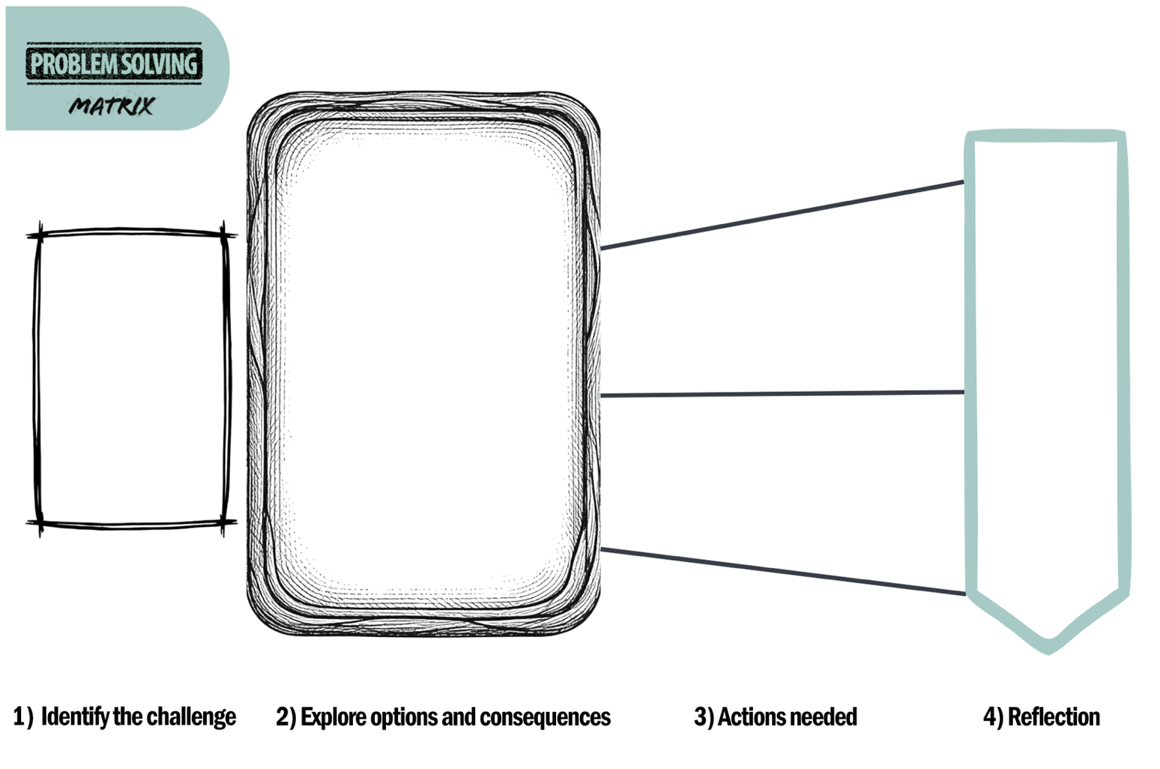

Lesson 6 – Scenarios

SCENARIO 2

Read through the scenario below. Then complete the problem-solving matrix in the grid provided.

The "fast track" peer pressure

Leo stares at his phone while the group chat buzzes with late-night messages. Mano is bragging about last weekend, and Julian joins in with stories of his own. In their circle, virginity is treated like something embarrassing that must be "fixed" as soon as possible.

Everyone is doing it, or at least that is how the messages make it sound.

Leo likes Bonang, but he knows he is not ready to have sex. Still, the fear of being left behind or mocked at school weighs heavily on him. He feels as if "doing it" is the only way to keep his place in the group.

Standing in front of the mirror, Leo faces a difficult choice: ignore his own boundaries to keep his status, or speak honestly and risk losing the approval of his friends.

Lesson 6 – Scenarios

SCENARIO 3

Read through the scenario below. Then complete the problem-solving matrix in the grid provided.

The boundary and consent grey area

The music vibrates through the floor as Sara sits alone, feeling uneasy. Earlier that evening, Jonty pushed past her usual boundaries. He did not cross her "hard line", but he ignored her hesitant body language and only stopped when someone walked past.

Now Sara feels confused and guilty. She wonders why she did not say “no” more clearly. She starts blaming herself, even though she knows she felt uncomfortable.

Sara likes Jonty, and the thought of speaking to him about it makes her nervous. She worries that he may get defensive or that it may cause conflict between them. Still, she realises that staying silent will not solve the problem. She needs to find a way to voice her boundaries clearly.

Lesson 6 – Scenarios

SCENARIO 4

Read through the scenario below. Then complete the problem-solving matrix in the grid provided.

The future horizons conflict

Liam stares at the positive pregnancy test, while the marks on his mid-year exam paper suddenly feel unimportant. Beside him, Charlotte sits in silence, her hands trembling.

This is their final year at school. Just yesterday, their biggest worry was university applications and possible scholarships. Now, the future they had planned feels uncertain.

Every choice ahead feels heavy. They know they need to take responsibility, but they are also afraid of how this may affect their studies, career plans and personal freedom. They are also worried about telling their parents and disappointing the people who believed in them.

Liam and Charlotte feel trapped between an unexpected crisis and the future they had imagined for themselves.

Lesson 6 – Scenarios

SCENARIO 5

Read through the scenario below. Then complete the problem-solving matrix in the grid provided.

The reputation pressure

Ingrid stares at her phone, the cursor blinking over a draft message to Katlego. She wants to say yes to seeing him on Friday night, but she is worried about what people at school might say.

In the school corridors, labels can spread quickly. If she says yes, she fears the rumours and judgment that may follow. If she says no, she worries that people will call her boring or too uptight.

Ingrid knows that her choices should belong to her, but it feels as if everyone else has an opinion about her body, her relationships and her reputation. She feels trapped between what she wants and the image others expect her to maintain.

She locks her screen and sighs. The fear of being judged has become louder than the excitement of making her own choice.

