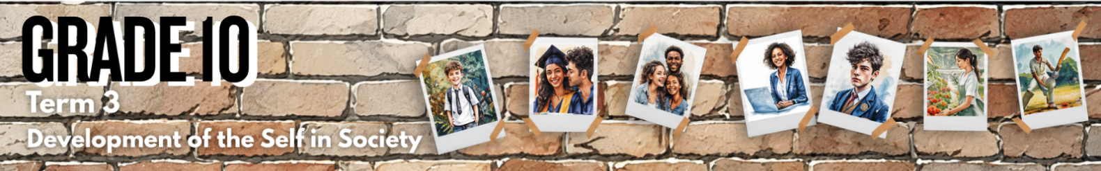

Lesson 4 – Worksheet MEMO
 | Activity 1: Substance Use and Unwanted Pregnancy  Complete the following activity in pairs.

Turn to your peer and briefly discuss the questions below.

- Why could using substances lead to an unwanted pregnancy?
It can affect judgment and self-control, which may lead to unsafe sexual decisions. It can also make it harder to say "no", set boundaries or to protect oneself in risky situations.
- What advice would you give to a friend who is going to a wild party with lots of alcohol, to help make sure that they do not end up in a situation where an unwanted pregnancy could occur?
They should go with trusted friends, avoid drinking alcohol, make sure that their drink is not spiked, keep their phone charged, arrange safe transport home and leave immediately if they feel pressured or unsafe. They should also decide on their boundaries before the party and not allow anyone to pressure them into sexual behaviour.
Activity 2: Reflection
Complete the following activity individually.

State ONE personal boundary you would like to set or strengthen to help you make responsible choices and feel more in control of your life. Explain why this boundary is important to you.
____________________________________________________________________________________________________________________________________________________________________________________________________________________________________________________________________________________________________________________________________________________________

→ Learners will have personal responses to this activity.

Activity 3: Homework Activity
Complete the following activity individually.

Study the infographic below and answer the following questions.

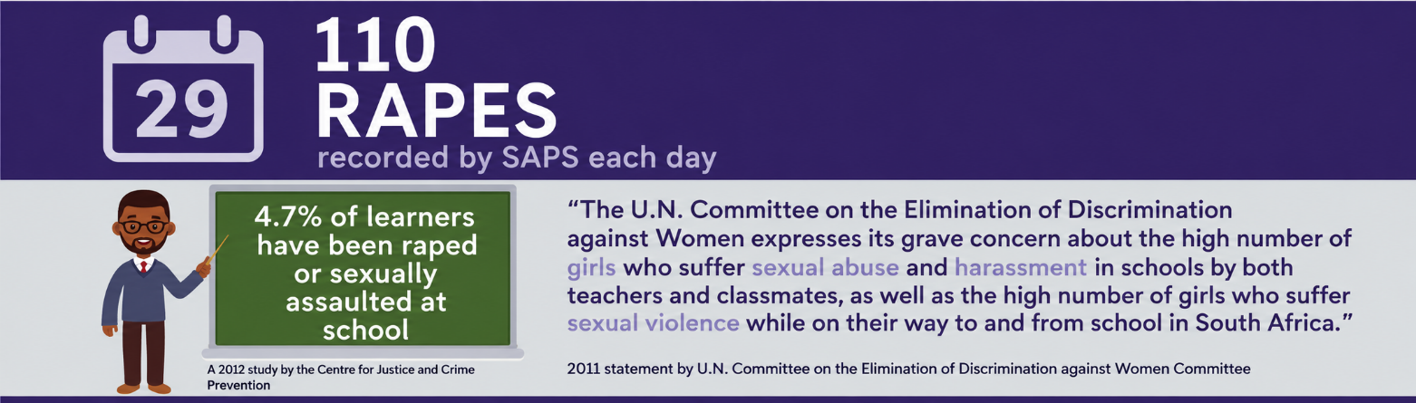
[Adapted from: https://www.soulcity.org.za/ Accessed: 18 May 2026]

1. Identify TWO situations where a teenager may need extra caution to reduce vulnerability
to sexual violence or rape. (2 × 1) (2)

Important note: Rape is always the fault of the perpetrator, never the victim. The examples below do not blame victims; they highlight situations that may increase vulnerability.

Possible responses could include:
- Being alone in unsafe/isolated places, such as walking alone at night in poorly lit areas. (🗸)
- Using alcohol/drugs that may reduce awareness/the ability to make safe decisions. (🗸)
- Leaving drinks unattended/accepting drinks from strangers. (🗸)
- Trusting unfamiliar people too quickly, including people met online. (🗸)
- Sharing personal information/location details too easily with strangers/online contacts. (🗸)
- Going somewhere alone with a person they do not know well. (🗸)

Any TWO of the above for ONE mark each

2. Differentiate between 'rape' and 'sexual abuse'. (1 × 2) (2)

Rape…
- refers to any form of sexual penetration without consent, (🗸) while sexual abuse refers to any unwanted sexual behaviour/activity forced on a person, which may or may not include penetration. (🗸)
- is when a person is sexually penetrated without giving consent, (🗸) while sexual abuse is a broader term that includes any unwanted sexual actions of someone. (🗸)

Any ONE of the above for TWO marks

3. Analyse how having a strong value system could help teenagers make responsible
decisions about sexual behaviour. In your answer, also indicate how this could
contribute to a healthy lifestyle. (1 × 3) (3)

Having a strong value system could…
- provide teenagers with a moral compass when making decisions about sexual behaviour, (🗸) helping them to think carefully about consent/respect/possible consequences, (🗸) thereby encouraging choices that protect their physical/emotional well-being. (🗸)
- help teenagers set clear personal boundaries in relationships, (🗸) making them more confident to say "no" to pressure/unsafe sexual behaviour, (🗸) thereby reducing the risk of harmful situations that could negatively affect their lifestyle. (🗸)
- promote self-respect and respect for others, (🗸) encouraging teenagers to value mutual consent/communication/responsible decision-making, (🗸) thereby helping them build healthier/safer relationships. (🗸)
- guide teenagers to consider the consequences of sexual behaviour, (🗸) helping them avoid choices that may place their health/safety/future at risk, (🗸) thereby supporting overall well-being. (🗸)
- shape positive attitudes towards intimate relationships, (🗸) encouraging teenagers to avoid coercion/manipulation/unsafe practices, (🗸) thereby contributing to relationships that are respectful/consensual/emotionally healthy. (🗸)

Any ONE of the above for THREE marks
(i.e. ONE mark for statement, ONE mark for qualifier/explanation and ONE mark for outcome)

4. Recommend ONE strategy a teenager could use to respond to unwanted sexual attention
from a fellow classmate. In your answer, also indicate how this strategy may enable the
teenager to build a respectful environment for other learners. (1 × 3) (3)

A teenager could…
- firmly tell the classmate to stop and make it clear that the attention is unwanted, (🗸) using assertive language/body language to show that the behaviour is not acceptable, (🗸) thereby encouraging respect for personal boundaries among other learners. (🗸)
- report the unwanted sexual attention to a teacher/school counsellor/parent, (🗸) ensuring that the behaviour is addressed/that the teenager receives support and protection, (🗸) thereby helping to create a school environment where learners feel safe to speak out against harassment. (🗸)
- clearly state their personal boundaries/refuse to laugh off/excuse the unwanted behaviour, (🗸) showing the classmate/bystanders that sexual comments/actions are not harmless jokes, (🗸) thereby helping to build a school culture where all learners are treated with dignity/ respect. (🗸)
- ask trusted friends to support them when addressing/reporting the behaviour, (🗸) so that they do not feel isolated/pressured to accept the unwanted attention, (🗸) thereby encouraging learners to stand together against disrespectful sexual behaviour. (🗸)

Any ONE of the above for THREE marks
(i.e. ONE mark for statement, ONE mark for qualifier/explanation and ONE mark for outcome)
[Total: 10]

