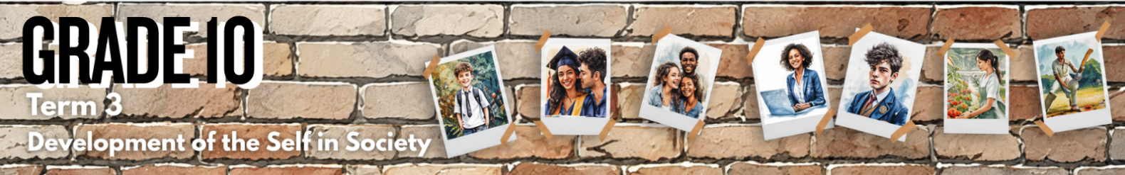

Lesson 3 – Worksheet MEMO
 | Activity 1: Thoughts During Adolescence  Complete the following activity individually.

Read the statements in the image below. Have you ever had some of these thoughts?

Rate the thoughts you struggle with the most by writing one of the following numbers next to each speech bubble in the image:
1 = I do not struggle with this at all
2 = I sometimes think about this
3 = I think about this quite often

Remember, your answers are private. You do not have to share them with anyone.

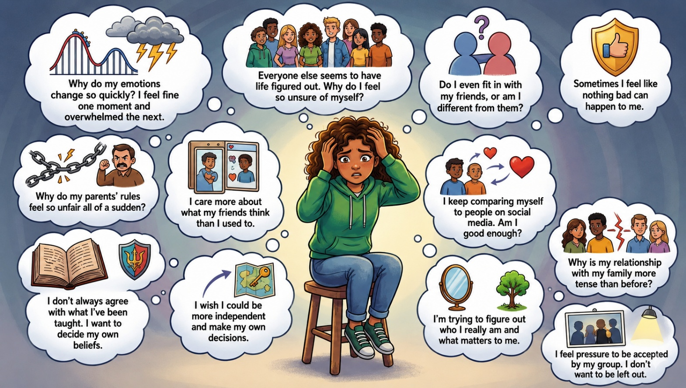

→ Learners will have personal responses to this activity.

Activity 2: Emotional and Social Changes During Adolescence
Complete the following activity individually.

Watch the video Emotional Shifts in Teenagers up until 3 min 36 sec. Then complete Part 1 below.

Part 1: Emotional changes during adolescence

Choose an emotional change from COLUMN B that matches an image in COLUMN A. Write only the letter (A–E) next to the question numbers (1 to 5).
Column A |  | Column B
1. | 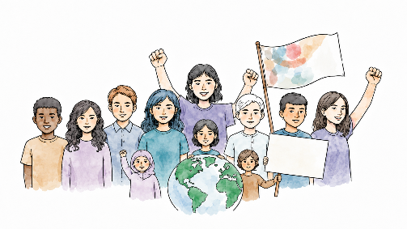 | A. | "Invincible" stage of thinking and acting
2. | 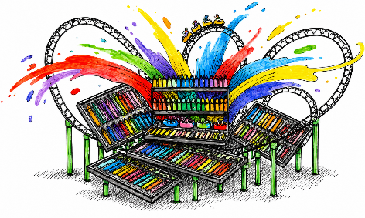 | B. | Feelings of insecurity
3. | 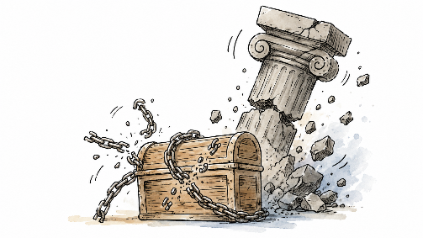 | C. | Changing needs in belief and values
4. | 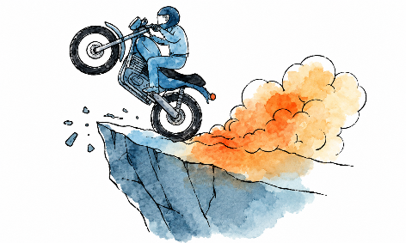 | D. | Emotions become more intense, and mood swings occur
5. | 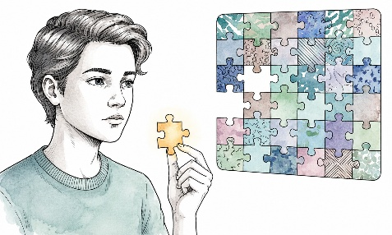 | E. | Challenging authority

Answers:
1. C (🗸) ; 2. D (🗸) ; 3. E (🗸) ; 4. A (🗸) ; 5. B (🗸)

Part 2: Social changes during adolescence

Study the images below and answer the following questions.

Image 1 | Image 2
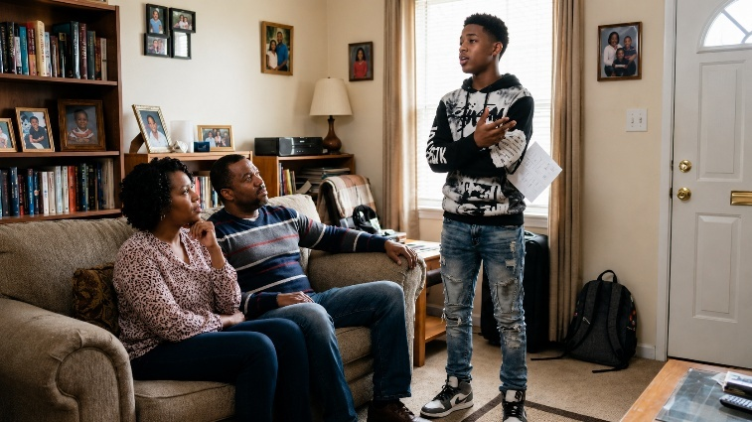 | 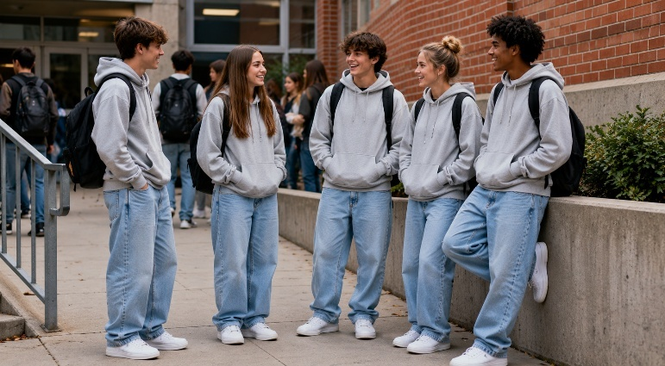
Image 3 | Image 4
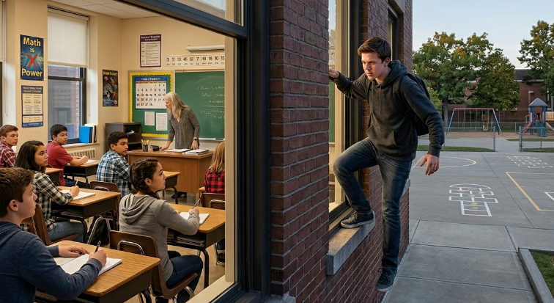 | 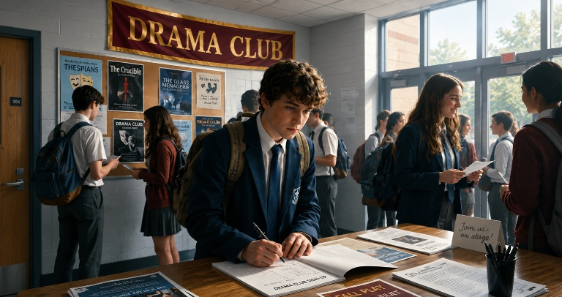

1. Identify the social change shown in each image. (4 × 1) (4)

Image 1:
  - Teenagers start relating differently to their parents/caregivers. (🗸)
  - Teenagers begin to set boundaries/show greater independence from their parents. (🗸)

Any ONE of the above for ONE mark

Image 2:
  - Teenagers may conform to peer group norms. (🗸)
  - Teenagers may change their behaviour/appearance to fit in with their peers. (🗸)

Any ONE of the above for ONE mark

Image 3:
  - Teenagers may engage in risk-taking behaviour. (🗸)
  - Teenagers may push boundaries/break rules to impress others/fit in. (🗸)

Any ONE of the above for ONE mark

Image 4:
  - Teenagers may join clubs/activities to meet like-minded peers. (🗸)
  - Teenagers may seek belonging by becoming part of a school/community group. (🗸)

Any ONE of the above for ONE mark

2. Discuss ONE possible negative effect of the social change in each image. (4 × 2) (8)

Image 1:
The teenager may…
  - challenge parental authority/push back against rules, (🗸) which could lead to conflict/strain the relationship between the teenager and their parents. (🗸)
  - become frustrated when parents still try to guide/protect them, (🗸) which could cause arguments/make communication at home more difficult. (🗸)

Any ONE of the above for TWO marks
(i.e. ONE mark for statement and ONE mark for qualifier/explanation)

Image 2:
The teenager may…
  - feel pressured to dress/act like their peer group, (🗸) which could cause them to lose their individuality/go against their own values. (🗸)
  - spend money on clothing/brands to fit in with peers, (🗸) which could create financial pressure/make them feel excluded if they cannot afford it. (🗸)

Any ONE of the above for TWO marks
(i.e. ONE mark for statement and ONE mark for qualifier/explanation)

Image 3:
The teenager may…
  - take part in unsafe behaviour to impress others/test boundaries, (🗸) which could lead to injury/punishment/trouble at school. (🗸)
  - break rules/act irresponsibly while trying to fit in, (🗸) which could damage their reputation/lead to serious consequences. (🗸)

Any ONE of the above for TWO marks
(i.e. ONE mark for statement and ONE mark for qualifier/explanation)

Image 4:
The teenager may…
  - spend too much time trying to belong to a group that does not suit their interests/values, (🗸) which could make them feel pressured/less confident about who they are. (🗸)
  - focus too much on gaining acceptance from a specific group, (🗸) which could distract them from schoolwork/other important responsibilities. (🗸)

Any ONE of the above for TWO marks
(i.e. ONE mark for statement and ONE mark for qualifier/explanation)

3. Discuss ONE possible positive effect of the social change in each image. (4 × 2) (8)

Image 1:
The teenager may…
  - learn to communicate their needs/boundaries more clearly, (🗸) which could help them become more independent/confident. (🗸)
  - begin making more decisions for themselves, (🗸) which could help them develop responsibility/prepare for adulthood. (🗸)

Any ONE of the above for TWO marks
(i.e. ONE mark for statement and ONE mark for qualifier/explanation)

Image 2:
The teenager may…
  - feel accepted by their peer group, (🗸) which could help them build friendships/develop a stronger sense of belonging. (🗸)
  - connect with peers who share similar interests, (🗸) which could improve their social confidence/emotional support. (🗸)

Any ONE of the above for TWO marks
(i.e. ONE mark for statement and ONE mark for qualifier/explanation)

Image 3:
The teenager may…
  - learn from mistakes after taking risks, (🗸) which could help them make safer/more responsible choices in future. (🗸)
  - become more aware of the consequences of unsafe behaviour, (🗸) which could help them develop better decision-making skills. (🗸)

Any ONE of the above for TWO marks
(i.e. ONE mark for statement and ONE mark for qualifier/explanation)

Image 4:
The teenager may…
  - join activities that match their interests/talents, (🗸) which could help them discover new skills/future pathways. (🗸)
  - become part of a positive community of like-minded peers, (🗸) which could increase their confidence/sense of belonging/participation at school. (🗸)

Any ONE of the above for TWO marks
(i.e. ONE mark for statement and ONE mark for qualifier/explanation)

[Total: 20]

Activity 3: Coping with Changes During Adolescence
Complete the following activity in groups.

Read through the scenario that was assigned to your group. Then discuss and answer the questions below.

1. State ONE emotional or social change shown in the scenario. (1 × 1) (1)

Possible responses could include:
Scenario 1:
- A desire to fit in with peers/gain peer acceptance. (🗸)
- Experiencing guilt/anxiety/internal conflict after doing something wrong to please friends. (🗸)
- Giving in to peer pressure. (🗸)
Scenario 2:
- Wanting more independence from parents. (🗸)
- Making personal decisions that differ from parents’ expectations. (🗸)
- Experiencing guilt/stress because of conflict with parents. (🗸)
Scenario 3:
- Engaging in risk-taking behaviour. (🗸)
- Seeking peer approval/social attention. (🗸)
- Acting impulsively without thinking about consequences. (🗸)
Scenario 4:
- Questioning beliefs/values/traditions. (🗸)
- Developing independent thinking. (🗸)
- Forming a personal identity separate from family expectations. (🗸)
Scenario 5:
- Developing a personal sense of purpose. (🗸)
- Choosing values that differ from peer/family expectations. (🗸)
- Wanting to contribute positively to the community. (🗸)
Scenario 6:
- Feeling self-conscious in social situations. (🗸)
- Experiencing anxiety around romantic/mixed-gender interactions. (🗸)
- Becoming more aware of how others perceive them. (🗸)

Any ONE relevant response for ONE mark

2. Explain why this change is common during adolescence. (1 × 2) (2)

Possible responses could include:
Scenario 1:
- Teenagers often want to feel accepted by their peer group, (🗸) which may make them more likely to follow friends even when they know the behaviour is wrong. (🗸)
- During adolescence, friends become more important in shaping identity/behaviour, (🗸) which may cause teenagers to fear rejection if they do not join in. (🗸)
- Teenagers may still be developing decision-making/self-control skills, (🗸) which can make it harder to resist pressure in the moment. (🗸)
Scenario 2:
- Teenagers begin to develop their own identity during adolescence, (🗸) which may cause them to make choices that differ from what their parents expect. (🗸)
- Adolescents often start exploring their own interests/future goals, (🗸) which can lead to conflict when parents have different plans for them. (🗸)
- Teenagers may want more control over important life decisions, (🗸) which can create tension if parents still want to guide/protect them. (🗸)
Scenario 3:
- Teenagers may enjoy excitement/peer approval, (🗸) which can make them more likely to take risks without thinking about the danger. (🗸)
- The part of the brain responsible for planning and impulse control is still developing, (🗸) which can make it harder for teenagers to judge long-term consequences. (🗸)
- Adolescents may sometimes feel 'invincible', (🗸) which can cause them to believe that serious consequences will not happen to them. (🗸)
Scenario 4:
- Teenagers begin to think more deeply about beliefs/values, (🗸) which may cause them to question ideas they previously accepted. (🗸)
- Adolescents are developing their own identity, (🗸) which can make them compare family expectations with their personal beliefs. (🗸)
- Teenagers may want their choices to reflect who they truly are, (🗸) which can lead them to question traditions/rules that no longer feel meaningful to them. (🗸)
Scenario 5:
- Teenagers often begin to think about the kind of person they want to become, (🗸) which may cause them to choose activities that match their values. (🗸)
- Adolescents may start questioning what society sees as success, (🗸) which can lead them to choose meaningful activities over popularity/status. (🗸)
- Teenagers are developing their own identity/values, (🗸) which may cause them to become more interested in helping others/supporting social causes. (🗸)

Scenario 6:
- During adolescence, teenagers become more aware of attraction/relationships, (🗸) which may make them feel nervous/awkward around others. (🗸)
- Teenagers may worry a lot about how they are judged by peers, (🗸) which can make social situations feel more stressful. (🗸)
- Puberty/emotional development can make teenagers more sensitive to social approval, (🗸) which may lead to overthinking/embarrassment in new social situations. (🗸)

Any ONE relevant response for TWO marks
(i.e. ONE mark for statement and ONE mark for qualifier/explanation)

3. Recommend ONE positive strategy that could be used to handle this situation. (1 × 2) (2)

Scenario 1: Leo could…
- use assertive communication to say no to risky behaviour, (🗸) so that he can protect himself from punishment/make choices that match his values. (🗸)
- walk away from friends who pressure him to break rules, (🗸) which could help him avoid dangerous situations/make more responsible decisions. (🗸)
- choose friends who respect his boundaries/values, (🗸) so that he is less likely to be pressured into harmful behaviour. (🗸)
Scenario 2: Aisha could…
- have an honest/calm conversation with her parents about her goals, (🗸) so that they can understand her interests/rebuild trust. (🗸)
- explain how she plans to balance her passion with her school responsibilities, (🗸) which may help her parents feel more confident about supporting her decision. (🗸)
- ask a trusted adult/teacher/counsellor to help with the conversation, (🗸) so that the disagreement can be handled respectfully/fairly. (🗸)
Scenario 3: Mia could…
- put her phone away or on “Do Not Disturb” while driving, (🗸) so that she can focus on the road/reduce the risk of an accident. (🗸)
- refuse to take part in unsafe driving behaviour, (🗸) which could protect her/others from injury/death. (🗸)
- think about the possible consequences before acting, (🗸) so that she can make safer/ more responsible decisions. (🗸)
Scenario 4: Xoliswa could…
- speak to her parents respectfully about her questions/feelings, (🗸) so that they can understand her without feeling attacked. (🗸)
- ask for time to explore her beliefs while still showing respect for her family, (🗸) which could help reduce conflict at home. (🗸)
- talk to a trusted adult/faith leader/counsellor for guidance, (🗸) so that she can process her questions in a healthy/respectful way. (🗸)
Scenario 5: Noah could…
- join youth groups/volunteer organisations that share his values, (🗸) so that he can feel supported by people who respect his choices. (🗸)
- explain to his parents and friends why community service matters to him, (🗸) which may help them understand his goals better. (🗸)
- balance his community work with school and family responsibilities, (🗸) so that others can see that his choices are meaningful/responsible. (🗸)
Scenario 6: Mark could…
- focus on listening/asking simple questions during conversations, (🗸) so that he feels less pressure to impress others. (🗸)
- remind himself that small mistakes are normal, (🗸) which may help him feel calmer/less embarrassed in social situations. (🗸)
- practise positive self-talk before social interactions, (🗸) so that he can build confidence/ manage his anxiety better. (🗸)

Any ONE relevant response for TWO marks
(i.e. ONE mark for statement and ONE mark for outcome)
[Total: 5]
Activity 4: Reflection
Complete the following activity individually.

Complete the statements below.

1. One aspect I learned about myself today is ______________________________________________
_________________________________________________________________________________

2. One question I still have about the work is ______________________________________________
_________________________________________________________________________________

3. One suggestion I have for coping with emotions is ________________________________________
_________________________________________________________________________________

→ Learners will have personal responses to this activity.

