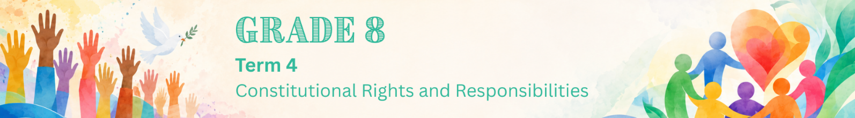

Lesson 1 – Worksheet MEMO
 | Activity 1: Recapping Human Rights  Complete the following activity in groups.

Write one human right you can remember in each puzzle piece. Try to fill in as many pieces as possible.

Human Rights Puzzle
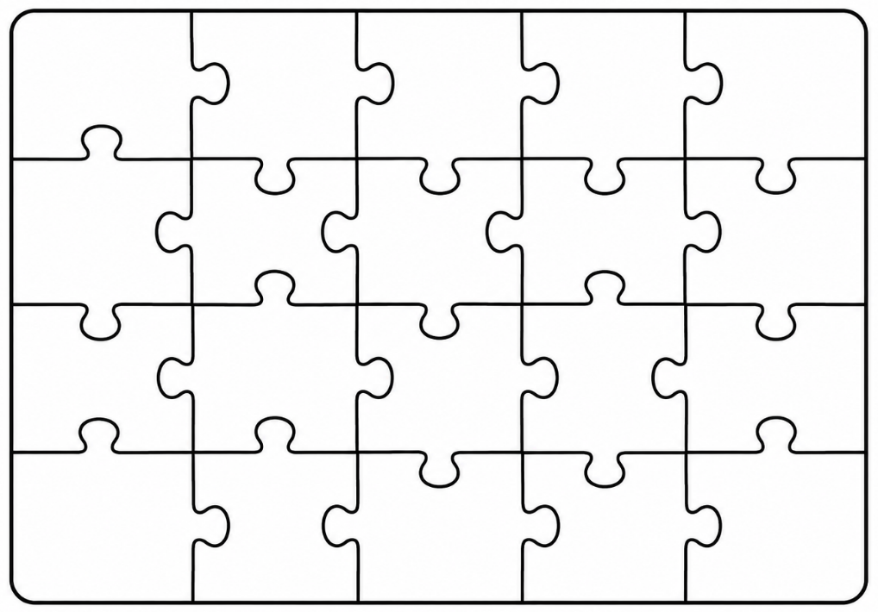

Human rights include:
- Equality (everyone is equal before the law)  - Human dignity  - Life  - Privacy (body, home and possessions)  - Citizenship  - Labour relations  - Healthcare, food, water and social security  - Children (right to a name, nationality and protection from abuse and exploitation)  - Political rights (voting)  - Freedom of religion, belief and opinion  - Freedom and security of the person (free from violence)  - Adequate housing |  | - Freedom of expression (no hate speech is allowed)  - May not be deprived of property  - Safe and healthy environment  - Freedom of association  - Assembly, demonstration, picket and petition  - Freedom of movement and residence  - Education  - May not be subjected to slavery or forced labour  - Language and culture  - Access to courts  - Access to information  - Freedom of trade, occupation and profession
Activity 2: Human Rights Violations & Counterstrategies
Complete the following activity individually.

1. Read the extract below and answer the following questions.

Private school investigated over learner’s beard

A private school is being investigated after it allegedly told a Muslim Grade 8 learner that he could not grow a beard for religious reasons. The learner’s family says the school treated him unfairly and did not respect his constitutional right to freedom of religion. They explain that, according to their religious beliefs, he is expected to grow a beard after reaching puberty.

The family claims the school told the learner to either shave his beard or leave the school. They have now asked the Department of Education to look into the matter.

This case has started a debate about how schools should balance their rules with learners’ constitutional rights. South African law protects people from being treated unfairly because of their religion, but schools may also have codes of conduct if these rules are fair and reasonable.

[Adapted from: https://www.news24.com/ Accessed on 01 July 2025]

a. Define the term 'human rights violation'. (1 × 1) (1)

A human rights violation is…
- when a person’s basic rights/freedoms are abused/not respected/protected. (🗸)
- when a person/group/government ignores/denies/stops someone from enjoying their rights/freedoms. (🗸)

Any ONE of the above for ONE mark

b. Discuss ONE right that is being violated in the above text. (1 × 2) (2)

Possible answers may include the following:
- The learner’s right to equality is being violated, (🗸) as he is facing discrimination on the basis of his religion/religious beliefs. (🗸)
- He is being denied the freedom to practice his religion, (🗸) which is protected under the Constitution. (🗸)
- By threatening to exclude him from school if he does not comply, (🗸) the school is potentially denying him access to education. (🗸)
- The learner is being treated unequally in comparison to learners of other faiths (🗸) whose religious practices are not restricted. (🗸)

Any ONE of the above for TWO marks
(i.e. ONE mark for statement and ONE mark for qualifier/explanation)

c. Suggest ONE counterstrategy the parents of the learner could use against this
human right violation. (1 × 3) (3)

The parents could…
- report the matter to the Department of Education, (🗸) which may investigate whether the school’s actions are fair/lawful, (🗸) thereby helping to protect the learner’s constitutional rights. (🗸)
- meet with the school management to discuss the issue, (🗸) which may help both parties find a fair solution that respects the learner’s religion, (🗸) thereby reducing conflict between the family and the school. (🗸)
- seek legal/human rights support, (🗸) which may help them better understand/defend the learner’s rights, (🗸) thereby increasing the chances of fair treatment. (🗸)

Any ONE of the above for THREE marks
(i.e. ONE mark for statement, ONE mark for qualifier/explanation and ONE mark for outcome)
[Sub-total: 6]

2. Read the extract below and answer the following questions.

Environmental injustice in South Durban

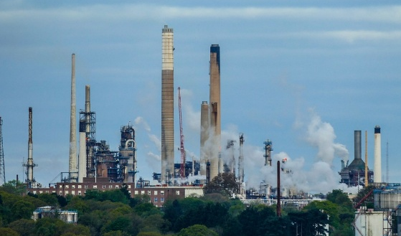
Communities in South Durban face serious health risks because they live close to large oil refineries. These refineries contribute to air pollution in the area.

A report by Greenpeace Africa found that air pollution caused about 42 000 deaths in South Africa in 2023.
This shows how environmental problems can affect people’s health and even lead to death. It also shows that vulnerable communities are often affected the most.

[Adapted from: https://www.dailymaverick.co.za/ Accessed on 01 July 2025]

a. State ONE human right being violated in the above text. (1 × 1) (1)

Possible answers may include the following:
- Right to a safe/healthy environment (🗸)
- Right to health care/health (🗸)
- Right to life (🗸)

Any ONE of the above for ONE mark

b. Explain ONE impact that the situation described above could have on the wider
community. (1 × 2) (2)

Possible answers may include the following:
- Hospitals/clinics may become overcrowded (🗸) due to many people struggling with breathing problems/other illnesses caused by air pollution. (🗸)
- More people in the community may become sick (🗸) because polluted air can cause health problems such as asthma/lung disease. (🗸)
- Learners may struggle to focus at school (🗸) because illness/breathing difficulties could affect their concentration/attendance. (🗸)
- People’s quality of life may decrease (🗸) because living in a polluted environment can affect their health/daily lives. (🗸)

Any ONE of the above for TWO marks
(i.e. ONE mark for statement and ONE mark for qualifier/explanation)

c. Suggest ONE counterstrategy community members can use against this violation. (1 × 3) (3)

They could…
- report the issue to environmental authorities, (🗸) which may help officials investigate the pollution, (🗸) thereby helping to protect the health/rights of the community. (🗸)
- organise awareness campaigns about air pollution, (🗸) which may teach people about the dangers of polluted environments, (🗸) thereby encouraging the community to work towards better living conditions. (🗸)
- work with organisations such as Greenpeace, (🗸) which may help the community speak out against pollution, (🗸) thereby encouraging companies to reduce pollution in the area. (🗸)
- peacefully protest against pollution in the area, (🗸) which may draw attention to the community’s challenges, (🗸) thereby encouraging the government/companies to take action. (🗸)

Any ONE of the above for THREE marks
(i.e. ONE mark for statement, ONE mark for qualifier/explanation and ONE mark for outcome)

[Sub-total: 6]
[Grand total: 12]

Activity 3: Homework Reflection
Complete the following activity individually.

1. Think about your school or community. State ONE human rights issue that you think young people should care more about.
_________________________________________________________________________________

2. Which counterstrategy do you think you would be most likely to use if you saw someone’s rights being violated? Motivate your answer.
__________________________________________________________________________________________________________________________________________________________________

→ Learners will have personal responses to this activity.

