

Lesson 4 – Worksheet MEMO
Activity 1: Knowledge about Self in Relation to Demands
Complete the following activity in pairs.

1. Discuss the following questions with your partner.
a. What career are you interested in pursuing?
b. Do your current subject choices meet the requirements if you plan to study further at a university or tertiary institution? Have you researched where you could study?
c. Have you done any job shadowing to determine whether you would enjoy this career?
d. Do you prefer working independently or with others? How could this influence your career choice?

2. Write a summary of your discussion.
___________________________________________________________________________________________________________________________________________________________________________________________________________________________________________________
→ Learners will have personal responses to this activity.
Activity 2: Socio-Economic Conditions
Complete the following activity in groups.

Study the infographic below and discuss the following questions.
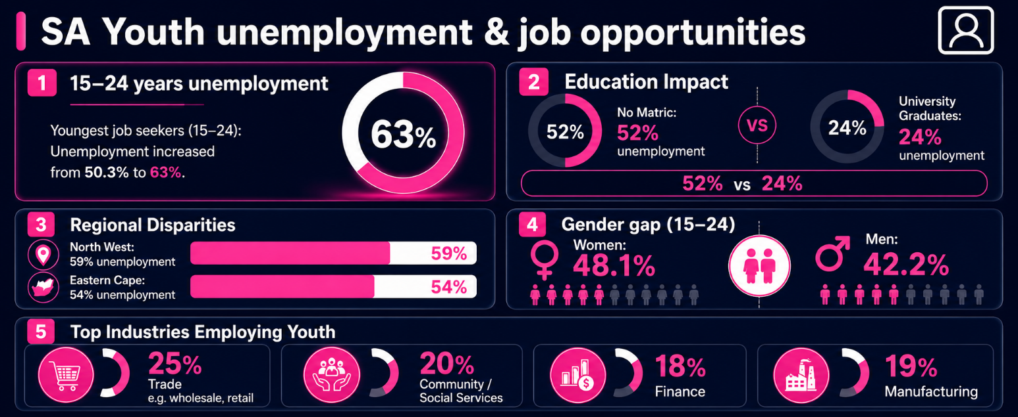
[Adapted from https://www.statssa.gov.za/?p=18398 Accessed 6 May 2026]

Make brief notes on your discussion so that your group can provide feedback to the class.

1. How can socio-economic conditions such as poverty, access to education, and geographic location influence career opportunities for young people?
- Young people living in poverty may struggle to afford school fees/transport/study resources, which can limit their access to quality education and career opportunities.
- Financial pressure may force some young people to leave school early to support their families, which can reduce their long-term employment opportunities.
- Limited access to education may reduce the qualifications/skills young people need to enter certain careers.
- Learners attending under-resourced schools may have fewer subject choices/technology resources/ career guidance opportunities, which can affect future career paths.
- Young people living in rural or remote areas may have limited access to universities/jobs/work experience opportunities compared to those living in urban areas.
2. How does a person’s level of education affect their chances of finding employment in South Africa?
- People with higher levels of education usually have more qualifications/skills, which can improve their chances of finding employment.
- Completing matric/tertiary studies can allow individuals to qualify for a wider range of careers/job opportunities.
- Employers often prefer candidates with relevant education/training, as they may require less supervision/additional training.
- Individuals with limited education may struggle to compete for jobs in South Africa’s highly competitive job market.
- Higher levels of education can increase access to better-paying/more stable jobs.
3. Why might young people living in rural or non-urban areas experience greater challenges in finding employment than those living in urban areas?
- Rural/non-urban areas often have fewer businesses/industries/job opportunities available to young people.
- Young people in rural areas may have limited access to tertiary institutions/training centres/career guidance services.
- Poor transport systems/long travelling distances can make it difficult to access jobs/attend interviews.
- Limited internet access/technology in some rural communities may reduce access to online job applications/information.

4. Which industries currently appear to offer the greatest employment opportunities for young people, and why do you think this is the case?
- The trade and retail sector often requires large numbers of employees for customer service/sales/stock management.
- Community and social services may have high demand for workers in areas such as healthcare/education/community support.
- Manufacturing industries may provide jobs that do not always require advanced tertiary qualifications, making them more accessible to young people.
- The finance sector continues to grow due to the increasing need for banking/financial services/administrative support.
Activity 3: Careers in demand in South Africa
Complete the following activity individually.

Read the article below and answer the questions that follow.
20 of the most in-demand jobs in South Africa right now

According to Career Junction’s analysis of South African labour trends, the most in-demand jobs were found in five main sectors: Business & Management, Finance, Information Technology (IT), Sales, and Admin, Office & Support.

Business and Management positions, such as managers, were among the most in demand because many workplaces need people with strong leadership skills. Finance careers, including accountants, also remained highly sought after, while IT careers such as software developers and data analysts continued to offer opportunities for skilled workers. Sales careers, such as sales consultants, help businesses remain sustainable, while administrative and customer support positions continue to play an essential role across many industries.

To prepare for these careers, learners should embrace the opportunity to develop the skills needed in different workplaces while they are still at school. Skills such as time management, creative and critical thinking, communication and leadership can help learners work towards setting realistic career goals and making informed decisions about their future.

[Adapted from https://businesstech.co.za/ Accessed on 6 May 2026]

1. Define the term 'skilled worker' and state TWO reasons why people might want to
become a skilled worker. (1 + 2) (3)

Skilled worker refers to…
- a person who has received specialised training/education/experience to perform a specific job effectively. (🗸)
The above for ONE mark

AND

They might…
- have better chances of finding employment. (🗸)
- qualify for higher-paying jobs. (🗸)
- gain specialised knowledge/practical skills. (🗸)
- have more career opportunities/job stability. (🗸)
- improve their chances of career growth/promotion. (🗸)
- contribute valuable skills to the economy/society. (🗸)
Any TWO of the above for ONE mark each

2. Provide TWO reasons why developing your IT skills could improve your chances of
finding employment in the future. (2 × 1) (2)

Possible answers may include the following:
- Many jobs require basic computer/technology skills. (🗸)
- IT skills can improve productivity/efficiency in the workplace. (🗸)
- People with IT skills may qualify for a wider range of careers. (🗸)
- Employers often prefer candidates who are confident using technology. (🗸)
- IT skills can help individuals adapt to modern/digital work environments. (🗸)
- Technology skills can create opportunities for online/remote work. (🗸)
Any TWO of the above for ONE mark each

3. Describe THREE ways in which skills developed at school could prepare learners for
the workplace. (3 × 2) (6)

Possible answers may include the following:
- Communication skills learnt through group tasks/oral presentations (🗸) can help learners interact professionally with employers/colleagues/customers. (🗸)
- Teamwork skills developed through group projects/sport activities (🗸) can help learners work effectively with others in a workplace environment. (🗸)
- Time management skills developed through completing homework/projects on time (🗸) can help learners meet deadlines/manage responsibilities in the workplace. (🗸)
- Problem-solving skills developed through class activities/tests/challenges (🗸) can help learners find solutions to workplace problems. (🗸)
- Leadership skills developed through leadership roles/school committees/team captaincy (🗸) can help learners take responsibility/guide others in the workplace. (🗸)
- Computer skills developed through school research/projects/CAT lessons (🗸) can help learners adapt to modern workplace technology. (🗸)
- Organisational skills developed through managing school timetables/tasks (🗸) can help learners complete workplace duties more efficiently. (🗸)
- Self-discipline developed through following school rules/routines (🗸) can help learners behave responsibly/professionally at work. (🗸)
Any THREE of the above for TWO marks each
(i.e. ONE mark for statement and ONE mark for qualifier/explanation)

4. Discuss why it is important that your personal expectations are in line with your job
of choice. (2 × 2) (4)

Possible answers may include the following:
- Having realistic expectations about a job (🗸) can help individuals feel more satisfied/motivated in their career. (🗸)
- Choosing a job that matches your interests/goals (🗸) can increase commitment/enjoyment in the workplace. (🗸)
- Understanding the demands/conditions of a job (🗸) can help individuals prepare for the responsibilities/challenges involved. (🗸)
- Matching personal expectations with career opportunities (🗸) can reduce disappointment/frustration in the future. (🗸)
- Choosing a career that suits your values/lifestyle (🗸) can improve work-life balance/overall well-being. (🗸)
- Having accurate expectations about salary/career growth (🗸) can help individuals make informed career decisions. (🗸)
Any TWO of the above for TWO marks each
(i.e. ONE mark for statement and ONE mark for qualifier/explanation)

5. Suggest ONE practical strategy you could use to improve your time-management skills
while still at school. In your answer, also indicate how this could contribute to greater
career success in the future. (1 × 3) (3)

I could…
- use a study timetable/planner to organise my daily tasks/deadlines, (🗸) which could help me manage my school responsibilities more effectively, (🗸) and that may prepare me to meet deadlines/manage workloads successfully in the workplace. (🗸)
- set priorities by completing important tasks first, (🗸) which could help me avoid falling behind with schoolwork, (🗸) and that may help me become more organised/reliable in my future career. (🗸)
- limit distractions such as social media while studying, (🗸) which could improve my focus/productivity, (🗸) and that may help me work more efficiently in a future job environment. (🗸)
- break large tasks into smaller, manageable steps, (🗸) which could make schoolwork feel less overwhelming, (🗸) and that may help me manage complex responsibilities more effectively in my career. (🗸)
- develop a consistent homework/study routine, (🗸) which could improve my discipline/time-management habits, (🗸) and that may contribute to greater responsibility/dependability in the workplace. (🗸)
Any ONE of the above for THREE marks
(i.e. ONE mark for statement, ONE mark for qualifier/explanation and ONE mark for outcome)
[Total: 18]

Activity 4: 3-2-1 Reflection
Complete the following activity individually.

Answer the following questions.

1. What THREE facts did you learn about the labour force in South Africa?
________________________________________________________________________________________________________________________________________________________________________________
________________________________________________________________________________________

2. What TWO characteristics about the expectations of the working world or the current job market surprised you?
________________________________________________________________________________________________________________________________________________________________________________

3. What is ONE factor you are still unsure about when it comes to choosing a career path?
________________________________________________________________________________________

→ Learners will have personal responses to this activity.

