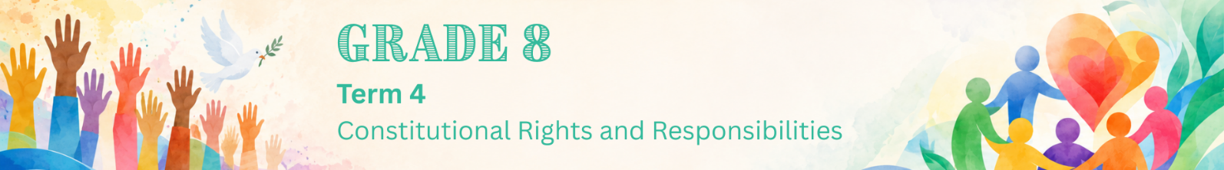

Lesson 4 – Worksheet
 | Activity 1: Rights, Safety and Support  Complete the following activity individually.

Read the scenario below and answer the following questions.

Thandi’s Dilemma

Thandi is 14 years old and in Grade 8. Over the last few weeks, her older cousin’s boyfriend, who visits their neighbourhood often, has started intimidating Thandi. Last weekend, things got worse when he cornered her at a local community park, shouted at her and sexually assaulted her.

Thandi managed to run away, but she is deeply shaken and upset. For the past two days, she has stayed inside her room, skipped her afternoon sports, and tried to hide her tears so her family won't notice. She feels deeply ashamed and is worried that her cousin will get angry with her or that nobody will believe her if she speaks up. She also sighs and thinks to herself, "Maybe this is just what happens around here, and I just have to deal with it."

Her classmate and friend, Sipho, notices she is missing from practice and visits her. Seeing Thandi so scared and quiet, Sipho wants to help, but he knows he cannot handle a dangerous situation like this alone.
[Created by Teenactiv, 28 May 2026]

1. Identify TWO reasons why Thandi is hiding in her room instead of immediately telling
someone what happened. (2 × 1) (2)
__________________________________________________________________________________________________________________________________________________________________

2. State TWO signs that show Thandi may need help after experiencing GBV. (2 × 1) (2)
__________________________________________________________________________________________________________________________________________________________________

3. Mention TWO things Sipho should do or say to make Thandi feel safe. (2 × 1) (2)
__________________________________________________________________________________________________________________________________________________________________

4. Explain why it is important for Sipho to encourage Thandi to speak to a trusted adult about
the situation. (1 × 2) (2)
__________________________________________________________________________________________________________________________________________________________________

5. Discuss TWO ways in which Thandi’s rights as a survivor of a sexual offence could help
protect and support her. (2 × 2) (4)
__________________________________________________________________________________________________________________________________________________________________
__________________________________________________________________________________________________________________________________________________________________

6. Suggest TWO actions Sipho could take to help Thandi find the support she needs. (2 × 2) (4)
__________________________________________________________________________________________________________________________________________________________________
__________________________________________________________________________________________________________________________________________________________________
[Total: 16]
Activity 2: Reflection
Complete the following activity individually.

1. Read each statement and rate yourself, using the following rating scale:
1 = I am not sure yet
2 = I understand some of it
3 = I understand this well

Statement | Rating: 1/2/3
I understand that GBV should never be ignored or treated as a joke.
I understand the rights of survivors of sexual offences.
I know where victims of GBV can receive help and support.
I understand why it is important not to blame someone who asks for help.
I know responsible actions I can take if someone tells me they feel unsafe.

2. Complete the sentence:
One important thing I learned today is: _________________________________________________
_________________________________________________________________________________.

