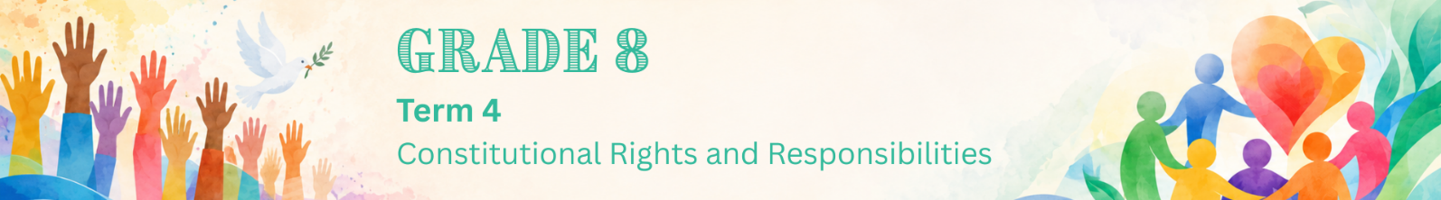

Lesson 3 – Worksheet MEMO
 | Activity 1: Impact of Gender-Based Violence  Complete the following activity in groups.

Study the infographic below and complete the following activity.
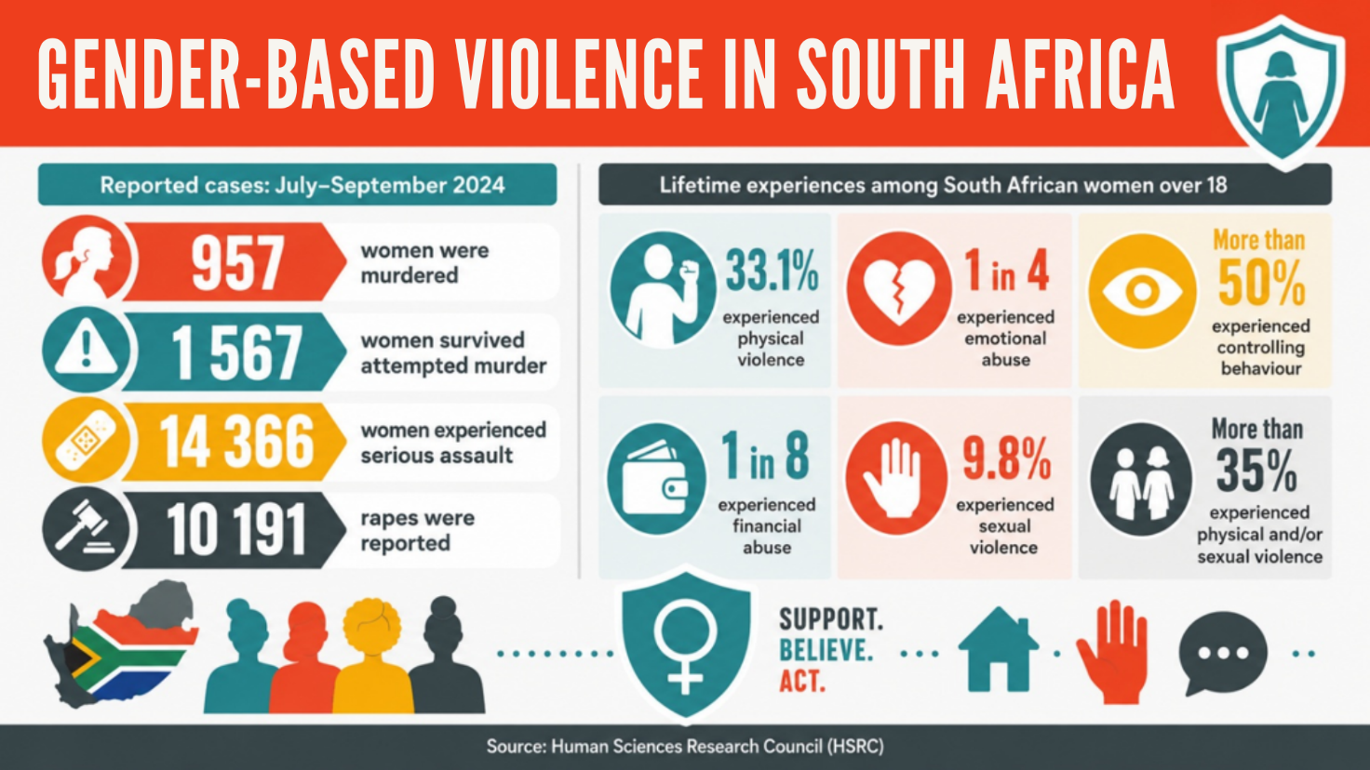
[Adapted from https://hsrc.ac.za/news/review/violence-against-women-in-south-africa-intersecting-vulnerabilities/
Accessed: 27 May 2026]

Brainstorm the impact that gender-based violence and rape may have on the following areas of a person's life. Mention examples.
Emotional Impact | Health Impact | Social Impact
Fear; feeling unsafe; mistrust of others; loneliness; shame; guilt; low self-esteem; depression; anger; trauma; anxiety; nightmares or flashbacks; difficulty trusting others; difficulty managing emotions | Physical injuries; risk of HIV or other STIs; unwanted pregnancy; need for medical care; stress-related health problems; trouble sleeping; disability; loss of life. | Isolation from friends and family; withdrawal from school or activities; poor concentration or attendance at school; breakdown of trust in relationships; fear of going into public spaces; difficulty taking part in community life; long-term effect on education or future opportunities; feeling unsupported by others; silence or fear in the community.

→ Learners may have varying responses to this activity.
Activity 2: Understanding and Responding to GBV
Complete the following activity individually.

Read the extract below and answer the following questions.

Gender-based violence as a human rights issue

“Violence against women is perhaps the most shameful human rights violation, and it is perhaps the most pervasive. It knows no boundaries of geography, culture or wealth. As long as it continues, we cannot claim to be making real progress towards equality, development and peace.”
- Kofi Annan

Former UN Secretary-General Kofi Annan was a strong supporter of women’s empowerment. He believed that women’s rights, equal opportunities and participation in decision-making are important for development, health, education and peace.

[Adapted from https://www.kofiannanfoundation.org/gender-equality-and-inclusion/ Accessed: 27 May 2026]

1. Define the term ‘gender-based violence’. (1 × 1) (1)

GBV refers to:
- a harmful act directed at an individual based on their gender/sex/perceived gender identity. ()
- when someone is hurt/treated unfairly as a result of their gender. ()
- any behaviour that harms a person physically/sexually/mentally due to their gender. ()
- any type of violence that is based on differences between the genders with the intention of causing harm. ()
- any harmful act done to someone against his/her will because of their gender. ()

Any ONE of the above for ONE mark

2. State TWO forms of gender-based violence. (2 × 1) (2)

Possible answers may include:
- Physical abuse/hitting (🗸)
- Verbal abuse/insults (🗸)
- Emotional abuse/threats (🗸)
- Psychological abuse/manipulation (🗸)
- Sexual harassment/unwanted touching/rape (🗸)
- Cyberbullying based on gender (🗸)
- Controlling behaviour in a relationship (🗸)

Any TWO of the above or any relevant answer for ONE mark each

3. Describe TWO factors that might contribute to gender-based violence. (2 × 2) (4)

When…
- people believe that one person has more power than another, (🗸) it may lead to controlling/threatening/harmful behaviour. (🗸)
- people have harmful beliefs about gender roles, (🗸) it may make unfair/disrespectful behaviour seem acceptable. (🗸)
- violence is seen as normal in a family/community, (🗸) it may cause harmful behaviour to be repeated. (🗸)
- media shows harmful ideas about power/relationships, (🗸) it may make controlling/disrespectful behaviour seem normal. (🗸)
- people abuse substances, (🗸) it may make aggressive behaviour/unsafe choices worse. (🗸)
- people lack healthy communication skills, (🗸) it may cause conflict to be handled in harmful ways. (🗸)

Any TWO of the above for TWO marks each
(i.e. ONE mark for statement and ONE mark for qualifier/explanation)

4. Recommend ONE responsible action a Grade 8 learner could take to challenge harmful
attitudes toward girls at school. In your answer, indicate how the action could help prevent
gender-based violence. (1 × 3) (3)

A Grade 8 learner could…
- speak out respectfully when someone makes sexist comments, (🗸) which may show that harmful attitudes are not acceptable, (🗸) and that may help prevent disrespect from becoming abuse. (🗸)
- report bullying/harassment of girls to a teacher, (🗸) which may ensure that the behaviour is addressed early, (🗸) and that may help protect learners from further harm. (🗸)
- include/respect girls in group activities, (🗸) which may challenge the idea that girls are less capable, (🗸) and that may promote equality at school. (🗸)
- encourage friends to treat girls with respect, (🗸) which may influence peer behaviour positively, (🗸) and that may reduce harmful attitudes that contribute to GBV. (🗸)
- support awareness campaigns against GBV at school, (🗸) which may educate learners about respectful behaviour, (🗸) and that may help create a safer school environment. (🗸)

Any ONE of the above for THREE marks
(i.e. ONE mark for statement, ONE mark for qualifier/explanation and ONE mark for outcome)
[Total: 10]

