
Lesson 2 – Worksheet
 | Activity 1: Lack of Knowledge and Poor Decision-making  Complete the following activity in pairs.

Study the newspaper headlines below and answer the following questions.

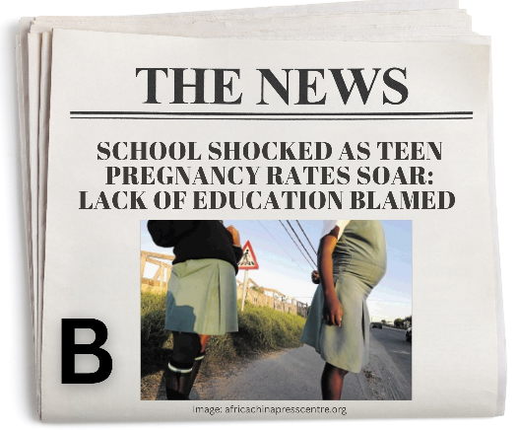
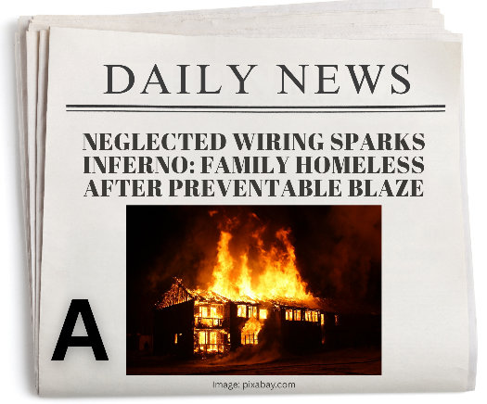
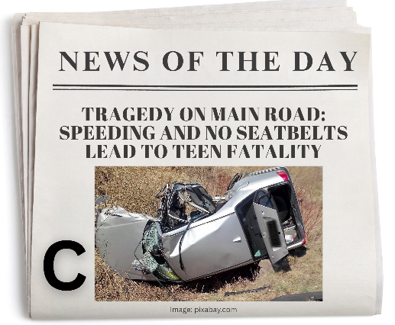
[Created by Teenactiv, January 2026]

1. Explain the 'lack of knowledge' or 'poor decision-making' that contributed to these three scenarios:
a. ___________________________________________________________________________
___________________________________________________________________________
b. ___________________________________________________________________________
___________________________________________________________________________
c. ___________________________________________________________________________
___________________________________________________________________________

2. What should have been done to prevent these situations?
a. ___________________________________________________________________________
___________________________________________________________________________
b. ___________________________________________________________________________
___________________________________________________________________________
c. ___________________________________________________________________________
___________________________________________________________________________

Activity 2: Reflection: Lifestyle Lens
Complete the following activity individually.

Take a moment to reflect and write your thoughts quietly below. You don’t need to share unless you feel comfortable.

1. Think about your own lifestyle.
a. List ONE healthy choice you are proud of.
______________________________________________________________________________________________________________________________________________________
b. Identify ONE area where you could make a better choice.
___________________________________________________________________________
___________________________________________________________________________

2. Consider the influences around you.
a. Which of the following has had the most significant impact on your lifestyle choices? Tick (🗸) the relevant box.

- Lack of knowledge
- Peer pressure
- Emotional stress
- Unsafe environment
- Socio-economic challenges
- Positive role models
- Supportive family environment
- Strong value system
- Participation in sport/cultural/healthy activities
- Good education and life skills

b. Briefly explain how this factor has influenced you.
___________________________________________________________________________
___________________________________________________________________________
___________________________________________________________________________
___________________________________________________________________________

3. Looking ahead:
a. Describe ONE small, realistic change you can make this week to improve your lifestyle.
___________________________________________________________________________
___________________________________________________________________________
___________________________________________________________________________
___________________________________________________________________________

