
Lesson 1 – Worksheet
 | Activity 1: How Balanced is Your Life?  Complete the following activity individually and in pairs.

Part 1: Self-assessment – The five pillars of a balanced life
Read each statement carefully and answer YES or NO for each question.
- Give yourself 1 mark for every “YES” answer.
- Give yourself 0 marks for every “NO” answer.
- Add up your marks for each pillar to get a score out of 5.
- A higher score shows that this pillar is currently stronger in your life.
 |  | NO (0) | YES (1)
1. Physical
a. | Do I get enough sleep (7–9 hours per night)?
b. | Am I physically active on a regular basis (e.g. walking, sport, exercise)?
c. | Do I eat a healthy, balanced diet most days?
d. | Do I take care of my body (e.g. hygiene, medical check-ups)?
e. | Do I generally feel energetic and physically well?
Score: _____/5
2. Psychological
a. | Do I take time to improve myself or learn new things?
b. | Do I manage stress in healthy ways?
c. | Do I avoid harmful or risky behaviours (e.g. substance use or negative peer pressure)?
d. | Am I focused and motivated in my schoolwork and personal goals?
e. | Do I feel confident in who I am becoming?
Score: _____/5
3. Social
a. | Do I have positive, supportive relationships with family and friends?
b. | Can I communicate openly and respectfully with others?
c. | Do I feel that I belong or am part of a group or community?
d. | Do I help others or give my time when I can (e.g. volunteering)?
e. | Do I avoid toxic or negative social influences?
Score: _____/5
4. Spiritual
a. | Do I feel a sense of purpose or meaning in my life?
b. | Do I reflect on my values and try to live according to them?
c. | Do I find peace through quiet time, prayer, reflection or meditation?
d. | Am I respectful of other people’s beliefs and values?
e. | Do my beliefs help guide my decisions and actions?
Score: _____/5
 |  | NO (0) | YES (1)
5. Emotional
a. | Can I recognise and name my emotions?
b. | Am I able to express my emotions in healthy ways?
c. | Do I manage strong emotions such as anger, sadness or anxiety effectively?
d. | Can I understand how others are feeling (empathy)?
e. | Do I try to respond calmly and kindly in emotional situations?
Score: _____/5

Part 2: Partner discussion and advice
Work with a partner in your group.

1. Share ONE pillar you feel strongest in and explain what you do to keep it strong.
2. Then share TWO pillars that need improvement.
3. Ask your partner for practical advice on how you could strengthen these pillars.
4. Listen carefully while your partner shares and offers advice.

Write the advice you received below:
____________________________________________________________________________________________________________________________________________________________________________________________________________________________________________________________________________________________________________________________________________

Part 3: Individual reflection – Getting life back in balance
Watch the video on getting your life back in balance: Tips for finding balance as a student
(bit.ly/4qOfeb8). Pay close attention to the tips and strategies mentioned.

After watching:
- Identify the advice that you find most helpful or realistic for your own life.
- Think about how you could apply it in your daily routine.

Write the advice below and briefly explain why it is helpful to you:
____________________________________________________________________________________________________________________________________________________________________________________________________________________________________________________________________________________________________________________________________________

Activity 2: Healthy Weight Loss and Nutrition
Complete the following activity in pairs.

Watch this clip: Is it possible to lose weight fast? (bit.ly/3LCvP2E) and answer the following questions.

1. List ONE reason why trying to lose weight fast can be unhealthy.
__________________________________________________________________________________________________________________________________________________________________

2. Explain what is meant by a 'balanced meal'.
__________________________________________________________________________________________________________________________________________________________________

3. Discuss ONE way in which an individual can try to lose weight healthily.
___________________________________________________________________________________________________________________________________________________________________________________________________________________________________________________

Activity 3: Reflecting on Sugar Intake
Complete the following activity individually.

1. Think carefully about everything you have eaten and drunk so far today.
- List each item below.
- Include as much detail as possible (e.g. type of food or drink, snacks, and drinks).

Food and drinks consumed today:
- ______________________________________________________________________________
- ______________________________________________________________________________
- ______________________________________________________________________________
- ______________________________________________________________________________
- ______________________________________________________________________________
- ______________________________________________________________________________
2. Identifying sugar intake
a. Circle the foods and drinks listed above that you think contain sugar.
b. Based on your list, estimate: What percentage of your daily food and drinks contained
sugar?
_________ %
c. What changes could you make tomorrow to eat more healthily and reduce your sugar intake?
_________________________________________________________________________________________________________________________________________________________________________________________________________________________________

Activity 4: Sugar Consumption
Complete the following activity in groups.

Study the infographic below and answer the following questions.

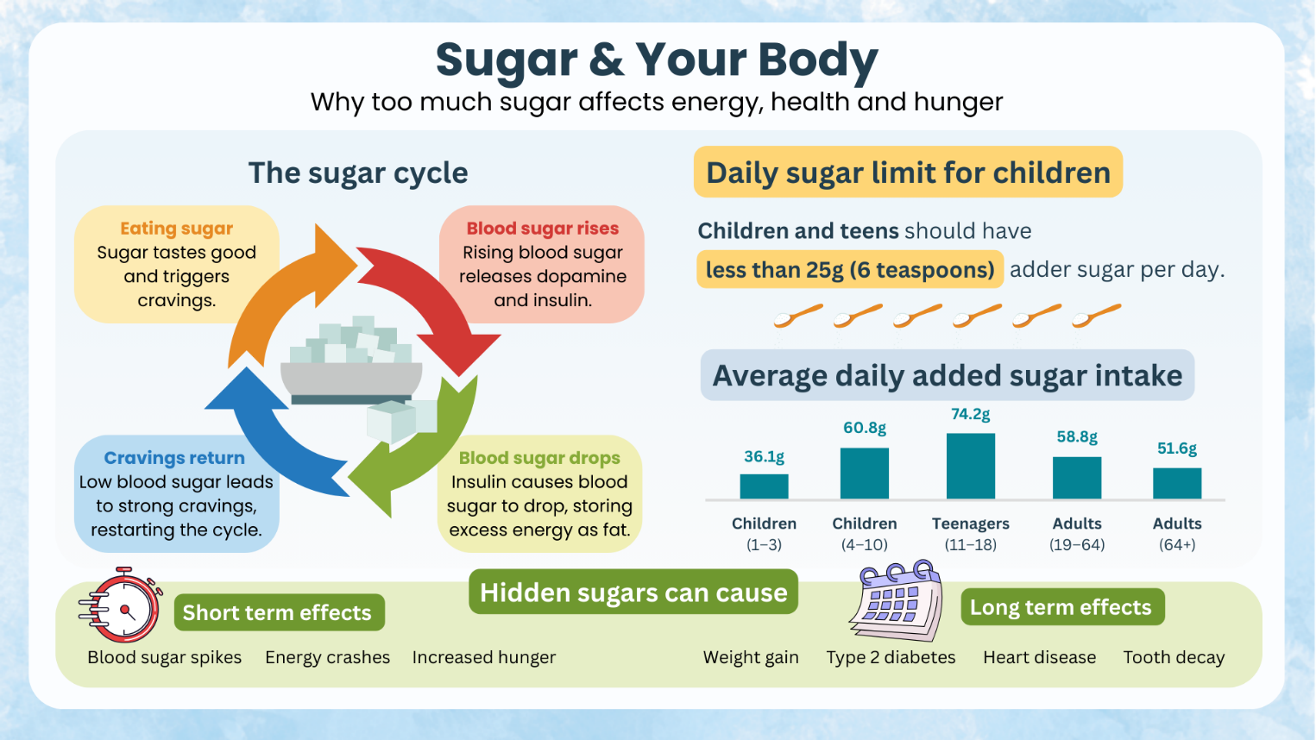
[Created by Teenactiv, 16 January 2025]

1. Identify the age group that consumes the most sugar daily and give ONE reason why
this is a particularly bad habit for this age group. (1 + 1) (2)
_________________________________________________________________________________
_________________________________________________________________________________

2. Discuss TWO dangers of consuming more than the recommended daily allowance of
sugar. (2 × 2) (4)
_________________________________________________________________________________
_________________________________________________________________________________
_________________________________________________________________________________
_________________________________________________________________________________
_________________________________________________________________________________
_________________________________________________________________________________

3. Suggest ONE practical strategy that Grade 11 learners can use to improve their health
through better nutrition and physical activity. (1 × 2) (2)
_________________________________________________________________________________
_________________________________________________________________________________
_________________________________________________________________________________
[Total: 8]

Activity 5: 3-2-1 Reflection
Complete the following activity individually.

As we come to the end of this lesson, take a moment to reflect on what you have learned.

On a small piece of paper, write the following:
1. THREE things you learned today.
2. TWO things you found interesting.
3. ONE question you still have about the work.

Activity 6: Homework: Lifestyle Improvement Plan
Complete the following activity individually.

Think about how you can make positive changes in different areas of your life. Complete the table below by setting a realistic goal and explaining how you will achieve it in each area.
Area | My goal (What do I want to improve?) | My plan (What steps will I take?)
Physical
Psychological
Social
Emotional
Spiritual

