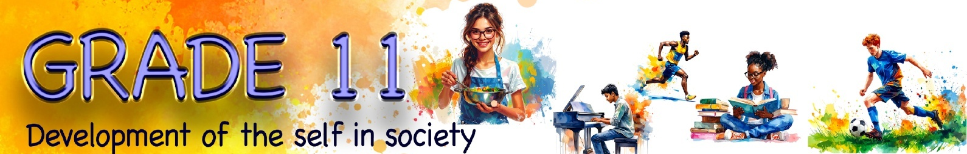

Content Summary

Lesson 1

In this lesson, you will need to understand and apply your knowledge to answer questions on healthy and balanced lifestyle choices:
- Healthy and balanced lifestyle choices:
- Maintaining physical, psychological, social, emotional and spiritual health
- Healthy nutrition and being physically active

Maintaining physical, psychological, social, emotional and spiritual health
Every day, you make choices that influence your overall health and well-being. Living a healthy lifestyle is not only about doing one thing well. A truly healthy lifestyle involves maintaining balance across different areas of health, including physical, psychological, social, emotional and spiritual well-being.

Imagine each of these areas as a pillar holding up your life. If one pillar is shorter or weaker than the others, the slab on top – representing a balanced life – will become unstable and may topple over.
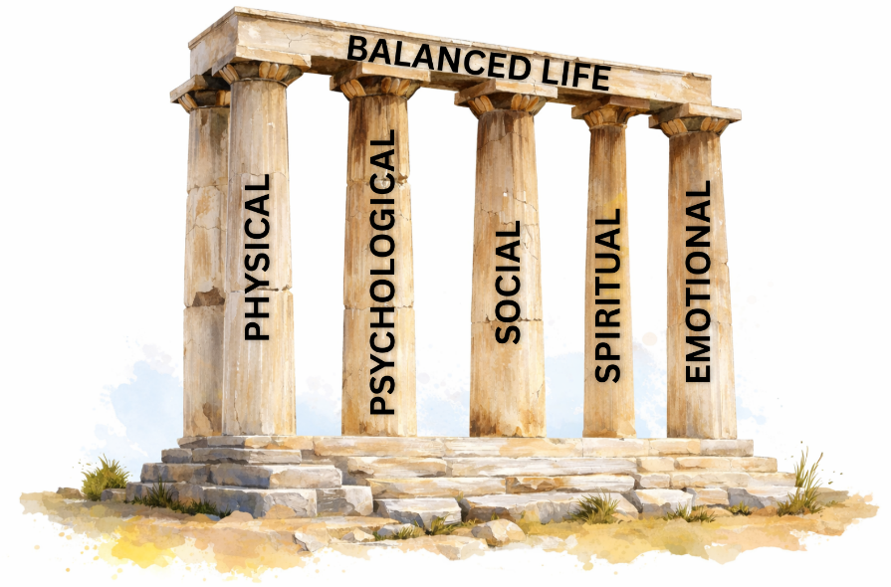
A balanced life is when there is harmony between the different areas of your life.

The five pillars of a balanced life
Every individual’s life is supported by five key pillars. These pillars work together, and balance is achieved when none of them is neglected.

Physical | This refers to your body and includes staying physically fit, eating healthily, and getting enough sleep. Maintaining physical balance is essential for overall well-being.
Psychological | This relates to your mental and emotional state. It includes a desire for self-improvement, avoiding risky behaviour, and applying yourself in your education in order to become the best version of yourself.
Social | This involves building and maintaining healthy relationships with family and friends. It also includes participating in community activities and volunteering when you identify a need.
Spiritual | This refers to following a belief system or religion of your choice. It involves living according to your values and finding peace and hope through practices such as meditation or prayer.
Emotional | This means being able to recognise, explore, express and manage your emotions. It also involves understanding and influencing the emotions of others. This skill is often referred to as emotional intelligence (EQ).

Healthy nutrition
Many people lack the knowledge needed to understand what their bodies really require to function well. Often, new diet trends or “quick fixes” on social media are followed without fully understanding their long-term effects on health and well-being.

In some cases, unhealthy eating habits develop simply because individuals are unsure of what healthy eating actually looks like. A helpful way to guide your food choices is to imagine using a medium-sized dinner plate at every meal and dividing it according to the sections shown in the healthy plate model. These proportions can help you visualise the types and amounts of food your body needs.

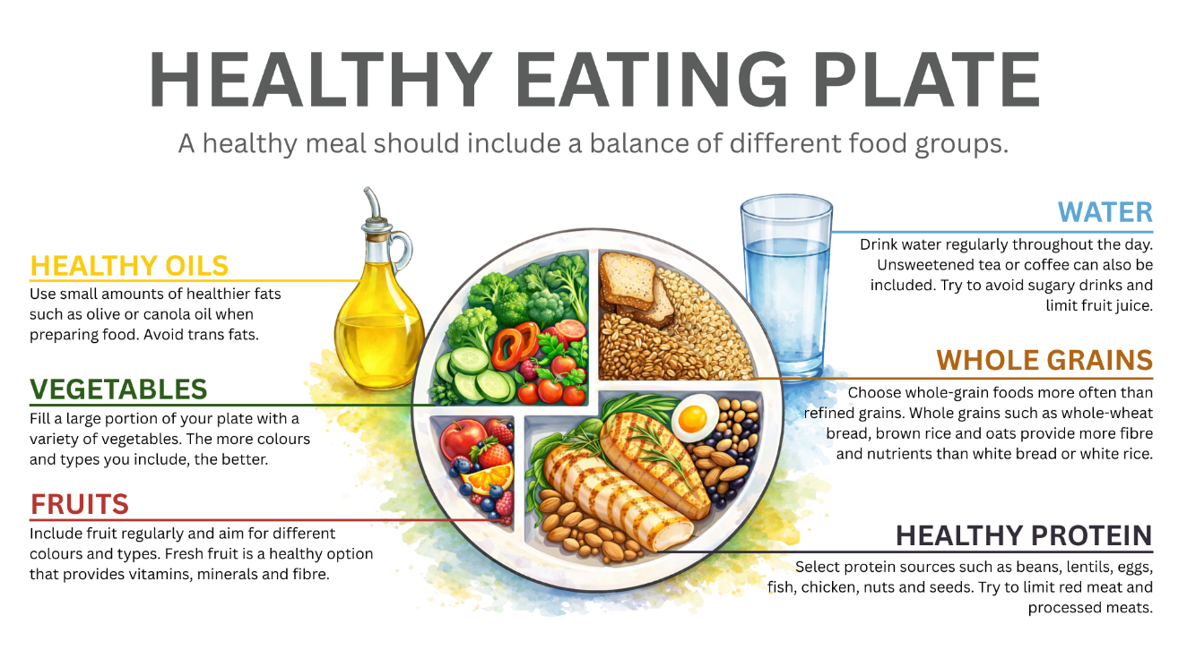
Eating regular meals is also important. Consuming three balanced meals a day supports steady energy levels, concentration and overall health.

Possible dangers of excessive sugar intake
- Blood sugar fluctuations (leading to anxiety, fatigue, headaches, etc.)
- Tooth decay (leading to pain and bad breath)
- Addiction (leading to cravings and addictive eating patterns)
- Weight gain
- Insulin resistance (can lead to obesity, cardiovascular disease, Type 2 diabetes)
- Heart damage (increases risk of heart disease/failure)

Being physically active
Being physically active is an essential part of living a healthy and balanced lifestyle. Physical activity helps to strengthen the body, improve fitness and maintain a healthy weight. It also supports the proper functioning of the heart, muscles and bones.

Regular physical activity not only benefits physical health. It also improves mental and emotional well-being by reducing stress, improving mood and increasing energy levels. Exercise can help you cope better with daily pressures and improve concentration and self-confidence.

Being active does not mean spending hours in the gym. Activities such as walking, cycling, dancing, playing sports, or participating in physical education at school all contribute to an active lifestyle. The key is to be consistent and to choose activities that are enjoyable and sustainable.

When physical activity is combined with healthy nutrition, it plays a vital role in maintaining balance across the different areas of health and supports long-term well-being.

Lesson 2

In this lesson, you will need to understand and apply your knowledge to answer questions on healthy and balanced lifestyle choices:
- Factors that impact negatively on lifestyle choices:
- Lack of knowledge
- Poor decision-making skills
- Unsafe attitudes and behaviours
- Unsafe environments
- Emotional factors
- Peer pressure
- Socio-economic aspects: Poor literacy, low income, poverty, and unfavourable social environments

Factors that negatively impact lifestyle choices
In the previous lessons, the focus was on what makes up a balanced lifestyle within an individual. You now understand that certain changes are often necessary in order to live a healthy and balanced life. If balance is so important for our well-being, an important question remains: why are so many people still unhealthy?

One reason is that lifestyle choices are not made in isolation. A lack of knowledge can limit a person’s ability to make informed and healthy decisions. In many cases, the lifestyle choices people make today may have negative effects on their health in the future.

It is therefore important to become an informed individual who understands the factors that influence lifestyle choices. Simply following trends or copying the behaviour of others does not always lead to healthy outcomes. Making balanced lifestyle choices requires awareness and the ability to evaluate information before acting on it.

Lack of knowledge
A lack of knowledge can negatively affect lifestyle choices because individuals may not fully understand what a healthy lifestyle looks like or why certain habits are harmful. When people are uninformed, they may rely on myths, misinformation or popular trends. As a result, they may also fail to recognise the long-term consequences of unhealthy habits.

Poor decision-making skills
Poor decision-making skills can negatively affect lifestyle choices when individuals act without carefully thinking about the consequences of their actions. In today’s world, people are constantly exposed to information through social media and online trends. You have a responsibility to yourself to question whether this information is trustworthy.

Every choice we make has consequences. Negative choices, such as drug use, can result in serious consequences, including addiction or even death. In contrast, positive choices, such as working consistently at school, can lead to positive outcomes like passing your Grade 11 year.

Unsafe attitudes and behaviours
Some events or accidents are unplanned and unintended but may still cause injury or damage. However, some types of accidents can be prevented, as there are actions individuals can take to reduce risk and avoid harm.

Unsafe attitudes and behaviours can negatively impact lifestyle choices when individuals underestimate risks or normalise harmful actions. When people believe that “it won’t happen to me,” they are more likely to take risks without considering the possible consequences. This can lead to behaviours that place their health, safety and future at risk.

Examples of unsafe attitudes and behaviours include:
- Engaging in risk-taking actions such as unprotected sex or reckless driving.
- Believing that negative outcomes only happen to others.
- Normalising unhealthy habits, such as smoking or substance use, as a way of coping with stress.

Unsafe environments
Unsafe environments can negatively influence lifestyle choices by limiting opportunities for healthy behaviour and increasing exposure to risk.

Unsafe environments may include:
- Living in areas with high levels of crime, violence or substance abuse.
- Having limited access to safe spaces such as parks, gyms or recreational facilities.
- Being exposed to negative role models who engage in risky or unhealthy behaviour.

Emotional factors
Emotional factors can have a strong influence on lifestyle choices, particularly when individuals struggle to cope with difficult feelings, for example:
- Emotions such as stress, anxiety or depression may lead people to adopt unhealthy coping mechanisms.
- Low self-esteem can cause individuals to neglect their physical and emotional well-being.
- Experiences of trauma or grief can also disrupt daily routines, reduce motivation and make it difficult to maintain healthy habits.

Peer pressure
Peer pressure can negatively influence lifestyle choices when individuals feel compelled to change their behaviour in order to be accepted by others. Friends may encourage risky or unhealthy behaviour, and the fear of being judged, rejected or excluded can make it difficult to say no. As a result, individuals may prioritise fitting in over making healthy and responsible choices.

Wanting to belong is a normal part of adolescence, but when the desire to fit in leads to poor decision-making, it can have serious consequences.

Socio-economic aspects
Socio-economic factors play a significant role in shaping lifestyle choices. These factors often lie outside an individual’s direct control but can strongly influence access to resources, opportunities and support.

Socio-economic aspect | How it negatively impacts lifestyle choices
Poor literacy | - Difficulty understanding health information, food labels or medication instructions.  - Struggling to access or interpret medical advice, which can result in poor health decisions.
Low income | - Healthy food options and gym memberships are often expensive.  - Limited access to healthcare and mental health support services.  - Basic survival needs may be prioritised over long-term wellness.
Poverty | - Living in overcrowded or unsafe housing conditions.  - Ongoing stress caused by financial insecurity.  - Limited access to quality education and employment opportunities, which affects future lifestyle choices.
Unfavourable social environments | - Living in communities with high unemployment, crime or substance abuse.  - Lack of positive role models or mentors.  - Unhealthy lifestyles may become normalised and accepted as the norm.

Lesson 3

In this lesson, you will need to understand and apply your knowledge to answer questions on risky behaviour and situations:
- Substance use and abuse, unsafe sexual behaviour, risk of pregnancy, teenage suicides; poor hygiene and dietary habits, unsafe road use

Risky behaviour and situations
In this lesson, you will learn about risky behaviour and risky situations, and how these choices can affect your personal safety and the safety of the people around you. You will also learn why risky behaviour is common in adolescence, what the consequences can be, and what safer choices look like in real life.

Understanding risky behaviour
Risky behaviour refers to choices and actions that increase the likelihood of harm. It is often linked to short-term thinking, poor decision-making, and the desire to fit in or feel accepted. Risky behaviour can affect your health, your safety, your relationships, your education, and your future opportunities.
Risky behaviour does not only affect the person making the decision. Many risky choices place others in danger as well. For example, substance abuse, unsafe sexual behaviour and unsafe road use can harm friends, families and communities.

Risky behaviour vs accidents
It is important to understand the difference between risky behaviour and an accident.

Term | Meaning | Example
Risky behaviour | Choices or behaviour that increase the chance of harm. Risky behaviour affects your personal safety and that of the people around you. | Driving after a party where you had been drinking and losing control of the car.
Accident | An event that is out of your control, not planned and/or causes injury or damage. | Being hit by a drunk driver when you had no control over the situation.

Substance use and abuse
Substance use and abuse refer to the harmful use of alcohol, drugs, or other substances that affect the brain and body. Substance abuse is a risky behaviour because it reduces self-control and judgment, which increases the chance of other dangerous choices.

How substance abuse affects the individual | How substance abuse affects the community
- Impairs judgement and decision-making.  - Increases aggression, conflict and risky behaviour.  - Cause absenteeism and poor academic performance.  - Leads to addiction and long-term health consequences. | - Increases violence and crime in the community.  - Places pressure on health services and emergency responders.  - Causes family conflict and breakdown.  - Leads to unsafe roads and accidents.

Environmental factors that increase substance abuse risk
Environmental factors refer to the conditions around a person that can increase risk. These may include:

Stressful home environments, trauma or family instability | Lack of adult support or guidance | Peer groups that normalise substance use | Easy access to substances in the community | Social stigma that prevents help-seeking

Unsafe sexual behaviour
Unsafe sexual behaviour refers to sexual choices that increase the risk of harm. This includes unprotected sex, sex under pressure, sex while intoxicated, and relying on myths or misinformation. Unsafe sexual behaviour is risky because it can lead to sexually transmitted infections (STIs), unplanned pregnancy, and emotional stress, such as anxiety and regret. It can also cause conflict, blame, and a breakdown of trust in relationships.

Many risky choices are based on incorrect beliefs. Misinformation can lead to unsafe decisions and delays in getting help.

Healthy relationships require communication and respect. Learners should be able to:
- talk openly about protection and boundaries.
- say no without fear of punishment or rejection.
- recognise pressure, manipulation or coercion.
- understand that consent must be clear, willing and ongoing.

Risk of pregnancy
Teen pregnancy is a serious issue because it affects health, education, relationships and future opportunities. It is not only a personal matter. It impacts families, schools and communities.

Teen pregnancy may happen as a result of unsafe sexual behaviour, a lack of access to contraception, or pressure from a partner. It may also be linked to misinformation and poor decision-making, as well as sexual abuse or coercion. In some cases, substance use can further increase the risk because it impairs judgment and leads to unsafe choices.

Impact on the learner | Impact on the community
- Disruption in education can lead to dropping out of school.  - Causes judgement and emotional stress.  - Creates financial dependence.  - Limits future career and study opportunities | - Increase poverty and dependence.  - Places pressure on families and support systems.  - Contributes to school dropout rates.  - Reinforce cycles of inequality.

Teenage suicides
Teen suicide is a serious issue and is often linked to emotional distress, trauma, isolation, bullying, family conflict, substance use, and untreated mental-health challenges. Suicidal thoughts are not a sign of weakness. They are a sign that someone needs help and support.

Warning signs
A learner may be at risk if they speak about hopelessness or wanting to disappear, withdraw from friends and activities, or show sudden mood changes. They may also begin taking unusual risks, show signs of self-harm, or give away possessions or say goodbye in unusual ways.

How to respond
If you are worried about someone, take it seriously and speak to a trusted adult immediately, such as a teacher, counsellor, parent or guardian.

Poor hygiene and dietary habits
Not all risky behaviour looks dramatic. Some risky choices are repeated daily and slowly affect health over time. Poor hygiene and poor dietary habits are examples of this.

Poor hygiene
Poor hygiene refers to habits that increase the risk of infection and illness. This may include not washing hands regularly, poor oral hygiene, not managing menstrual hygiene safely, or avoiding health support due to shame. Poor hygiene can lead to infections and illness, as well as low self-esteem and school absenteeism.

Menstrual health and dignity
Menstrual health is a human rights issue, not just a “girls’ problem”. When learners lack access to sanitary products, safe bathrooms, or accurate information, they may miss school and fall behind academically. Shame and silence make the problem worse.

Poor dietary habits
Dietary habits affect energy levels, concentration, mood and physical health. Unhealthy patterns include skipping meals regularly, consuming too many sugary foods and drinks, having a low fibre and low water intake, and eating an unbalanced diet with a poor mix of food groups. These habits can lead to poor concentration, weight gain/loss, fatigue and long-term health risks.

Unsafe road use
Unsafe road use is a major cause of injury and death among young people. Many teenagers underestimate how quickly a crash can happen and how serious the consequences can be.

Examples of unsafe road behaviour:
- Driving under the influence of alcohol or drugs
- Riding with a drunk or unlicensed driver
- Not wearing a seatbelt
- Speeding or showing off
- Distracted driving (phones, loud music, joking around)
- Unsafe pedestrian behaviour (crossing roads carelessly, ignoring traffic rules)

The impact on individuals and communities
Road accidents can have a serious impact on both individuals and communities. They may result in death, disability or long-term injuries, and survivors often experience trauma and guilt. Families can suffer deep grief and emotional damage, while the financial costs of medical care and funerals can place a strain on households. Road accidents also put pressure on emergency services and hospitals, affecting the wider community.

Safer choices and assertiveness
Sometimes learners take risks because they are afraid of being judged or they don’t want to upset their friends. However, being assertive can prevent tragedy. A learner can respond safely by:
- refusing to get into a car with a drunk or unlicensed driver.
- calling a parent or trusted adult, even if it feels uncomfortable.
- insisting on seatbelts for everyone.
- leaving unsafe situations before they become dangerous.

Lesson 4

In this lesson, you will need to understand and apply your knowledge to answer questions on risky behaviour and situations:
- Impact of unsafe practices on self and others: Physically, emotionally, spiritually and socially

Impact of unsafe practices on self and others
Unsafe practices can affect a person physically, emotionally, socially and spiritually. In many cases, the person engaging in risky behaviour does not consider how far the consequences will spread.

Physical impact
Unsafe practices can place the body under serious strain. Physical impacts may include injury, illness, addiction, weakened immunity, long-term organ damage, fatigue, or health complications that affect daily functioning. In some cases, physical harm can be permanent and may limit future opportunities, such as sport participation, career plans or study goals.

Emotional impact
Risky behaviour often leads to emotional distress. Even when a learner tries to hide the behaviour, emotions such as guilt, shame, fear and anxiety may increase. Learners may also feel overwhelmed, hopeless or emotionally withdrawn. Emotional impact can worsen if the learner is judged, isolated, or afraid of getting caught.

Social impact
Risky behaviour can damage relationships. Friends may withdraw because they do not know how to help. Families may feel hurt, disappointed or worried. Teachers and coaches may lose trust, and learners may experience judgment or stigma from peers. Social impact may also include conflict, isolation and a breakdown of support networks.

Spiritual impact
Spiritual impact refers to the effect risky behaviour has on a person’s beliefs, values and sense of purpose. Unsafe practices may cause inner conflict, especially if the behaviour goes against the learner’s personal morals, religious beliefs or identity. A learner may begin questioning their self-worth or feel that their future has lost direction.

How risky behaviour affects more than one person
Risky behaviour not only affects the person who makes the choice. The impact often spreads outward to friends, family members, teachers, classmates and the wider community. Some effects happen immediately, while others develop over time.

Example: The ripple effect of how suicide impacts others

Suicide not only ends the valuable life of a teenager; it also deeply impacts the lives of everyone around them. When a person is overwhelmed with hopelessness, they may not consider the impact their decisions will have on those around them.

A helpful way to understand this is the ripple effect. If you drop a pebble into calm water, one small pebble creates ripples that keep moving outward. In the same way, one suicide attempt can create ongoing effects across many people and areas of life.

Lesson 5

In this lesson, you will need to understand and apply your knowledge to answer questions on risky behaviour and situations:
- Individual responsibility for making informed decisions and choices: Prioritising personal safety, seeking support and advice to change risky behaviour

Individual responsibility for making informed decisions and choices
We know that our choices always have consequences. Sometimes those consequences are negative, but the outcome can also be positive. However, when you are in the moment and faced with making a choice, it is not always easy to see what the best outcome might be.

It is important to recognise when we have made a mistake so that we can take ownership of it and make things right. This means taking responsibility for our actions and the decisions we make. No one can make decisions for you. So, how do you make the best decision?

We can use the STOP & ACT approach. These words will help you remember the steps involved in effective decision-making.

S | Stop and identify the decision you need to make.
T | Think about the different options or choices.
O | Outcomes – consider one possible impact or effect of each option.
P | Pick the best option.

This places you in a position where you have made a decision that you are ready to ACT on.
A | Take action.
C | Consider the impact that your action has had.
T | Take stock – reflect on whether you would make the same choice in the future.
Advice to change risky behaviour
To change, you must first identify what starts the behaviour. Recognising whether a specific environment, peer group, or emotional state acts as a "trigger" allows you to understand why the behaviour persists.

Prioritise personal safety
Once you know your triggers, create obstacles to make the risky choice harder and the healthy choice easier, for example:
- Create distance: Avoid "certain parties" or locations where you know drinking and drugs will be present.
- Change your routine: If you usually skip breakfast and eat sugary snacks at school, prepare a healthy meal the night before to break the habit of unhealthy snacking.
- Reset behaviours: Use life changes, like starting a new school term, as an opportunity to set new boundaries and "reset" your daily habits.

Instead of just stopping a habit, replace a harmful action with a safer one. Use healthy coping mechanisms to manage stress and practice assertiveness to ensure you have a pre-planned response when facing pressure.

Seek support
Some risky behaviours, such as addiction, eating disorders, or suicidal thoughts, are too complex to handle alone. Seeking support is a sign of strength and a practical way to protect your "one life to live". Doctors, counsellors and teachers are trained to help you navigate these health risks.

Lesson 6

In this lesson, you will need to understand and apply your knowledge to answer questions on factors that impact positively on lifestyle choices:
- Positive role models, e.g., parents, peers and others; personal values; belief system; religion; social skills; positive cultural influences and economic conditions

Factors that impact positively on lifestyle choices
It is important to self-reflect when you try to implement changes by introducing new habits. This helps you to evaluate what is working and what still needs improvement. Sometimes, we are fortunate to have people around us who inspire us or can advise us on how to implement these changes effectively.

Positive role models
It is important to have positive role models – people in your life whom you can look up to or who motivate you to make healthy lifestyle choices. The lifestyle and values of this person can inspire you to become a better version of yourself. When you adopt the positive behaviours, values or actions of these individuals, you can also become a positive influence in your community.

Positive role models can include sportspeople, public figures or leaders whom you respect. Their behaviour and lifestyle can influence your morals and values based on what they project to the public.

Role models are not only well-known individuals. They can also be people you interact with regularly, such as your parents, peers, friends, coaches and teachers. These individuals can inspire you to become a better person and may teach you important life skills that help you make responsible decisions.

Personal values
Your personal values are the principles and standards that guide your behaviour and decision-making. They develop over time and are influenced by your home environment, school, culture and experiences.

These values help you decide what is right or wrong and support you in making choices that align with who you are. For example, if you value honesty, you are more likely to tell the truth even when it is difficult. If you value respect, you may choose to treat others kindly and avoid harmful behaviour such as bullying.

Belief system
Your belief system refers to the ideas and viewpoints you hold about yourself, others and the world around you. These beliefs are often shaped by your upbringing, culture, religion and personal experiences.

Your belief system influences how you interpret situations and can strengthen your ability to make responsible choices. For instance, if you believe that your future goals are important, you may choose to focus on your schoolwork instead of giving in to peer pressure.

Religion and positive cultural influences
These practices can help you manage different aspects of your life and influence the choices you make. They often provide a moral framework that can guide your behaviour and protect you from risky choices. For example, some religions promote abstaining from sex until marriage, which can help prevent unwanted pregnancies and sexually transmitted infections (STIs).

Social skills
These skills help you make decisions in challenging social situations. You learn from others, such as your parents, how to handle these situations. As you become more aware of social cues, such as body language and communication, you are better able to make informed choices.

Economic conditions
Economic circumstances can either limit or create opportunities. It is important to understand how financial factors influence your lifestyle choices. For example, having money to buy healthy food or pay for a gym membership can make it easier to maintain a healthy lifestyle. However, not everyone has access to these opportunities.

