

Lesson 6 – Worksheet
 | Activity 1: Reflecting on your Lifestyle Plan  Complete the following activity individually.

Review your response to Activity 6 (Lesson 1 – Worksheet).

1. In the space below, reflect on how well you have implemented your plan to improve your lifestyle. Rate each area by circling the number of stars that best represents your progress.

1 star = My plan was unrealistic, and I need to reconsider it.
5 stars = My plan was realistic, and I have been able to apply the changes successfully.

Physical: | ☆ ☆ ☆ ☆ ☆ ☆
Psychological: | ☆ ☆ ☆ ☆ ☆ ☆
Social: | ☆ ☆ ☆ ☆ ☆ ☆
Emotional: | ☆ ☆ ☆ ☆ ☆ ☆
Spiritual: | ☆ ☆ ☆ ☆ ☆ ☆

2. Identify the area that received the lowest rating. Write a new, more realistic plan for this area below:
___________________________________________________________________________________________________________________________________________________________________________________________________________________________________________________

Activity 2: My Influence Web
Complete the following activity individually.

Create an "influence web" to show the people who have had a positive impact on your life.

Think about individuals you respect and admire. These could include a family member, friend, teacher, coach, celebrity or role model.

For each person, write who the person is and how they have influenced you positively, for example: Dad – taught me to be kind and listen to others

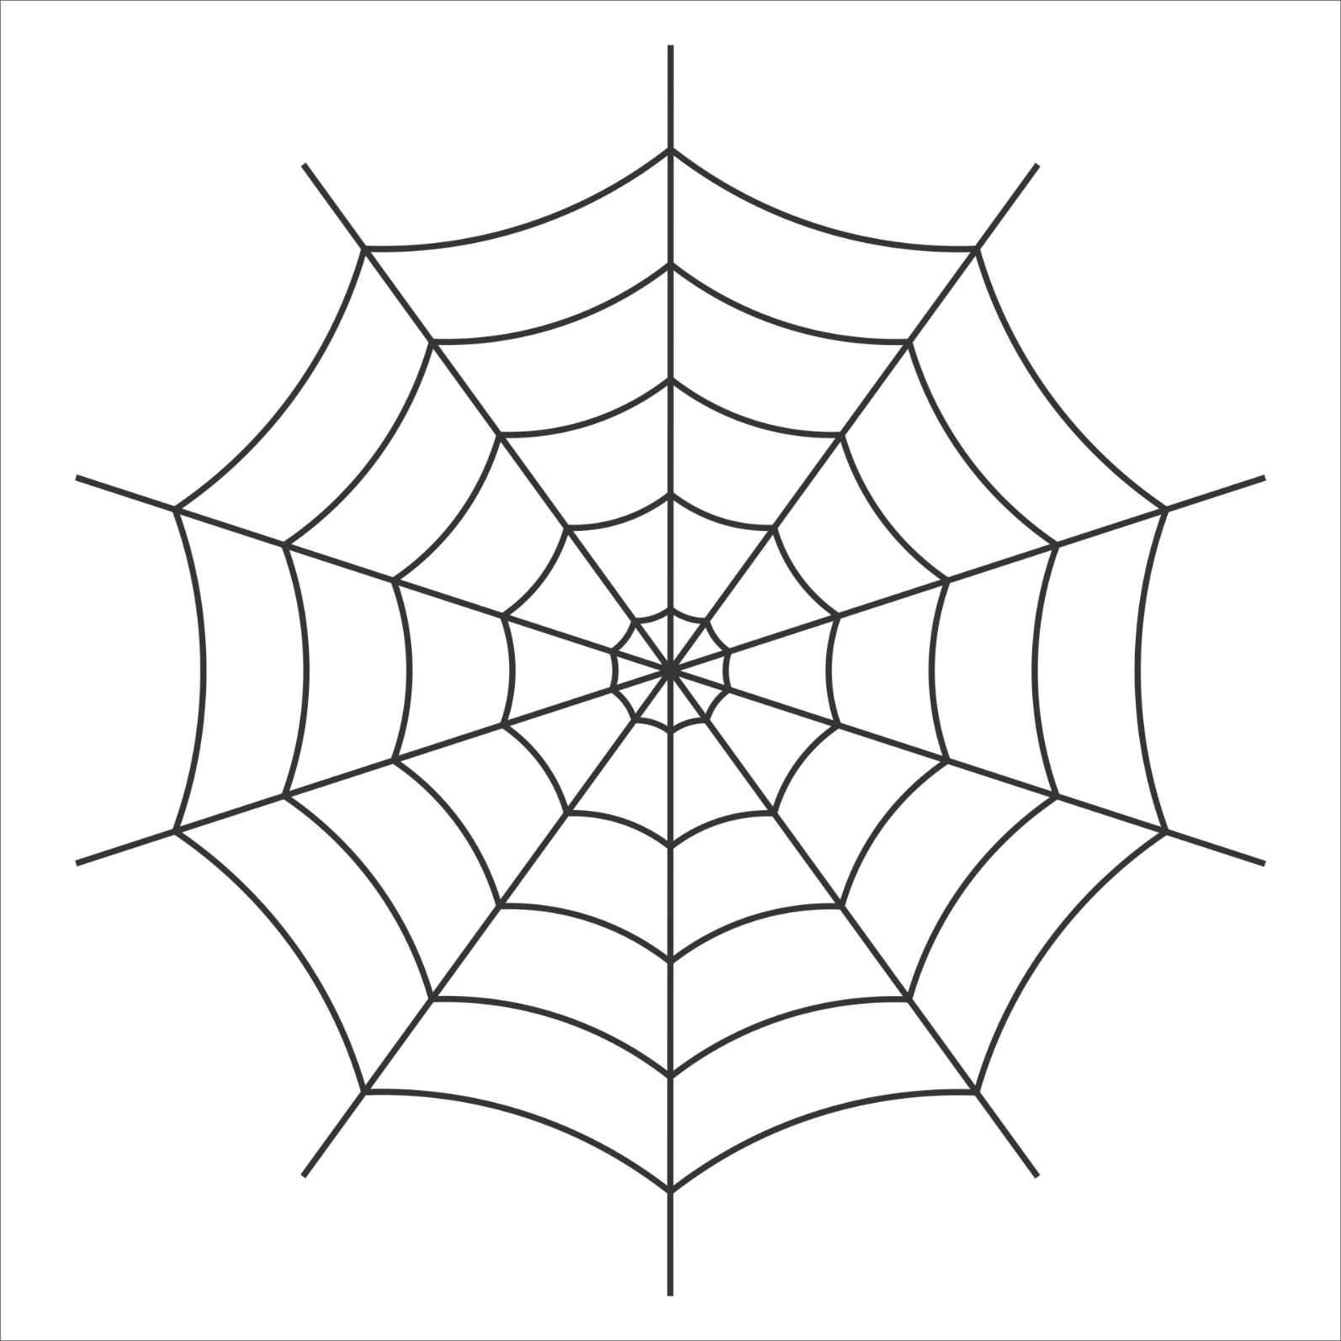
ME

Activity 3: What shapes you?
Complete the following activity individually.

You will be given six pieces of paper. Respond to each of the six statements below by writing one sentence per page. Start by writing out the statement and then complete it with a positive response.

- One piece of advice I would give for living a healthy lifestyle is…
- One positive influence in my life is…
- One value I want to live by is…
- One lifestyle choice I am proud of is…
- One goal I have for my future is…
- As a role model, the one influence I want to have is…

