
Lesson 5 – Worksheet
 | Activity 1: Applying the STOP & ACT Decision-Making Method  Complete the following activity individually.

Study the STOP & ACT decision-making steps below and complete the task that follows.
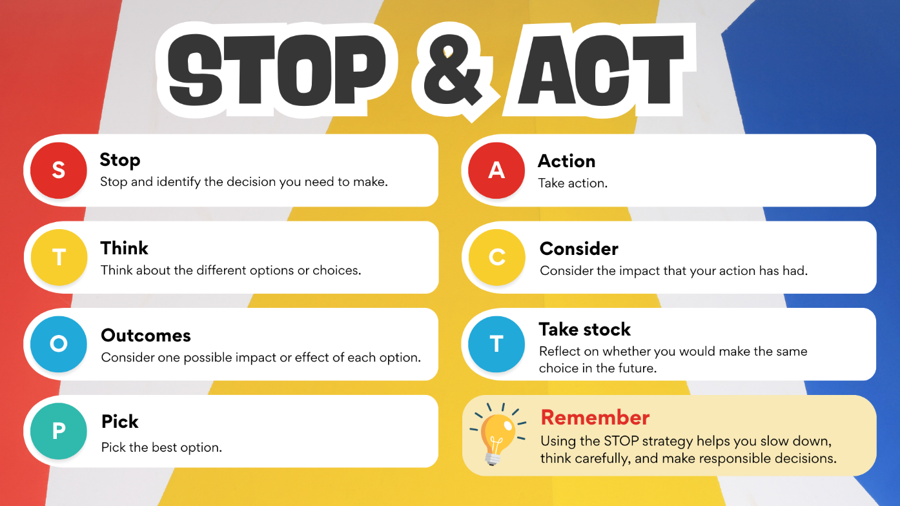

Choose ONE of the scenarios below, then complete the table that follows by carefully applying the STOP & ACT method to decide on the best possible course of action.

Scenario 1
You are invited to a birthday party where you do not know many of the guests. After a while, someone offers you a vape and says, “Everyone’s doing it, it’s not a big deal.” You have never vaped before and feel uncomfortable, but you also do not want to seem boring or uptight. What do you do?

Scenario 2
You are struggling to finish a big assignment that is due tomorrow. A classmate offers to send you their completed work and says, “Just change a few words, no one will know.” You feel tempted because you are behind and stressed. What do you do?

Scenario 3
You receive a message from someone you met online. They seem friendly and easy to talk to, but they are now asking you to send a photo that you are not comfortable sharing. They say, “It’s just between us.” You are unsure whether you should trust them. What do you do?

Scenario 4
Your close friend starts making fun of another learner behind their back and encourages you to join in. You know it is wrong, but you also do not want to lose your friend or feel left out of the group. What do you do?

Chosen scenario: _________________________________________________________________________
Stop
Think
Outcomes
Pick

Action
Consider
Take stock
Activity 2: Create a Poster
Complete the following activity in groups.

Use the template provided by your teacher to create a poster. In your poster, you must:

1. Identify and explain ONE issue
- Choose ONE risky behaviour that can lead to an unhealthy lifestyle.
- Clearly outline the steps a teenager can take to break this risky behaviour.
2. Provide support options
- Suggest THREE places where learners can seek help.
- If you have access to computers, research community organisations in your area and include contact details (e.g. phone numbers and email addresses).
Activity 3: Reflection
Complete the following activity individually.

Walk around the classroom to view the different posters created in Activity 2. Then answer the questions below.

1. Identify ONE issue from a poster that you felt was presented in a very creative way – something
that would catch the attention of your peers.
_________________________________________________________________________________

2. Describe ONE strategy you learnt in today’s lesson that could help you break a bad habit/unhealthy behaviour in your own life.
___________________________________________________________________________________________________________________________________________________________________________________________________________________________________________________
_________________________________________________________________________________

3. Evaluate your own decision-making skills by reflecting on how effectively you apply the steps discussed in today’s lesson.
___________________________________________________________________________________________________________________________________________________________________________________________________________________________________________________
_________________________________________________________________________________

