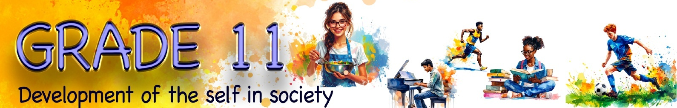
Lesson 4 – Worksheet
 | Activity 1: Suicidal Thoughts  Complete the following activity individually.

Watch the clip Understanding teen suicidal thoughts (bit.ly/4aNGYqe) and then answer the questions below.

1. Define the term 'suicidal thoughts' by stating TWO examples. (2 × 1) (2)
___________________________________________________________________________________________________________________________________________________________________________________________________________________________________________________

2. Identify THREE warning signs that could indicate a teenager is struggling with suicidal
thoughts. (3 × 1) (3)
___________________________________________________________________________________________________________________________________________________________________________________________________________________________________________________

3. Suggest ONE piece of advice you would give to a friend who is struggling with suicidal
thoughts and has come to you for help. (1 × 2) (2)
___________________________________________________________________________________________________________________________________________________________________________________________________________________________________________________
[Total: 7]
Activity 2: Impact of a Suicide Attempt on Others
Complete the following activity in groups.

Imagine a scenario where a young person in your community has attempted suicide. Think about how this could affect the people around them.

Complete the table below to show the impact of a suicide attempt. For each area, write ONE impact on the people around them/the community.

Physical impact |  | Emotional impact
__________________________________________  __________________________________________ |  | __________________________________________  __________________________________________
Social impact |  | Spiritual impact
__________________________________________  __________________________________________ |  | __________________________________________  __________________________________________
Activity 3: Impact of Unsafe Practices on the Individual
Complete the following activity in pairs.

1. Read the scenario below and answer the following questions.

Kayla is 16 and in Grade 11. She is popular, plays netball, and always seems happy. But secretly, Kayla is battling bulimia, an eating disorder where she devours a lot of food (bingeing) and then forces herself to vomit (purging) to avoid gaining weight. It started because she felt pressure to look perfect for sports and social media.

a. Physical: How can this behaviour affect Kayla’s physical health?
___________________________________________________________________________
___________________________________________________________________________

b. Emotional: How can it impact her emotions?
___________________________________________________________________________
___________________________________________________________________________

c. Spiritual: How can it affect her beliefs or sense of purpose?
___________________________________________________________________________
___________________________________________________________________________

d. Social: How could it change her relationships with others?
___________________________________________________________________________
___________________________________________________________________________

2. Read the scenario below and answer the following questions.

A group of first-team rugby boys were selected to represent their school at Craven Week. However, they were sent home after seven of them tested positive for drugs and were found guilty of using banned substances.

When questioned, they explained that they felt pressured to “bulk up” to fit into the team and appear stronger.

a. Physical: How can this behaviour affect the boys' physical health?
___________________________________________________________________________
___________________________________________________________________________

b. Emotional: How can it impact their emotions?
___________________________________________________________________________
___________________________________________________________________________

c. Spiritual: How can it affect their beliefs or sense of purpose?
___________________________________________________________________________
___________________________________________________________________________

d. Social: How could it change their relationships with others?
___________________________________________________________________________
___________________________________________________________________________

Activity 4: Reflection
Complete the following activity individually.

In this reflection, rate how confident you feel about understanding and writing about this content in a test/examination.

Use the scale below:
1 = Not confident at all
5 = Very confident

Content |  | Rating (1–5)
1 | I can explain how to make healthy lifestyle choices to a friend who is asking for advice.
2 | I understand how to maintain physical, psychological, social, emotional and spiritual health.
3 | I feel confident about making the best nutritional choices for myself.
4 | I am aware that being physically active is necessary for a healthy body.
5 | I am confident that I can discuss different factors that negatively impact my lifestyle choices.
6 | I would be able to identify risky behaviour in a case study and advise the person on how to make positive changes.

