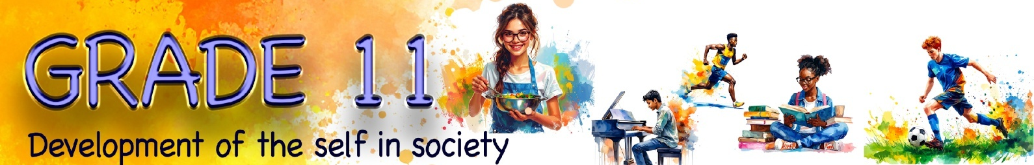
Lesson 3 – Worksheet
 | Activity 1: Risky behaviour  Complete the following activity in pairs.

Read the three scenarios below and answer the questions for each scenario.

1. Scenario 1: The viral dare

A learner named Thabo is tagged in a TikTok challenge where teenagers are dared to consume a dangerous mixture of energy drinks and alcohol. His friends are encouraging him in the comments, saying he’ll go viral if he does it.

a. Mention ONE reason why consuming a dangerous mixture of alcohol and energy
drinks is a risky behaviour. (1 × 1) (1)
___________________________________________________________________________

b. Explain how social media can negatively influence teens' decision-making. (1 × 2) (2)
___________________________________________________________________________
___________________________________________________________________________

c. Discuss how Thabo's participation in this challenge can harm his physical health. (1 × 2) (2)
___________________________________________________________________________
___________________________________________________________________________

d. Suggest ONE way in which Thabo can respond safely to decline his friends' dare. (1 × 2) (2)
___________________________________________________________________________
___________________________________________________________________________
[Sub-total: 7]

2. Scenario 2: Late-night lift

Naledi is offered a ride home from a party by a friend who doesn’t have a driver’s license and has been drinking. She’s tempted because it’s late and she doesn’t want to call her parents.

a. Mention why accepting this ride can be viewed as a risky behaviour. (1 × 1) (1)
___________________________________________________________________________

b. State TWO safer alternative ways Naledi can use to get home. (2 × 1) (2)
___________________________________________________________________________
___________________________________________________________________________

c. Discuss ONE danger of drunk driving. (1 × 2) (2)
___________________________________________________________________________
___________________________________________________________________________

d. Recommend ONE assertive strategy Naledi can use to decline the lift. (1 × 2) (2)
___________________________________________________________________________
___________________________________________________________________________
[Sub-total: 7]

3. Scenario 3: No Protection, No Problem

Sipho and his girlfriend are in a relationship and considering becoming sexually active. His girlfriend says they don’t need protection because she’s on the pill.

a. Mention why unprotected sex is a risky behaviour. (1 × 1) (1)
___________________________________________________________________________

b. State TWO protective measures the couple should be taking if they engage in
sexual activity. (2 × 1) (2)
___________________________________________________________________________
___________________________________________________________________________

c. Discuss ONE emotional consequence of taking part in unprotected sex. (1 × 2) (2)
___________________________________________________________________________
___________________________________________________________________________

d. Recommend ONE strategy Sipho can use to have a respectful conversation with
his partner about safety. (1 × 2) (2)
___________________________________________________________________________
___________________________________________________________________________
[Sub-total: 7]
[Grand total: 21]

Activity 2: Reflection: Design your Destiny
Complete the following activity individually.

Reflect on these areas and think about what changes you may need to make in your own life by answering the following questions. Think about your greatest desires, dreams and aspirations. Be as specific and detailed as possible.

a. What kind of person do you want to be?
__________________________________________________________________________________________________________________________________________________________________

b. What do you want to have more of in your life?
__________________________________________________________________________________________________________________________________________________________________

c. What changes do you need to make now to reduce negative influences on your health?
__________________________________________________________________________________________________________________________________________________________________

