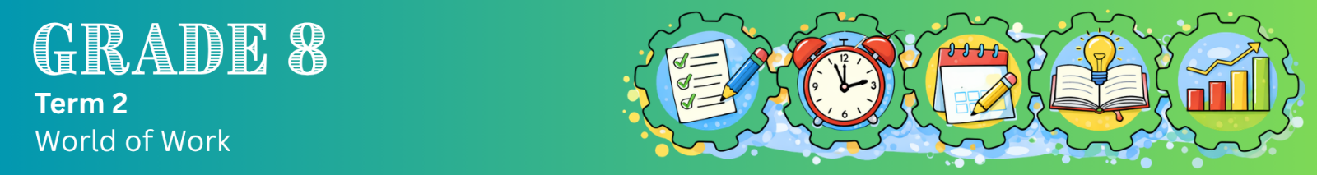
Content Summary
Self-management skills
Self-management is an important life skill. It means being in control of your thoughts, feelings and actions. It also includes managing your emotions, trying to improve yourself, avoiding procrastination, and thinking before you react. These skills help you take responsibility for your behaviour and make better choices in your everyday life.

Self-management during learning means taking control of how you study, using your time wisely, staying organised, and making choices that help you do better at school.

Three steps to self-management during learning
 | Plan  Decide what you will study, how long you will study, and which method you will use.  Example:  Instead of saying, "I’ll study later", you say: "I will study Natural Sciences for one hour using a method that works for me", for example:  - Visual learner: Draw and label a diagram of the digestive system.  - Auditory learner: Explain the digestive system out loud as if teaching someone.

 | Monitor  Check if your study method is working while you are studying.  Example:  Ask yourself: "Do I understand this?" If you can’t explain it in your own words, your method may not be appropriate.

 | Adjust  Change your study method if it is not helping you understand.  Example:  If reading your notes is not working, try something different:  - Draw it  - Explain it out loud  - Practise questions

Self-management in your everyday school life
Self-management skills are not only used when preparing for tests and exams. You should be using these skills every day at school.

The table below lists examples of ways in which self-management could be applied during a normal school day.
Situation | Self-management in action
Listening in class | Focus during class and try to understand the work being explained.
Taking notes | Make meaningful summaries during class time, or use a note-taking method that helps you understand the work better.
Doing homework | Do not rush through your homework, but think about it and determine whether you truly understand the work. (Monitoring)
Not understanding something | Do not ignore it. Ask for help or try a different study method. (Adjusting)

Most learners do not have only one learning style. You may prefer certain methods, but learning is most effective when you use a combination of different strategies. By doing this, you give yourself a better chance of understanding and remembering your work.

