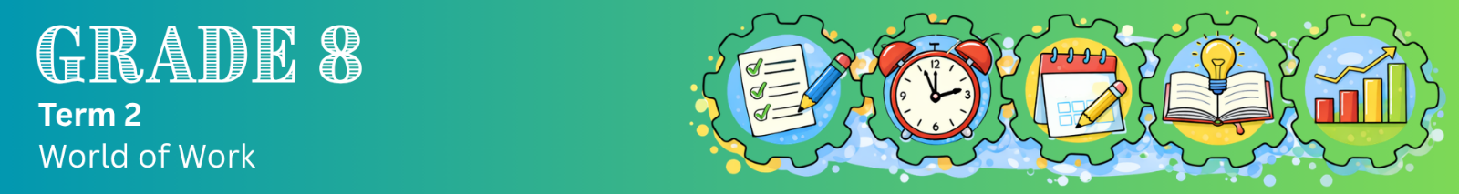
Lesson 1 – Worksheet MEMO
 | Activity 1: Apply Different Learning Style Strategies  The following activity uses a combination of individual, pair and group work.

Read the extract below and complete the following tasks.

A healthy daily routine

Having a daily routine can help you stay organised and feel less stressed. A healthy routine includes habits that support your body and mind throughout the day.

In the morning, this could include stretching, drinking water, and eating a healthy breakfast to give you energy.

During the day, it is important to stay active, take short breaks, and eat balanced meals so that you can stay focused and productive.

In the evening, your routine should help your body rest. This may include switching off devices, reflecting on your day, and getting enough sleep.

[Adapted from: https://www.bu.edu/studentwellbeing Accessed: 25 March 2026]

PART 1: Reading/Writing
Complete this section individually.

Summarise the extract by writing the THREE main points in your OWN words.

1. What should you do in the morning?
Move your body, hydrate with water, and eat a nutritious breakfast.

2. What should you do during the day?
Move regularly, take pauses between tasks, and eat properly to maintain concentration.

3. What should you do in the evening?
Slow down, avoid screens, think about your day, and sleep enough to rest your body.

PART 2: Visual
Complete this section individually.

Complete the diagram below by adding small drawings for each part of the day. The first part has already been done as an example.
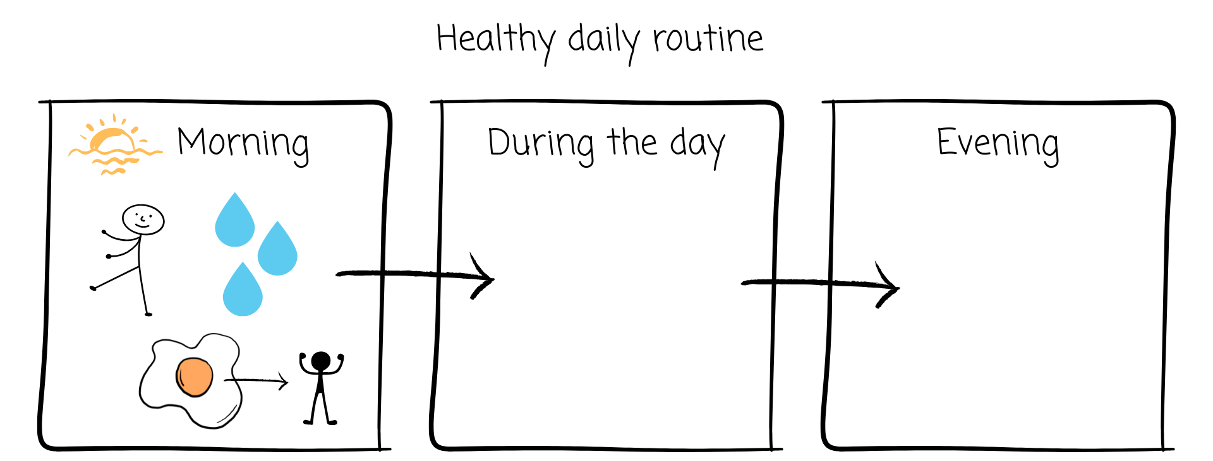
→ Learners will have personal responses for this section.

PART 3: Kinaesthetic
Complete this section in groups.

Stand in a circle. Each learner will take a turn to mime (act out without speaking) one healthy habit from the extract.

Instructions:
- Choose a healthy habit from the extract.
- Act it out using only actions (no talking).
- The rest of the group must guess the habit and say when it would fit into the day (morning, during the day, or evening).
Note: Once a habit has been mimed, it may not be repeated by another group member.

→ Learners will have personal responses for this section.

PART 4: Auditory
Complete this section in pairs.

Take turns to explain the healthy routine to your partner as if you are teaching them.

Instructions:
- Partner A explains the routine (morning, during the day, and evening).
- Partner B listens and checks if the explanation is clear and correct.
- Then swap roles.
→ Learners will have personal responses for this section.
Activity 2: Reflection
Complete the following activity individually.

Think about Activity 1 and answer the questions below.

1. Which learning method helped you understand the content best?
_________________________________________________________________________________

2. Which method did you find difficult or less helpful?
_________________________________________________________________________________

3. Compile a short self-management plan for how you will prepare for your Term 2 exams.

a. What will you do in class throughout the term to make sure you understand your work?
____________________________________________________________________________________________________________________________________________________________________________________________________________________________________________________________________________________________________________

b. How will you use your learning style(s) when you study for tests and exams?
____________________________________________________________________________________________________________________________________________________________________________________________________________________________________________________________________________________________________________

→ Learners will have personal responses for this activity.

