

Lesson 5 – Worksheet

 | Activity 1: Needs and Wants  Complete the following activity individually.

Read the list of items below. Place a tick (🗸​) in the correct column to show whether each item is a need or a want.

Item | Need | Want
Clean drinking water
Fresh, healthy food
New designer clothes
Takeaways
PlayStation & Xbox consoles
Warm clothes in winter
Activity 2: Identifying Community Needs
Complete the following activity groups.

Think about your own neighbourhood and South Africa as a whole. Use the table below to identify specific needs, explain why they are a problem, and think about which careers could help solve them.

Type of need |  | Identified need |  | Why is this a problem? | Who is affected? | Careers that could help
Social
(well-being)
Social
(well-being)
Economic
(productivity)
Economic
(productivity)
Activity 3: Work and Community Needs
Complete the following activity individually.

Study the image below and answer the questions that follow.

Healthcare, work and community needs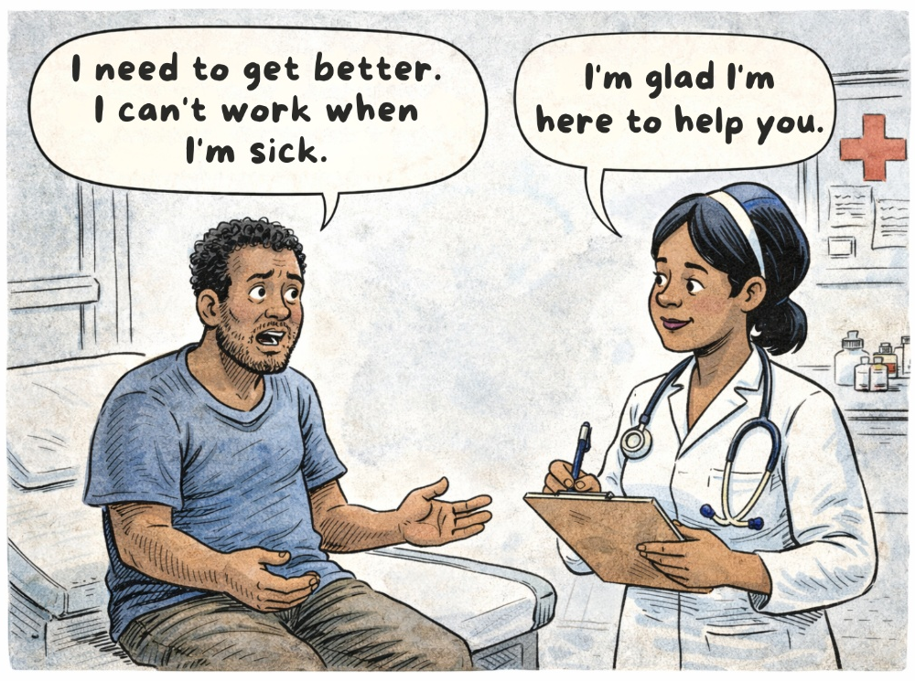
[Image generated by ChatGPT, OpenAI, Accessed: 7 March 2026]

1. Explain how the nurse's daily work helps solve a social need for the people living in her neighbourhood. (1 × 2) (2)
_________________________________________________________________________________ _________________________________________________________________________________

2. Describe how the nurse earning an income helps other businesses in the community. (1 × 2) (2)
_________________________________________________________________________________ _________________________________________________________________________________

3. State TWO ways in which the nurse's contribution to taxes could help the government
meet social needs in the country. (2 × 1) (2)
_________________________________________________________________________________ _________________________________________________________________________________

4. Analyse why a country with a high unemployment rate could struggle to keep its citizens
healthy. (1 × 3) (3)
_________________________________________________________________________________ _________________________________________________________________________________
[Total: 9]

