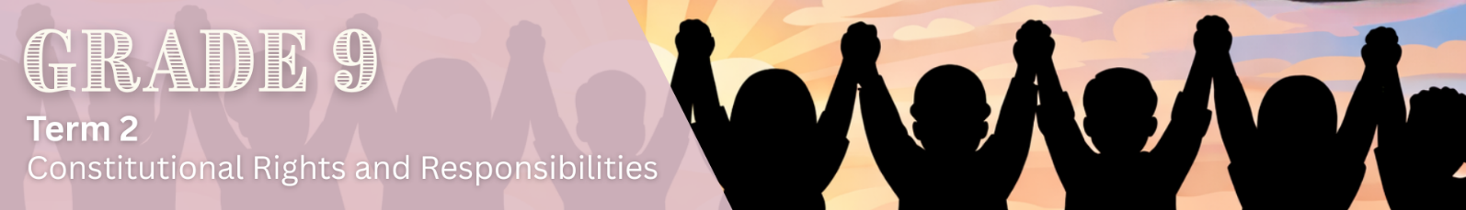

Lesson 2 – Worksheet
 | Activity 1: Positive and Negative Role Models  Complete the following mind map in pairs.
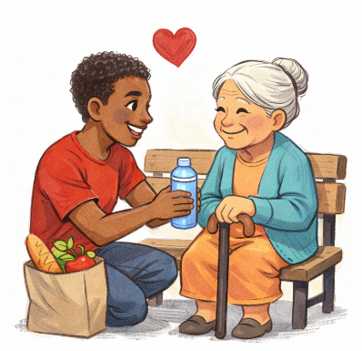
Role models |  | Examples
Definition of a role model: ______________  ____________________________________  ____________________________________  ____________________________________ |  | e.g. Parents/Guardians  ___________________  ___________________  ___________________

Qualities/behaviours of positive role models |  | Qualities/behaviours of negative role models
_______________________________________  _______________________________________  _______________________________________  _______________________________________  _______________________________________  _______________________________________  _______________________________________  _______________________________________  _______________________________________  _______________________________________  _______________________________________ |  | _______________________________________  _______________________________________  _______________________________________  _______________________________________  _______________________________________  _______________________________________  _______________________________________  _______________________________________  _______________________________________  _______________________________________  _______________________________________

Effect on young people |  | Effect on young people
_______________________________________  _______________________________________  _______________________________________  _______________________________________  _______________________________________  _______________________________________  _______________________________________ |  | _______________________________________  _______________________________________  _______________________________________  _______________________________________  _______________________________________  _______________________________________  _______________________________________

Activity 2: Informal Assessment
Complete the following activity individually.

Study the infographic below and answer the following questions.

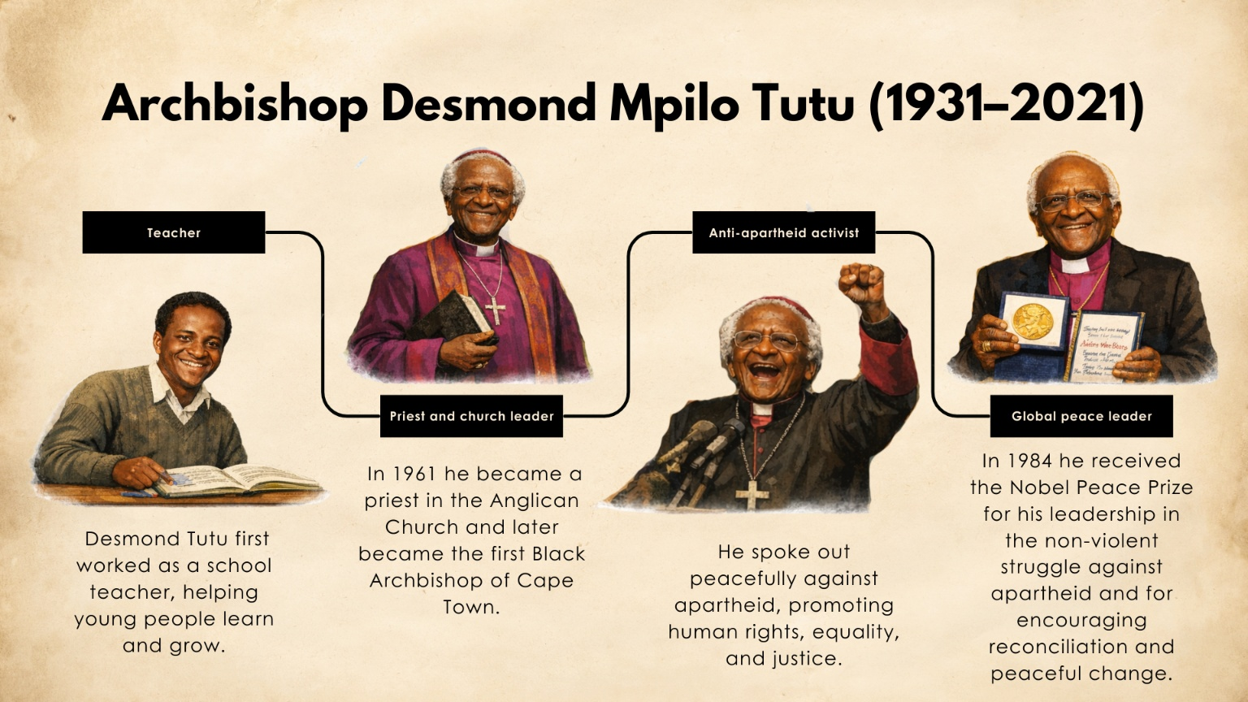
Desmond Tutu: A role model for justice and peace
[Adapted from: https://www.britannica.com/biography/Desmond-Tutu Accessed on 10 January 2026]

1. Define the term 'role model'. (1 × 1) (1)
_________________________________________________________________________________
_________________________________________________________________________________

2. Differentiate between a positive role model and a negative role model. In your answer,
also state an example of the behaviour of each one. (1 × 4) (4)
_________________________________________________________________________________
_________________________________________________________________________________
_________________________________________________________________________________
_________________________________________________________________________________

3. Discuss TWO ways in which a positive role model can uphold the constitutional values of
South Africa. (2 × 2) (4)
_________________________________________________________________________________
_________________________________________________________________________________
_________________________________________________________________________________
_________________________________________________________________________________

4. Recommend TWO acts of kindness young people could practice to become positive role
models within their communities. In your answers, also indicate how these acts would
improve their communities. (2 × 3) (6)
_________________________________________________________________________________
_________________________________________________________________________________
_________________________________________________________________________________
_________________________________________________________________________________
_________________________________________________________________________________
_________________________________________________________________________________
_________________________________________________________________________________
_________________________________________________________________________________

[Total: 15]

Activity 3: Reflection
Complete the following activity individually.

Reflect on the role models in your life and the kind of person you would like to become.

1. List TWO of your role models and explain what positive qualities or behaviours they show.
________________________________________________________________________________________
________________________________________________________________________________________
________________________________________________________________________________________ ________________________________________________________________________________________

2. Think about your own behaviour. To what extent do you think you are a positive role model for others at
school, at home, or in your community?
________________________________________________________________________________________
________________________________________________________________________________________
________________________________________________________________________________________ ________________________________________________________________________________________

3. Suggest ONE way you can improve your behaviour so that you can be a more positive role model for others.
________________________________________________________________________________________
________________________________________________________________________________________
________________________________________________________________________________________ ________________________________________________________________________________________

