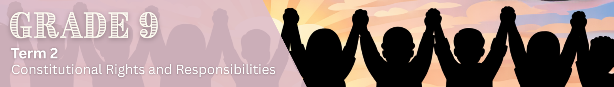

Lesson 1 – Worksheet
 | Activity 1: Mind Map  Complete the following activity individually as your teacher goes through the lesson.

What is the Constitution? |  | South Africa as a constitutional democracy
________________________________  ________________________________  ________________________________  ________________________________  ________________________________  ________________________________ |  | ________________________________  ________________________________  ________________________________  ________________________________  ________________________________  ________________________________
Purpose of the Constitution |  | The Bill of Rights (Chapter 2)
________________________________  ________________________________  ________________________________  ________________________________  ________________________________  ________________________________ |  | ________________________________  ________________________________  ________________________________  ________________________________  ________________________________  ________________________________

The South African Constitution

Constitutional values

Human dignity |  | Equality |  | Non-racism and non-sexism
_________________________  _________________________  _________________________  _________________________  _________________________  _________________________  _________________________  _________________________  _________________________ |  | _________________________  _________________________  _________________________  _________________________  _________________________  _________________________  _________________________  _________________________  _________________________ |  | _________________________  _________________________  _________________________  _________________________  _________________________  _________________________  _________________________  _________________________  _________________________

Activity 2: Informal Assessment
Complete the following activity individually.

1. Choose a description from COLUMN B that matches an item in COLUMN A. Write only the letter (A–G) next to the question numbers (1.1 to 1.4).

Column A |  | Column B
1.1 | Values | A | The most important law in South Africa that explains how the country should be governed and sets out the rights and responsibilities of both the government and the people.
1.2 | The Constitution | B | Beliefs and principles that guide how people behave and help them decide what is right, fair, and acceptable.
1.3 | Rule of law | C | The process where citizens choose their leaders in democratic elections.
1.4 | Voting | D | Everyone, including leaders and the government, must obey the country's rule and make decisions according to the Constitution.
(4 × 1) (4)
Answers:
1.1 _________ | 1.2 _________ | 1.3 ________ | 1.4 _______

2. Read the following extract and answer the following questions.

Creating a constitutional school environment

At a high school, a learner who uses a wheelchair attends classes and participates in school activities with other learners. Moving between classrooms or taking part in certain activities sometimes takes a little longer for this learner. Some learners make an effort to include their classmate in group work, conversations, and games during break, while others are unsure how to interact and sometimes avoid involving them.

Teachers at the school encourage learners to treat everyone with respect and kindness, even when people have different abilities or needs. They remind learners that every person deserves to feel valued and included in the school community. The school is also discussing ways to make the environment more accessible so that all learners can participate fully in school life.

[Adapted from: https://www.safesearchkids.com/teaching-kids-to-include-a-classmate-who-uses-a-wheelchair/
Accessed: 4 March 2026]

2.1 Define the concept 'constitutional value' and state ONE example of a constitutional value. (1 + 1) (2)
_________________________________________________________________________________ _________________________________________________________________________________ _________________________________________________________________________________

2.2 Discuss ONE way in which a learner could respect the human dignity of others at school. (1 × 2) (2)
___________________________________________________________________________________________________________________________________________________________________________________________________________________________________________________
2.3 Suggest ONE way in which the school environment could be improved to promote
equality for learners with physical disabilities. (1 × 2) (2)
___________________________________________________________________________________________________________________________________________________________________________________________________________________________________________________
[Total: 10]
Activity 3: Reflection
Complete the following activity individually.

Think about how you can uphold constitutional values in different areas of your life. Complete the following table:
At home | ________________________________________________________________________  ________________________________________________________________________  ________________________________________________________________________  ________________________________________________________________________
At school | ________________________________________________________________________  ________________________________________________________________________  ________________________________________________________________________  ________________________________________________________________________
Toward the environment | ________________________________________________________________________  ________________________________________________________________________  ________________________________________________________________________  ________________________________________________________________________
In your community | ________________________________________________________________________  ________________________________________________________________________  ________________________________________________________________________  ________________________________________________________________________

