GRADE 11 LIFE ORIENTATION:
CONTROLLED TASK: MINI DISCURSIVE ESSAY

Topic:
Nike (SER)

Time: 90 minutes Total: 50 Marks

Instructions:
1. Read the source on the overleaf and then answer the Topic Statement (in the block) in the form of a mini discursive essay as per the instructed format.
2. NB: Consider those points that you identify with and which you disagree with in order to respond to these points in an essay.
3. Answer truthfully but ensure that your responses remain intelligent and objective.

Mini-Essay
You are required to write a response to the following statement using some of the points outlined in the source below.

Briefly discuss the extent to which you agree or disagree with the statement below:

Ethical consumerism* is a powerful, market-based tool for social change. When consumers spend money on ethical brands, companies are forced to become more sustainable to keep up with the competition.

Use the source as a context for your stance and arguments, and include research to justify your arguments fully.

You may agree or disagree with the sentiments of the source, or both agree and disagree to the same extent. In either case, you need to provide specific examples (i.e. from the source, your own experience, knowledge, etc.) and justify your position by referring to these examples.

Follow the structure below:
Introduction: Include an opening statement (for effect), some background information, and state your mini essay's stance (position on the topic) and your goal.

Body: Include each separate point of your argument in a paragraph – ensure that you have a minimum of 6 different points. For each point – state your point, explain what you mean, and give examples to support your point – either from the source or/and from your own experience.

Conclusion: Include a summary of your main points, restate your stance, and include a closing
statement (for effect)

Please refer to the rubric at the end of the assessment for an indication of how you will be assessed.
Source: Is Nike Ethical? The Truth Behind Its Empowering Image
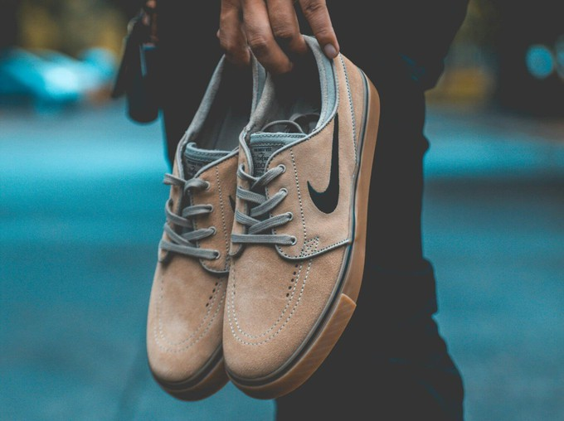

Its minimalist but instantly recognisable swoosh* logo. Inspirational ads that spin stories and make us feel that we can “just do it," too.

We can’t blame you if, when you hear ‘activewear’, you immediately think of Nike.

If you’re sprinting towards a fairer wardrobe, though, is it the right choice?

In other words, is Nike as ethical as it appears?

Let’s look at it from both a human and environmental perspective.

Does Nike have any ethical issues?

Nike’s sweatshop* scandals and lack of transparency
This brand seems to have a bit of a history of getting called out and exposed, occasionally doing something about it, but then finding itself involved in similar problems.

For example:
- Nike’s sweatshops scandal in the 90s – While it appears to have been using sweatshops since as early as the 70s, Nike was first exposed for it in 1991. Jeffrey Ballinger, an American labour activist, published a report on its Indonesian factories hiding unsafe working conditions, below-minimum wages, and even child labour
- Early 2000s – The same problems were explored even further in the documentary Behind the Swoosh
- Another step back in 2017 – Nike did a U-turn on its commitment to the WRC (Worker Rights Consortium*), blocking external labour rights experts from monitoring their supplier factories
- Pandemic (Covid) problems – Nike came under fire again for refusing to settle $2.2 million in unpaid wages and benefits to over 4000 garment workers in Cambodia and Thailand, abruptly dismissed during the pandemic.
- Transparency issues – Nike does disclose some details on their suppliers, but, in our opinion, not enough. In fact, the Fashion Transparency Index* only ranked it at 41-50% in transparency. We also don’t believe Nike is ethical because it doesn’t guarantee a living wage across its supply chain*.
Empowering women? Not always!
Nike is particularly famous for its campaigns on women's empowerment and inclusiveness… and yet the reality doesn’t seem to match that image.

Sure, this brand does do a lot, from diversity programmes to big donations, but some other reasons why Nike isn’t as ethical as it appears are:
- Problematic culture – In 2018, two former women employees sued Nike, accusing the brand of fostering a culture of gender discrimination and even sexual harassment.
- Athletes speaking up – Alysia Montaño had to fight with Nike to keep their sponsorship and paycheck when she got pregnant, and so did Allyson Felix, who was offered 70% less. Luckily, the sportswear giant made some changes to their maternity policy after this came out, but it makes us wonder: how exploited are the people with less visibility?

Animal rights: Is Nike cruelty-free?
Much like with the welfare of its workers, it's hard to know the truth about the animals involved in its production process.

While Nike does choose recycled and vegan leather sometimes, Nike also uses wool, down, silk, and regular leather, but doesn’t specify their sources.

On the plus side, it recently committed to the Responsible Wool Standard, avoiding mulesing (the removal of strips of skin to prevent parasitic infections, often without anaesthesia), and is part of PETA's long list of brands banning exotic animal skins.

Is Nike actually environmentally friendly?
Overall, Nike has made several steps forward when it comes to reducing its environmental footprint.

For example, it’s a founding member of the Sustainable Apparel Coalition* and uses lower-impact materials in some of its collections (like organic or recycled cotton, recycled leather, and recycled polyester). It also launched a refurbished programme to reduce waste by giving a second chance to their footwear.

So far, so good, right?

There’s just one main problem when it comes to Nike’s environmental impact and approach:
Lack of transparency
- Not transparent enough – As seen before, it only scores 41-50% in transparency. For example, Nike sets lots of eco-friendly targets, but doesn’t seem to provide enough evidence to show that it’s actually working towards them.
- Greenwashing – Nike makes many eco-friendly claims without backing them up. So, it’s been accused of greenwashing and even faced a lawsuit over it.

So, is Nike an ethical brand?
The world of fairtrade fashion isn’t black and white, but overall, we don’t believe that Nike can be considered an ethical brand.
It also seems to be working more towards sustainability (from an eco-friendly perspective) than ethical goals from a humanitarian point of view.

So, we believe that one of its priorities should be guaranteeing living wages and fair working conditions across all stages of its supply chain.

Finding more sustainable and ethical Nike alternatives

If you want to support some activewear and footwear brands that are more ethical than Nike, where can you start?

Right here!

At Project Cece, we brought hundreds of fair-trade brands in one place, and that includes:
- Wellicious, making compostable activewear
- Iron Roots, making plastic-free activewear
- ACBC, an ethical active footwear brand
- Alohas, an on-demand brand with a good range of trainers

Find even more ethical Nike alternatives in our sustainable sportswear and sneakers sections in particular.

[Melissa Wijngaarden. M, 29/05/2024, Project Cece, https://www.projectcece.com/blog/647/is-nike-ethical/#:~:text=Nike's%20sweatshop%20scandals%20and%20lack%20of%20transparency&text=Jeffrey%20Ballinger%2C%20an%20American%20labour,the%20documentary%20Behind%20the%20Swoosh, accessed 8/1/2026]

*GLOSSARY

Ethical Consumerism – making purchasing choices based on personal moral beliefs, supporting companies with responsible environmental and social practices (like fair labour and eco-friendly production) while avoiding those with harmful ones, essentially "voting with your wallet" for a better world by aligning spending with values, covering areas from fair trade and cruelty-free products to local sourcing.

Swoosh – The Nike Logo

Sweatshop – a factory or workshop, especially in the clothing industry, where manual workers are employed at very low wages for long hours and under poor conditions.

Worker Rights Consortium - The Worker Rights Consortium (WRC) is an independent, non-profit labour rights organisation that investigates sweatshop conditions in global apparel factories, focusing on protecting workers making university-branded merchandise and other goods.

Fashion Transparency Index – produced yearly by Fashion Revolution, ranks major global fashion brands on how much social & environmental information they publicly disclose about their supply chains.

Supply chain – the entire journey a product takes, from the raw materials (like trees for paper) being gathered, to the factory making it (turning trees into paper), to the trucks delivering it, and finally to the store shelf or your doorstep where you buy it.

Sustainable Apparel Coalition – Known as Cascale - is the global nonprofit alliance empowering collaboration across the consumer goods industry to combat climate change and support decent work for all.

Marking Rubric

Introduction | 0 - 2 | 3 | 4 | 5
Includes an opening statement (for effect), some background info., a stance, and a goal of the mini-essay. | All elements are included – but poorly written and thought through / only a few of the elements are included and delivered at a poor standard. | All elements are included but delivered at an average standard / most of the elements are included – effort is adequate. | All elements are incorporated and are well-written and thought-through. | All elements are excellently incorporated and are intelligently written and well-thought-through.
Conclusion | 0 - 2 | 3 | 4 | 5
Includes a summary of the main points, a stance is restated, and a closing statement is included. | All elements are included – but poorly written and thought through / only a few of the elements are included and delivered at a poor standard. | All elements are included but delivered at an average standard / most of the elements are included – effort is adequate. | All elements are incorporated and are well-written and thought-through. | All elements are excellently incorporated and are intelligently written and well-thought-through.
 | 0 - 11 | 12 - 20 | 21 - 23 | 24 - 30
6 × 5 = 30  5 marks for each point paragraph comprised of a valid point aligned with the stance (1); explanation (2), e.g’s (2) | The student's responses show a lack of adequate justification and thought around the topic. Tends to get sidetracked and does not make a valid argument.  Limited or no use of examples. | The student attempts to build a response but lacks insight into the nature of the topic.  Poor or limited use of examples. Examples are generally superficial. | A good response to the question shows the student’s position or argument on both sides of the issue with validity.  Use of valid examples as justification. | Detailed and thorough response showing a clear position agreeing or disagreeing with the question statement. The student uses highly valid examples to justify his/her argument.
Own Voice | Is clearly conveyed |  |  | 5
Structure | Paragraphs flow logically & the required structure is followed |  |  | 5
Total (50)

