GRADE 10 LIFE ORIENTATION:
CONTROLLED TASK: MINI DISCURSIVE ESSAY

Topic:
Environmental Degradation (SER)

Time: 90 minutes Total: 50 Marks

Instructions:
1. Read the sources on the overleaf and then answer the Topic Statement (in the block) in the form of a mini discursive essay as per the instructed format.
2. NB: Consider those points that you identify with and which you disagree with in order to respond to these points in an essay.
3. Answer truthfully but ensure that your responses remain intelligent and objective.

Mini-Essay
You are required to write a response to the following statement using some of the points outlined in the sources below.

Briefly discuss the extent to which you agree or disagree with the statement below:

Environmentally, the world is in a dire state: many of our plant and animal species are already extinct, and many are on the brink of extinction.

Therefore, it is too late for young people to make any significant impact on the earth’s already degraded environment

You may agree or disagree with the sentiments of the source, or both agree and disagree to the same extent. In either case, you need to provide specific examples (i.e. from the sources, your own experience, knowledge, etc.) and justify your position by referring to these examples.

Follow the structure below:
Introduction: Include an opening statement (for effect), some background information, and state your mini essay's stance (position on the topic) and your goal.

Body: Include each separate point of your argument in a paragraph – ensure that you have a minimum of 6 different points. For each point – state your point, explain what you mean, and give examples to support your point – either from the source or/and from your own experience.

Conclusion: Include a summary of your main points, restate your stance, and include a closing
statement (for effect)

Please refer to the rubric at the end of the assessment for an indication of how you will be assessed.
Source 1: Environmental Risks' Rise to Global Dominance Chart

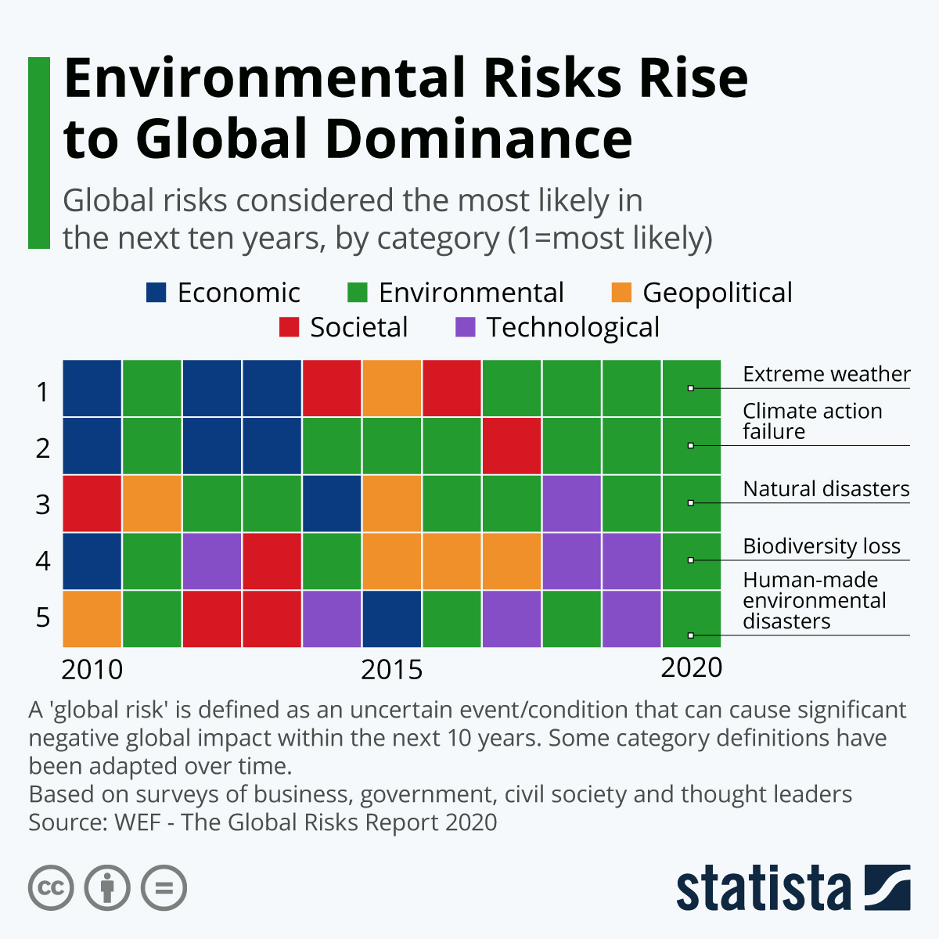

[Environmental Risks' Rise to Global Dominance, 2020
https://www.statista.com/chart/20567/global-risks-considered-most-likely-wef/, accessed 09/01/2026]

Source 2: Youth and the Environment

Young people are central to achieving a more sustainable and healthier planet. Youth have repeatedly demonstrated their willingness and capacity to address environmental and climatic challenges through innovative ideas, demanding policy- and decision-makers for bolder action through advocacy. Meaningful and effective inclusion of young people in environmental action and decision-making is not only a duty, as they represent an important part of the demography and disproportionately bear the consequences of the triple planetary crisis. Doing so ensures better, more resilient, inclusive and sustainable decisions that will have long-term impacts.

Youth and the Environment
Although no universally agreed international definition of the youth age group exists, the United Nations refers to youth as people aged from 15 to 24. Today, there are 1.2 billion young people aged 15 to 24 years, accounting for 16 percent of the global population. By 2030, the number of youths is projected to have grown by 7 percent, to nearly 1.3 billion.

In less than 10 years, when humanity is supposed to deliver the Sustainable Development Goals (SDGs), it will be people who are currently young and those entering their youth years who will be bearing the fruits of current environmental and climate decisions and suffer or enjoy their consequences the most.

Young people are not only victims of the environmental and climate crises; they are powerful actors and agents of change that contribute to achieving a more sustainable planet, SDGs, equality and respect of human rights.

Humanity depends on the boundless energy, ideas and contributions of youth everywhere. Today and every day, let’s support and stand with young people in shaping a just and sustainable world, for people and planet.
— UN Secretary-General António Guterres

Young people have helped reshape the global climate debate because they know that they’ll be the ones who could inherit a broken planet.
— Inger Andersen, UNEP Executive Director

In spite of the recognition of youth capacities and potential as a driving force for a sustainable future, young people often lack access to policy and decision-making spaces and power or struggle to be really listened to and make an impact when included in these processes. To fully unlock youth potential to address the challenges of the triple planetary crisis, they must be granted access to adequate education, skills, and opportunities.

[UN Environmental Programme, 25/10/25, Youth and the Environment, Geneva Environmental Network https://www.genevaenvironmentnetwork.org/resources/updates/youth-and-the-environment/, accessed 9/01/2026]

Source 3: Placing meaningful youth engagement at the heart of environmental action

As the world gets ready for Stockholm+50, an important environmental meeting that marks 50 years of global efforts to protect the planet, it’s clear we need to include young people more in taking care of the environment. The climate crisis is getting worse, and young people will face the biggest impacts. We must listen to their voices, support their leadership, and make sure they have a say in decisions that affect their future.

Young people are especially vulnerable because of the climate crisis and the economic problems caused by the COVID-19 pandemic. Pollution from rich countries is threatening the health and safety of everyone. If climate change doesn't slow down, children and young people will face more heatwaves, floods, wildfires, diseases, and food shortages. Many young people feel sad, angry, and powerless about these issues, which affect their daily lives. A child born in 2020 will face almost three times as many droughts and floods, and over six times more heatwaves in their lifetime compared to someone born in 1960.

Women and young people are some of the most affected by climate change, but they often face barriers like a lack of education, health care, and rights, which make it harder for them to participate in decision-making. Despite these challenges, young people are strong and capable leaders. They need more support and a bigger voice in climate and environmental efforts. We must include young people in making policies, holding governments accountable, and leading change. If we don’t, we risk losing their energy and ideas.

UNDP (United Nations Development Programme) has worked with youth groups and organisations to promote youth involvement in climate action. They share lessons learned and new ideas on how to better support young people in these efforts. Here are seven key points:

1. Ambition and empowerment: Countries need to set strong climate goals and support youth to help achieve them. Many countries now include youth and gender considerations in their climate plans.

2. Youth participation is a right: Young people have the right to be involved in decisions that affect their lives. Their voices should be heard and valued.

3. Listening to youth voices: We need to ask young people what they want and need and create safe spaces for them to share their ideas.

4. Meaningful involvement: It’s not enough to just listen; young people should have real influence over policies and actions, not just be asked for opinions.

5. Address inequality: We must fix unfair systems that hold back women and marginalised groups, giving everyone an equal chance to participate and lead.

6. Financial support: Funding is needed to help youth-led organisations and projects. Supporting youth financially helps them lead change.

7. Measure impact: We should find ways to see how young people are influencing climate actions, so we can learn what works best.

UNDP’s campaign, “Don’t Choose Extinction,” calls for ending fossil fuel subsidies and switching to sustainable energy, leaving no one behind. They also have a platform called Global Mindpool that connects young people with policymakers to push for urgent climate solutions.

Join UNDP and others in working with youth to protect the planet, share ideas, and build a better future.

[Modéer, U & Richar, N, 3/06/2022, Placing meaningful youth engagement at the heart of environmental action, UNDP, https://www.undp.org/blog/placing-meaningful-youth-engagement-heart-environmental-action, accessed 09/01/2026]

Marking Rubric

Introduction | 0 - 2 | 3 | 4 | 5
Includes an opening statement (for effect), some background info., a stance, and a goal of the mini-essay. | All elements are included – but poorly written and thought through / only a few of the elements are included and delivered at a poor standard. | All elements are included but delivered at an average standard / most of the elements are included – effort is adequate. | All elements are incorporated and are well-written and thought-through. | All elements are excellently incorporated and are intelligently written and well-thought-through.
Conclusion | 0 - 2 | 3 | 4 | 5
Includes a summary of the main points, a stance is restated, and a closing statement is included. | All elements are included – but poorly written and thought through / only a few of the elements are included and delivered at a poor standard. | All elements are included but delivered at an average standard / most of the elements are included – effort is adequate. | All elements are incorporated and are well-written and thought-through. | All elements are excellently incorporated and are intelligently written and well-thought-through.
 | 0 - 11 | 12 - 20 | 21 - 23 | 24 - 30
6 × 5 = 30  5 marks for each point paragraph comprised of a valid point aligned with the stance (1); explanation (2), e.g’s (2) | The student's responses show a lack of adequate justification and thought around the topic. Tends to get sidetracked and does not make a valid argument.  Limited or no use of examples. | The student attempts to build a response but lacks insight into the nature of the topic.  Poor or limited use of examples. Examples are generally superficial. | A good response to the question shows the student’s position or argument on both sides of the issue with validity.  Use of valid examples as justification. | Detailed and thorough response showing a clear position agreeing or disagreeing with the question statement. The student uses highly valid examples to justify his/her argument.
Own Voice | Is clearly conveyed |  |  | 5
Structure | Paragraphs flow logically & the required structure is followed |  |  | 5
Total (50)

