

Lesson 3 – Worksheet
 | Activity 1: Participant and Spectator Behaviour in Sport  Complete the following activity in pairs or small groups.

List examples of positive behaviour in sport for the category your teacher has assigned to your group.

Note: While your teacher goes through the answers, you must also complete the other categories on the table.

Players |  | Coaches
________________________________________________  ________________________________________________  ________________________________________________  ________________________________________________  ________________________________________________  ________________________________________________  ________________________________________________  ________________________________________________  ________________________________________________  ________________________________________________  ________________________________________________ |  | ________________________________________________  ________________________________________________  ________________________________________________  ________________________________________________  ________________________________________________  ________________________________________________  ________________________________________________  ________________________________________________  ________________________________________________  ________________________________________________  ________________________________________________
Officials (referees and umpires) |  | Fans and spectators
________________________________________________  ________________________________________________  ________________________________________________  ________________________________________________  ________________________________________________  ________________________________________________  ________________________________________________  ________________________________________________  ________________________________________________  ________________________________________________  ________________________________________________ |  | ________________________________________________  ________________________________________________  ________________________________________________  ________________________________________________  ________________________________________________  ________________________________________________  ________________________________________________  ________________________________________________  ________________________________________________  ________________________________________________  ________________________________________________

Activity 2: The Role of Sport in Nation-Building
Complete the following activity individually.

Study the cartoon below and answer the following questions.

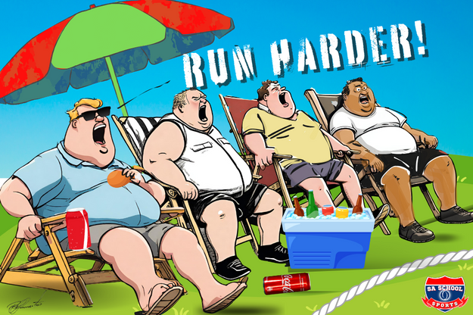

[Taken from: https://saschoolsports.co.za/parents-and-sport/ Accessed: 11 November 2025]

Write paragraphs on the role of sport in nation-building. Use the following as a guideline:

- State FOUR positive behaviours that parents can demonstrate at school sports
matches as spectators. (4 × 1) (4)
__________________________________________________________________________________________________________________________________________________________________
___________________________________________________________________________________________________________________________________________________________________________________________________________________________________________________

- Analyse how inappropriate parental behaviour, such as arguing with the referee,
could affect nation-building. (2 × 4) (8)

__________________________________________________________________________________________________________________________________________________________________
___________________________________________________________________________________________________________________________________________________________________________________________________________________________________________________
__________________________________________________________________________________________________________________________________________________________________
___________________________________________________________________________________________________________________________________________________________________________________________________________________________________________________
__________________________________________________________________________________________________________________________________________________________________
___________________________________________________________________________________________________________________________________________________________________________________________________________________________________________________

- Critically discuss how spectators cheering opposing teams respectfully during school
sports could contribute to a positive experience for the learners. (2 × 4) (8)

__________________________________________________________________________________________________________________________________________________________________
___________________________________________________________________________________________________________________________________________________________________________________________________________________________________________________
__________________________________________________________________________________________________________________________________________________________________
___________________________________________________________________________________________________________________________________________________________________________________________________________________________________________________
__________________________________________________________________________________________________________________________________________________________________
___________________________________________________________________________________________________________________________________________________________________________________________________________________________________________________

[Total: 20]

Activity 3: Reflection
Complete the following activity individually.

- Describe ONE sporting moment (at school or in South Africa) that made you feel hopeful, proud or inspired.
___________________________________________________________________________________________________________________________________________________________________________________________________________________________________________________

- How can moments like these help build national unity?

_____________________________________________________________________________________________________________________________________________________________________________________________________________________________________________________________________________________________________________________________________________________________________________________________________________________

