

Les 3 – Werkkaart
 | Aktiwiteit 1: Deelnemer- en Toeskouergedrag in Sport  Voltooi die volgende aktiwiteit in pare of klein groepies.

Lys voorbeelde van positiewe gedrag in sport vir die kategorie wat jou onderwyser aan jou groep toegewys het.

Let wel: Terwyl jou onderwyser deur die antwoorde gaan, moet jy ook die ander kategorieë in die tabel voltooi.

Spelers |  | Afrigters
________________________________________________  ________________________________________________  ________________________________________________  ________________________________________________  ________________________________________________  ________________________________________________  ________________________________________________  ________________________________________________  ________________________________________________  ________________________________________________  ________________________________________________ |  | ________________________________________________  ________________________________________________  ________________________________________________  ________________________________________________  ________________________________________________  ________________________________________________  ________________________________________________  ________________________________________________  ________________________________________________  ________________________________________________  ________________________________________________
Amptenare (skeidsregters) |  | Aanhangers en toeskouers
________________________________________________  ________________________________________________  ________________________________________________  ________________________________________________  ________________________________________________  ________________________________________________  ________________________________________________  ________________________________________________  ________________________________________________  ________________________________________________  ________________________________________________ |  | ________________________________________________  ________________________________________________  ________________________________________________  ________________________________________________  ________________________________________________  ________________________________________________  ________________________________________________  ________________________________________________  ________________________________________________  ________________________________________________  ________________________________________________

Aktiwiteit 2: Die Rol van Sport in Nasiebou
Voltooi die volgende aktiwiteit individueel.

Bestudeer die spotprent hieronder en beantwoord die vrae wat volg.

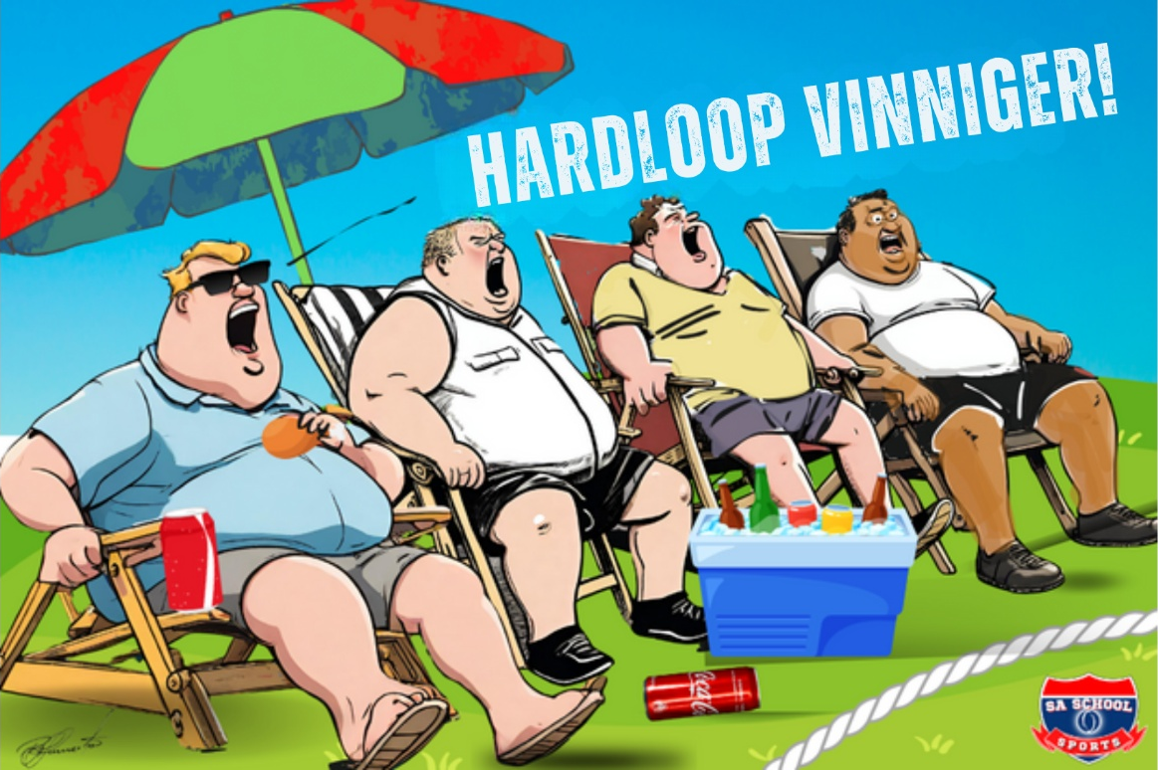

[Aangepas uit: https://saschoolsports.co.za/parents-and-sport/ Toegangsdatum: 11 November 2025]

Skryf paragrawe oor die rol van sport in nasiebou. Gebruik die volgende as ŉ riglyn:

- Noem VIER voorbeelde van positiewe gedrag wat ouers, as toeskouers by skoolsport,
kan toon. (4 × 1) (4)
__________________________________________________________________________________________________________________________________________________________________
___________________________________________________________________________________________________________________________________________________________________________________________________________________________________________________

- Analiseer hoe onvanpaste gedrag deur ouers, soos om met die skeidsregter te argumenteer,
nasiebou kan benadeel. (2 × 4) (8)

__________________________________________________________________________________________________________________________________________________________________
___________________________________________________________________________________________________________________________________________________________________________________________________________________________________________________
__________________________________________________________________________________________________________________________________________________________________
___________________________________________________________________________________________________________________________________________________________________________________________________________________________________________________
__________________________________________________________________________________________________________________________________________________________________
___________________________________________________________________________________________________________________________________________________________________________________________________________________________________________________

- Bespreek krities hoe toeskouers, wat opponerende spanne respekvol tydens skoolsport
aanmoedig, tot ’n positiewe ervaring vir leerders kan bydra. (2 × 4) (8)

__________________________________________________________________________________________________________________________________________________________________
___________________________________________________________________________________________________________________________________________________________________________________________________________________________________________________
__________________________________________________________________________________________________________________________________________________________________
___________________________________________________________________________________________________________________________________________________________________________________________________________________________________________________
__________________________________________________________________________________________________________________________________________________________________
___________________________________________________________________________________________________________________________________________________________________________________________________________________________________________________

[Totaal: 20]

Aktiwiteit 3: Refleksie
Voltooi die volgende aktiwiteit individueel.

- Beskryf EEN sportoomblik (by die skool of in Suid-Afrika) wat jou hoopvol, trots of geïnspireerd laat voel het.
___________________________________________________________________________________________________________________________________________________________________________________________________________________________________________________

- Verduidelik hoe sulke oomblikke nasionale eenheid kan help bou.

_____________________________________________________________________________________________________________________________________________________________________________________________________________________________________________________________________________________________________________________________________________________________________________________________________________________

