

Lesson 4 – Worksheet
 | Activity 1: Impact of Participant and Spectator Behaviour in Sport  Complete the following activity individually.

1. Study the image below and answer the following questions.
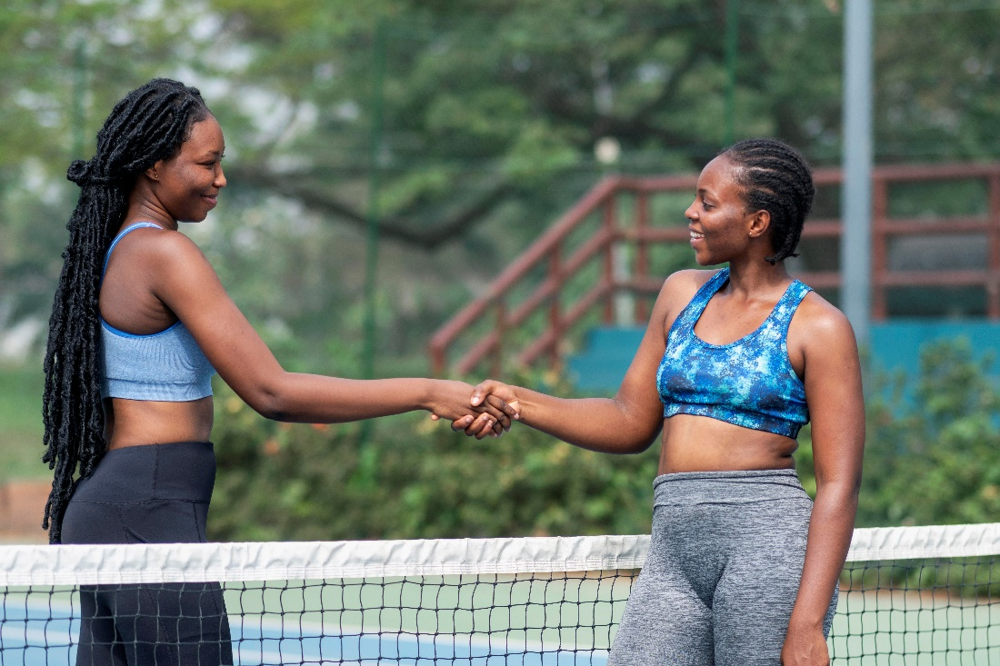

[Source: www.freepik.com Accessed: 14 January 2026]

a. State TWO possible messages that the shaking of hands after a match may illustrate. (2 × 1) (2)
__________________________________________________________________________________________________________________________________________________________________

b. Recommend TWO acts that school sports players can demonstrate to show respect
for their opponents. (2 × 2) (4)

__________________________________________________________________________________________________________________________________________________________________
__________________________________________________________________________________________________________________________________________________________________
[Sub-total: 6]

2. Read the extract below and answer the following questions.
Spectator behaviour in school sport
Many people have witnessed a parent or supporter at a school sporting event become overly aggressive while supporting a learner from the sidelines. Such behaviour often creates discomfort for fellow spectators and embarrassment for the learner involved.

In recent years, concerns about parent and spectator behaviour at school sports events have increased, particularly regarding the treatment of referees. In one reported incident, a 19-year-old school rugby referee suffered a concussion after being physically attacked by a spectator. This incident raised serious questions about safety, respect, and accountability within school sport.

When negative behaviour is tolerated, it risks spreading beyond the sports field, weakening social cohesion within communities and damaging the role of sport as a tool for unity at a national level.

[Adapted from: https://www.jacarandafm.com/shows/breakfast/watch-school-rugby-ref-takes-rowdy-parent-game/ Accessed: 14 January 2026]

a. State TWO reasons why referees should be respected. (2 × 1) (2)

__________________________________________________________________________________________________________________________________________________________________
_________________________________________________________________________________

b. Explain ONE spectator behaviour that may discourage young people from participating
in community sporting events. (1 × 2) (2)

__________________________________________________________________________________________________________________________________________________________________
_________________________________________________________________________________

c. Assess the importance of positive behaviour when attending a sporting event. In your
answer, also indicate how it may contribute to nation-building. (1 × 3) (3)

__________________________________________________________________________________________________________________________________________________________________
__________________________________________________________________________________________________________________________________________________________________
[Sub-total: 7]
[Grand-total: 13]

Activity 2: Reflection
Complete the following activity individually.

1. Read each statement carefully and tick (🗸) the column that best describes how often the statement applies to your own behaviour during sport, whether as a player or supporter.
Choose the response that reflects your honest behaviour, not what you think the “correct” answer should be. Note: This activity is about self-awareness, not judgment.
Statement |  | Never | Rarely | Sometimes | Often | Always
a. | I treat all players with respect, even when they make mistakes or are less skilled than others.
b. | I avoid mocking, blaming or excluding others during practices or matches.
c. | I behave in a way that helps make sport a safe and welcoming space for everyone involved.
d. | When I feel frustrated or emotional during sport, I manage my reactions responsibly.
e. | I show respect towards referees or officials, even when I disagree with their decisions.
f. | I understand that my behaviour during sport can influence others in my team, school or community.
g. | I believe that positive behaviour in sport can help build unity within my community and country.

2. Complete the following statement.
One behaviour I would like to improve in future sporting situations is ________________________
_____________________________________, because ____________________________________
_________________________________________________________________________________
_________________________________________________________________________________.

