

Lesson 3 – Worksheet MEMO
 | Activity 1: Participant and Spectator Behaviour in Sport  Complete the following activity in pairs or small groups.

List examples of positive behaviour in sport for the category your teacher has assigned to your group.

Note: While your teacher goes through the answers, you must also complete the other categories on the table.

Players |  | Coaches
- Encourage teammates and maintain a positive attitude.  - Demonstrate self-control even when under pressure.  - Represent their team and country with pride and dignity. |  | - Treat all players equally and without discrimination.  - Promote safe and healthy training practices.  - Support players emotionally and help them build confidence.
Officials (referees and umpires) |  | Fans and spectators
- Promote safety and protect players from injury.  - Show integrity by avoiding bias or corruption.  - Encourage a spirit of fair play and mutual respect. |  | - Avoid violence, swearing or offensive chants.  - Accept the outcome of the game gracefully.  - Support their team without discriminating against others.

→ Learners may have varying responses to this activity.

Activity 2: The Role of Sport in Nation-Building
Complete the following activity individually.

Study the cartoon below and answer the following questions.

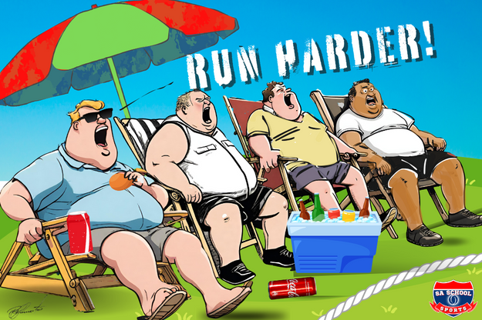

[Taken from: https://saschoolsports.co.za/parents-and-sport/ Accessed: 11 November 2025]

Write paragraphs on the role of sport in nation-building. Use the following as a guideline:

- State FOUR positive behaviours that parents can demonstrate at school sports
matches as spectators. (4 × 1) (4)

Parents can…
- cheer respectfully for all learners/applaud good play from both teams. (🗸)
- encourage good sportsmanship on and off the field. (🗸)
- follow the rules set by coaches/officials. (🗸)
- model calm/supportive behaviour during the game. (🗸)
- stay positive even when their child’s team is losing. applaud good play from both teams.
- avoid arguing with referees/coaches/other spectators. (🗸)
- show appreciation for coaches/officials. (🗸)
- use encouraging language/avoid criticism. (🗸)
- respect the decisions made by the officials. (🗸)
- be good role models by controlling their emotions. (🗸)

Any FOUR of the above for ONE mark each

- Analyse how inappropriate parental behaviour, such as arguing with the referee,
could affect nation-building. (2 × 4) (8)

It can…
  - create an atmosphere of disrespect towards officials (🗸) by showing learners that rules/authority can be challenged aggressively, (🗸) which can encourage them to imitate this behaviour during matches/in school settings, (🗸) and that can weaken the shared values of respect/unity needed for nation-building. (🗸)
  - discourage learners from participating in sport (🗸) by creating a negative/stressful atmosphere around matches, (🗸) which can make learners avoid activities meant to bring the school together, (🗸) and that can reduce shared experiences that contribute to nation-building. (🗸)
  - create tension between supporters from different teams (🗸) by making the environment hostile/emotionally charged, (🗸) which can make learners feel unsafe/uncomfortable at school events, (🗸) and that can reduce opportunities for unity/shared celebration in the school community. (🗸)
  - undermine the spirit of fair play in school sports (🗸) by suggesting that decisions should only be accepted when they benefit one’s own team, (🗸) which can influence learners to adopt biased/unfair attitudes, (🗸) and that can weaken efforts to promote fairness/integrity in the school community. (🗸)

Any TWO of the above for FOUR marks each
(i.e. ONE mark for statement, ONE mark for elaboration, ONE mark for qualifier and ONE mark for outcome)

- Critically discuss how spectators cheering opposing teams respectfully during school
sports could contribute to a positive experience for the learners. (2 × 4) (8)

It can…
- create a supportive/encouraging atmosphere for all players (🗸) by showing appreciation for effort rather than just winning, (🗸) which can help learners feel valued regardless of their performance, (🗸) and that can increase their confidence/enjoyment of the match. (🗸)
- promote fairness and respect between the teams (🗸) by modelling positive behaviour that treats all learners equally (🗸), which can reduce feelings of pressure/intimidation, and exclusion (🗸), and can lead to healthier competition/stronger school unity. (🗸)
- encourage good sportsmanship among learners (🗸) by reinforcing the idea that effort/discipline/teamwork are more important than the score, (🗸) which can help learners focus on playing fairly/enjoying the game, (🗸) and can contribute to a more positive sporting culture in the school. (🗸)
- reduce tension/conflict during the match (🗸) by preventing spectators from displaying biased/aggressive reactions, (🗸) which can keep the environment safe/calm/enjoyable for everyone, (🗸) and help learners feel supported while playing. (🗸)

Any TWO of the above for FOUR marks each
(i.e. ONE mark for statement, ONE mark for elaboration, ONE mark for qualifier and ONE mark for outcome)

[Total: 20]
Activity 3: Reflection
Complete the following activity individually.

- Describe ONE sporting moment (at school or in South Africa) that made you feel hopeful, proud or inspired.
___________________________________________________________________________________________________________________________________________________________________________________________________________________________________________________

- How can moments like these help build national unity?

_____________________________________________________________________________________________________________________________________________________________________________________________________________________________________________________________________________________________________________________________________________________________________________________________________________________
→ Learners will have personal responses to this activity.

