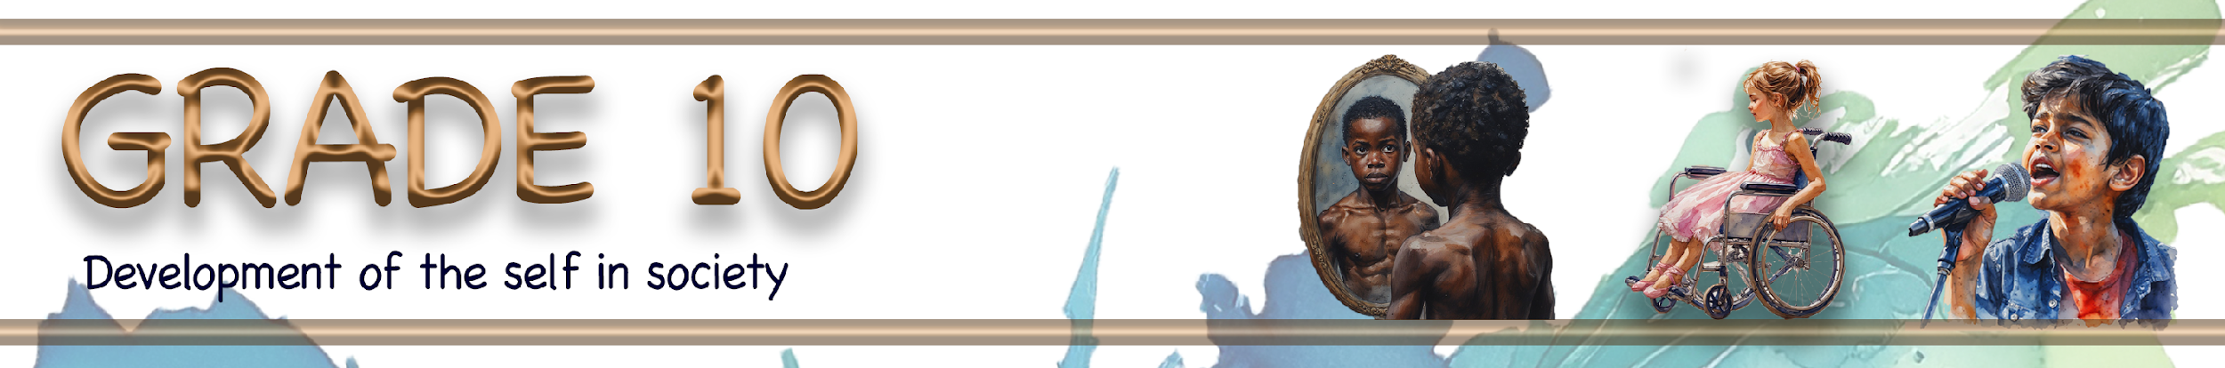

Lesson 3 – Group Activities MEMO

Group 1

Main question: Why is gender-based violence such a serious problem in South Africa, and how can it be addressed?

Read the extract below and answer the following questions.

Gender-based violence (GBV): An increasing epidemic in South Africa
Why is GBV so prevalent in South Africa? Is it because of the way males are brought up to exert power and control over vulnerable women? South Africa is well known as a very patriarchal country, and many cultural and traditional events and activities entrench this patriarchal behaviour, reinforcing power over women.

Media, in reporting incidences of GBV, focus on the victim by publishing headlines that read ‘a woman has been raped’ rather than stating ‘a man has raped a woman’.

The issue of consent is blurred with Lobola. Consent is something that should be freely given, that can be recalled at any time, and a person must be capable and understand the consequences of such consent. Young children, especially those below the age of 12, do not have the mental capacity for such consent.

The South African Constitution clearly states that everyone is entitled to freedom and security of the person, including the right to be free from all forms of violence.

[Adapted from: https://safpj.co.za/index.php/safpj/article/view/5729/7927 Accessed: 12 December 2025]

1. Do you agree with the statement that the way males are brought up contributes to gender-based
violence? Explain how this may add to GBV in South Africa.
- Yes, the way some males are raised can contribute to GBV, as boys may be taught that men should be dominant and in control of women.
- Yes, these beliefs can normalise aggressive behaviour and make violence seem acceptable in relationships.
- Yes, patriarchal cultural practices may reinforce unequal power between men and women, increasing the risk of abuse.
2. How does media reporting influence the way society understands and responds to sexual abuse?
- Media often focuses on the victim instead of the perpetrator, which can lead to victim-blaming.
- This reporting style can reduce accountability for offenders and shift responsibility onto women.

- It may cause society to see sexual abuse as something that 'happens to women' rather than a crime committed by men.
3. Compile a list of FIVE recommendations that your group believes the government could implement to address gender-based violence. (Complete your recommendations on the poster provided by your teacher.)
- Strengthen and enforce laws that protect victims of GBV.
- Provide better training for police and officials on handling GBV cases.
- Increase access to shelters, counselling and support services for victims.
- Run national awareness campaigns on consent and gender equality.
- Include GBV education in schools and community programmes.

→ Learners may have varying responses to these questions.

Group 2

Main question: Why is gender-based violence such a serious problem in South Africa, and how can it be addressed?

Read the Instagram post below and answer the following questions.

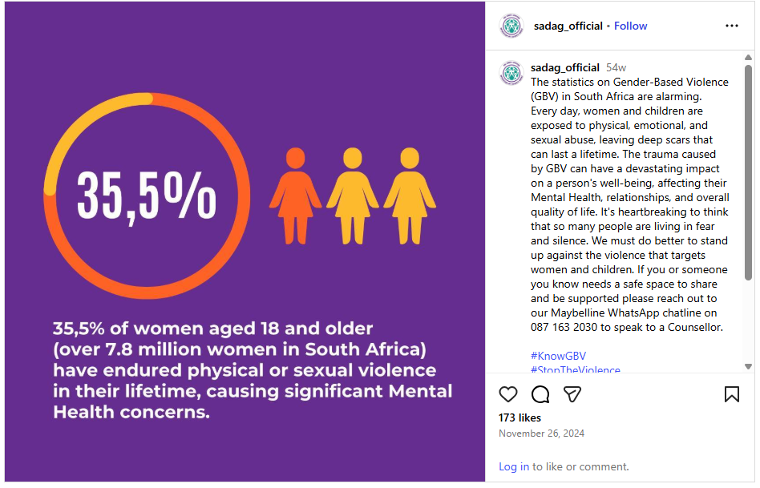
[Adapted from: https://www.instagram.com/p/DC1RJCxR4aZ/ Accessed: 12 December 2025]

1. What does the statistic that 35.5% of women experience physical or sexual violence reveal about the seriousness of gender-based violence in South Africa?
- It shows that GBV is widespread and affects a large number of women.
- The statistic highlights that violence against women is a serious national problem.
- It suggests that many women are unsafe in their homes and communities.
2. How does sexual abuse affect a person’s mental health?
- Victims may experience depression, anxiety and post-traumatic stress disorder (PTSD).
- It can lead to feelings of fear, shame, guilt and low self-esteem.
- Some victims struggle with trust and forming healthy relationships.
3. Compile a list of FIVE practical actions that young people can take to help reduce gender-based violence in their communities. (Complete your responses on the poster provided by your teacher.)
- Speak out against abusive behaviour and harmful jokes.
- Respect boundaries and promote the importance of consent.
- Support friends who experience abuse by encouraging them to seek help.
- Participate in awareness campaigns and school programmes.
- Use social media responsibly to challenge violence and sexism.
→ Learners may have varying responses to these questions.

Group 3

Main question: Why is gender-based violence such a serious problem in South Africa, and how can it be addressed?

Study the statistics below and answer the following questions.

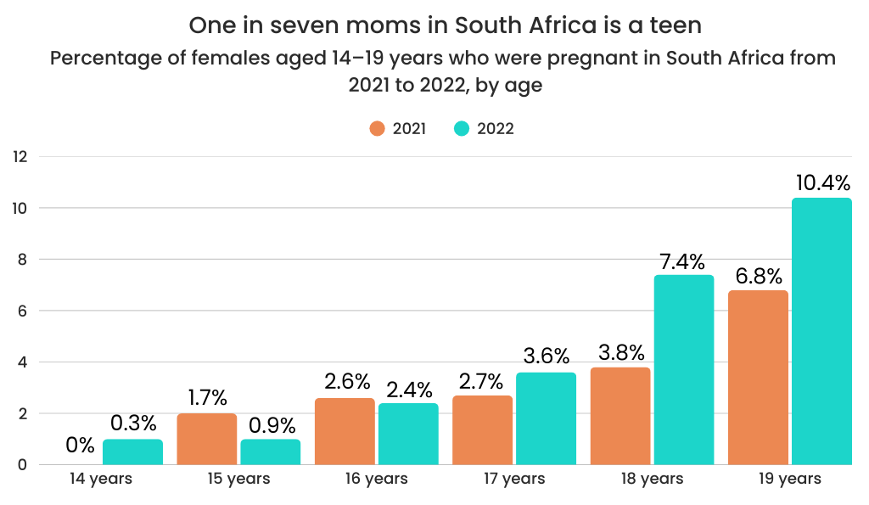

[Adapted from: bit.l2y/456Ibqj Accessed: 12 December 2025]

1. Identify which age group had the highest teenage pregnancy rate, as well as the age group that shows the greatest increase in pregnancies. Discuss possible reasons for this increase.
- The age group with the highest teenage pregnancy rate is 19-year-olds, increasing from 6.8% in 2021 to 10.4% in 2022.
- The greatest increase in pregnancies is also seen among 18- and 19-year-olds, with a sharp rise between 2021 and 2022.
- Possible reasons for this increase include:
  - increased sexual activity among older teenagers
  - limited access to contraception and reproductive health services
  - peer pressure and unequal power in relationships
  - lack of consistent sexual education and guidance
  - reduced supervision as teenagers become more independent

2. Discuss some of the effects of teenage pregnancy on a young mother. Refer specifically to:
- education,
- relationships with friends and family,
- physical and emotional health.
Education
- Teenage pregnancy may cause learners to miss school or drop out.
- It can make it difficult to complete schoolwork and achieve academic goals.
Relationships with friends and family
- Friendships may change due to new responsibilities and stigma.
- Family relationships may become strained because of stress, disappointment or financial pressure.
Physical and emotional health
- Young mothers face higher health risks during pregnancy due to their age.
- They may experience emotional stress, anxiety or depression.

3. Compile a list of FIVE practical steps that young people can take to help reduce teenage pregnancy in their communities. (Complete your responses on the poster provided by your teacher.)
- Educate themselves and others about safe sex and contraception.
- Encourage open conversations about relationships and consent.
- Support peers in making responsible and informed decisions.
- Delay sexual activity and focus on personal goals and education.
- Seek advice and support from trusted adults or health professionals.

→ Learners may have varying responses to these questions.

Group 4

Main question: Why is gender-based violence such a serious problem in South Africa, and how can it be addressed?

Read the extract below and answer the following questions.

One third of children in South Africa are at risk of online violence, exploitation and abuse
In South Africa, almost all children (over 95%) use the internet regularly, but this also puts them at risk of online violence, exploitation, and abuse. Many children share personal information or talk to strangers online without understanding the dangers. This can lead to serious harm, like bullying, sexual exploitation, or being tricked by people with bad intentions.

UNICEF warns that children need better protection online through education, strong laws, and support from parents and communities to keep them safe.
[Adapted from: bit.ly/3KHGIA0 Accessed: 12 December 2025]

1. Explain how online violence and exploitation are linked to gender-based violence in South Africa.
- Online abuse can involve sexual harassment, grooming and exploitation.
- These actions are forms of gender-based violence when they target girls and women.
- Online abuse can lead to physical abuse or sexual violence offline.
2. The article states that many children face risks such as sexual exploitation online. What does this suggest about how vulnerable groups are treated within communities in South Africa?
- It shows that children and vulnerable groups are not adequately protected.
- Some communities fail to recognise or address abuse early.
- It suggests a lack of awareness, education and accountability.
3. Compile a list of FIVE practical steps that schools can take to help reduce child abuse in their communities. (Complete your responses on the poster provided by your teacher.)
- Teach learners about online safety and recognising abuse.
- Create clear reporting systems for abuse at school.
- Train teachers to identify signs of abuse and neglect.
- Involve parents through workshops and information sessions.
- Work with social workers and child protection services.

→ Learners may have varying responses to these questions.

