

Lesson 3 – Worksheet
 | Activity 1: Toxic Friendships  Complete the following activity in pairs.

Read the TWO scenarios below and answer the questions that follow.

Scenario 1: The story of Ethan and Liam
Ethan: (16): An academically strong, well-rounded learner with high-achieving parents.
Liam (16): Ethan's best friend, who struggles with schoolwork and has an insecure home life.

Ethan and Liam have a friendship defined by constant, subtle competition from Liam. If Ethan gets a good grade, Liam will immediately point out a mistake or dismiss it as an "easy class". If Ethan mentions a success (e.g. scoring a spot on the soccer team), Liam will either minimise it or brag about something unrelated he did (e.g. "That's cool, but I was out all night – my parents don't care what time I come home").

Liam has also started asking Ethan to do his homework or cheat on tests, leveraging their long history of friendship with phrases like, "A real friend wouldn't let me fail." When Ethan refuses, Liam gives him the silent treatment for days. Ethan now dreads sharing good news with Liam and has started intentionally downplaying his achievements, which is making him feel guilty and dishonest with himself and his family.

Scenario 2: The story of Sarah and Jessie
Sarah (16): Kind-hearted and empathetic, she often prioritises others' needs above her own.
Jessie (16): Sarah's friend, who is constantly embroiled in self-created drama and takes on a perpetual victim role.

Jessie's life seems to be one crisis after another – a fight with a sibling, a poor test grade, a minor social media slight – all of which she presents to Sarah with intense emotional distress. Jessie demands hours of Sarah's time for "trauma dumping", often late into the night. She rarely asks about Sarah's life or problems, and if Sarah tries to share, Jessie quickly redirects the conversation back to her own issues, saying, "I just can't handle anything else right now."

When Sarah tried to set a boundary by saying she needed to study, Jessie texted her for two days about how hurt and abandoned she felt, culminating in a vague threat to do something drastic. Sarah felt forced to apologise and resume her role as Jessie's emotional caretaker. Sarah is now constantly exhausted, her grades are slipping, and she feels completely drained and overwhelmed by Jessie's problems.

1. Identify the victim of the toxic friendship in each scenario and give a reason for your answer.

Scenario 1:  _____________________________________  _____________________________________  _____________________________________  _____________________________________ |  | Scenario 2:  _____________________________________  _____________________________________  _____________________________________  _____________________________________

2. Describe the long-term impact that this toxic relationship may have on each of the victims.

Scenario 1:  _____________________________________  _____________________________________  _____________________________________  _____________________________________ |  | Scenario 2:  _____________________________________  _____________________________________  _____________________________________  _____________________________________

3. Explain how the story of Ethan and Liam illustrates a conflict of values among the friends.
___________________________________________________________________________________________________________________________________________________________________________________________________________________________________________________

4. If the victim in the story of Sarah and Jessie were your sister, what advice would you give her?
___________________________________________________________________________________________________________________________________________________________________________________________________________________________________________________

Activity 2: The Impact of Social Media on Relationships (Homework)
Complete the following activity individually.

Study the cartoon below and answer the following questions.

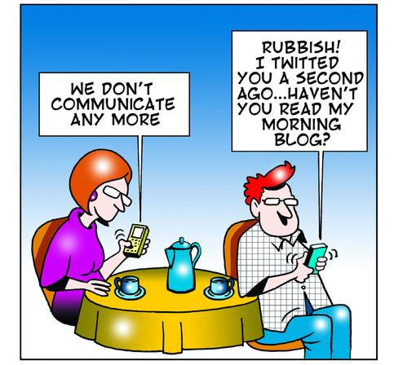

[Sourced from: https://www.toonpool.com/cartoons/my%20morning%20blog_63143 Accessed on: 20 November 2025]
1.1 State TWO positive influences of social media on our relationships. (2 × 1) (2)
___________________________________________________________________________________________________________________________________________________________________________________________________________________________________________________

1.2 Assess the negative impact that social media has on our values regarding our
relationships. (2 × 2) (4)
___________________________________________________________________________________________________________________________________________________________________________________________________________________________________________________
___________________________________________________________________________________________________________________________________________________________________________________________________________________________________________________

1.3 Provide TWO strategies you could implement to manage your social media use in your
relationships. In your answers, also indicate the long-term impact of these changes. (2 × 3) (6)
___________________________________________________________________________________________________________________________________________________________________________________________________________________________________________________
___________________________________________________________________________________________________________________________________________________________________________________________________________________________________________________
__________________________________________________________________________________________________________________________________________________________________
[Total: 12]
Activity 3: Reflection
Complete the following activity individually.

Reflect on what you have learnt in today's lesson by answering the following questions.

1. Which type of media has the greatest influence on your perceptions of relationships?
_________________________________________________________________________________

2. Discuss the positive and negative ways in which media role models influence your life.

Positive:  _____________________________________  _____________________________________  _____________________________________  _____________________________________ |  | Negative:  _____________________________________  _____________________________________  _____________________________________  _____________________________________

3. Name TWO personal qualities you consider a "weakness" in your friendships, and explain how you plan to improve them.
_____________________________________________________________________________________________________________________________________________________________________________________________________________________________________________________________________________________________________________________________________________________________________________________________________________________

