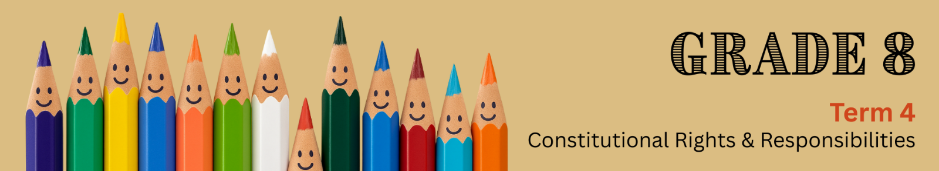
Lesson 2 – Worksheet MEMO
 | Activity 1: Terminology  Complete the following activity individually.

Match the correct description in Column B with the term in Column A. Write only the correct letter (A–J) next to the question number.

COLUMN A |  | COLUMN B
1.1 | Value | A. | The way of life, including beliefs and customs, of a group of people.
1.2 | Traditions | B. | Features or traditions passed down from earlier generations that belong to the culture of a society.
1.3 | Tolerance | C. | Inherited, established, or customary patterns of thought, action, or behaviour passed down through generations.
1.4 | Heritage | D. | A system of faith, worship, and belief in a higher power.
1.5 | Norms | E. | A positive way we treat others, showing admiration or consideration.
1.6 | Religion | F. | Principles or beliefs about what is good, right, or important.
1.7 | Respect | G. | Principles or rules made by a government to guide a society.
1.8 | Culture | H. | The presence of people with different backgrounds, lifestyles, and experiences.
1.9 | Diversity | I. | The ability or willingness to accept differences between people.
 |  | J. | Shared rules or ways of behaviour that are seen as normal in a society.
(9 x 1) (9)
  - ____
  - ____
  - ____
  - ____
  - ____
  - ____
  - ____
  - ____
  - ____
[Sub-total: 9]

Activity 2: Informal Assessment
Complete the following activity in pairs.

Read the extract below and answer the questions that follow.

What diversity in education really looks like – and why it matters
South African classrooms reflect the diversity of our country, with many cultures, languages, and traditions. This diversity is a strength, but it also means schools must work hard to promote inclusion, equality, and respect.

When learners see their identities, languages, and traditions reflected in what they are taught and who teaches them, they feel a stronger sense of belonging. Inclusion is not just about having diverse people in the room; it’s about making sure everyone is seen, heard, and valued.

[Adapted from bit.ly/4k5VTyr Accessed: 24 June 2025]

2.1 Define the concept ‘cultural diversity’ and state ONE way in which an individual could
learn about other cultures in their community. (1 + 1) (2)

_____________________________________________________________________________________________________________________________________________________________________________________________________________________________________________________________________________________________________________________________________________________________________________________________________________________
2.2 Identify ONE way in which cultural diversity can strengthen a school community. (1 x 1) (1)

___________________________________________________________________________________________________________________________________________________________________________________________________________________________________________________

2.3 Explain ONE way in which cultural norms may affect communication in relationships
with classmates. (1 x 2) (2)

___________________________________________________________________________________________________________________________________________________________________________________________________________________________________________________

2.4 Discuss how a learner can be supportive of a peer who is culturally different from them. (1 x 2) (2)

____________________________________________________________________________________________________________________________________________________________________________________________________________________________________________________________________________________________________________________________________

2.5 Recommend ONE way in which a school can be more inclusive of culturally diverse
learners. (1 x 3) (3)
___________________________________________________________________________________________________________________________________________________________________________________________________________________________________________________
___________________________________________________________________________________________________________________________________________________________________________________________________________________________________________________
[Sub-total: 10]

