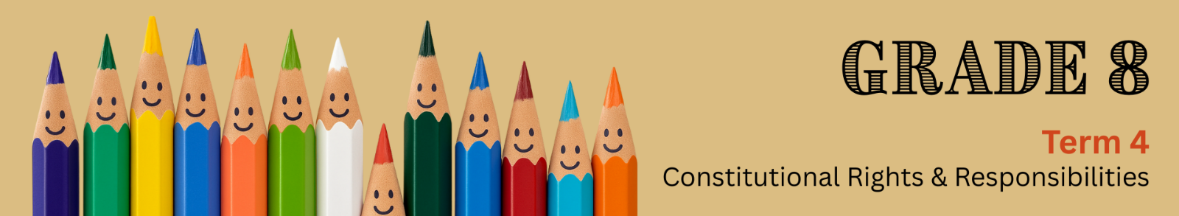

Lesson 1 – Worksheet MEMO
 | Activity 1: Introductory Activity  Answer the following questions individually.

1.1 Define the terms ‘culture’ and ‘diversity’.
Culture: | Diversity:
The way of life of a group of people, including their customs, beliefs, arts, language, religion, food, dress, and traditions, passed down from generation to generation. | The presence of differences among people, such as culture, religion, gender, language, age, appearance, disability, or race.

1.2 Using your answers from 1.2, define the term ‘cultural diversity’.
- Cultural diversity means that many different cultures live together in one society.
Activity 2: Embracing South Africa
Complete the following activity individually.

Watch the video (South Africa: Rainbow Nation, Desmond Tutu, 11 Official Languages, Society: bit.ly/3TDfzyM) and answer the following questions.
Complete the following statements by filling in the missing words. Choose the correct words from the word bank provided below.
ethnicities; multicultural; religions; twelve; beacon; diversity
Rainbow Nation; cultural heritage; diverse; races

2.1 South Africa is known for its diverse population and multicultural society.
2.2 It has people from many different races, religions and ethnicities.
2.3 The country has twelve official languages.

2.4 These languages reflect the country's cultural heritage.
2.5 South Africa's culture is influenced by the diversity of its people, including dance, art and cuisine.
2.6 The term Rainbow Nation was coined by Archbishop Desmond Tutu in the early 1990s.

2.7 South Africa serves as a beacon of hope for people around the world.

Activity 3: Lesson Reflection
Complete this activity individually.

Answer the following questions.

3.1 How do you feel when you see or experience a culture that is different from your own? What thoughts go through your mind?

3.2 Is there a cultural practice you have seen or learned about that you admire? Motivate your answer.

→ Learners will have personal responses to this activity.

