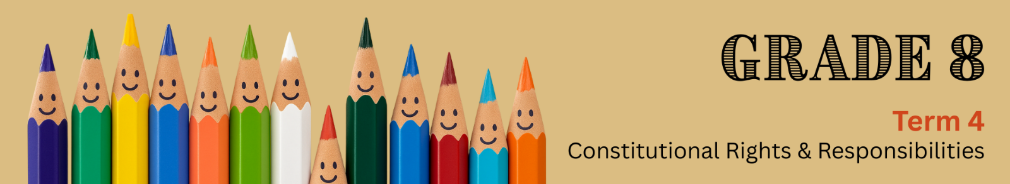
Lesson 3 – Worksheet MEMO
 | Activity 1: Group Reflection  Complete the following activity in groups.

Read the poem If All the Trees Were Oaks and answer the questions that follow.
If All the Trees Were Oaks
Author unknown
What if all the trees were oaks
How plain the world would seem;
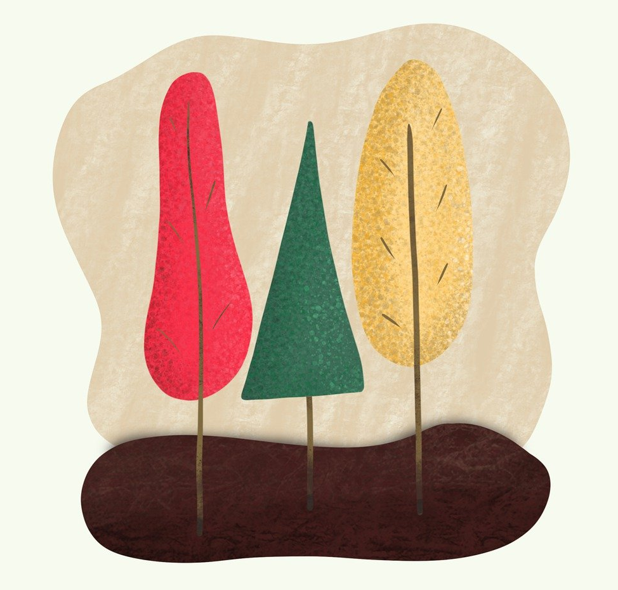
No maple syrup, banana splits,
And how would orange juice be?
Wouldn’t it be a boring place,
If all the people were the same;
Just one colour, just one language,
Just one family name!
~But~
If the forest were the world,
And all the people were the trees;
Palm and pine, bamboo and willow,
Live and grow in harmony.
Aren’t you glad, my good friend,
Different though we be;
We are here to help each other,
I learn from you, and you, from me
[Source: bit.ly/4ehsgcg Accessed: 24 June 2025]

  - Describe TWO benefits of having friends from different cultures or backgrounds. (2 x 1) (2)

→ It can…
- make friendships more fun because friends bring different personalities and ideas. (🗸)
- help you learn new customs/traditions/ways of thinking. (🗸)
- give you new experiences that help you grow. (🗸)
- help you enjoy learning about other cultures/languages. (🗸)
- help you see the world in new ways. (🗸)
- stop friendships from becoming boring, as differences bring excitement/variety. (🗸)

Any TWO of the above for ONE mark each

1.2 Identify TWO life skills you can develop by associating with people who are different from
you. (2 x 1) (2)
→ You can develop…
- problem-solving skills. (🗸)
- ability to build good relationships. (🗸)
- communication skills. (🗸)
- teamwork skills. (🗸)
- conflict management skills. (🗸)
- leadership skills. (🗸)
Any TWO of the above for ONE mark each

1.3 Explain why it is positive that everyone in the world is different. (1 x 2) (2)
→ It is positive because…
- it makes life more interesting, (🗸) which can help us learn from one another/respect other cultures. (🗸)
- diversity brings different ideas/ways of thinking, (🗸) which can help us solve problems creatively. (🗸)
- people’s differences give us new experiences, (🗸) which can help us grow/understand the world better. (🗸)
- differences between people make communities stronger, (🗸) which can help us work together/support each other. (🗸)
Any ONE of the above for TWO marks
(i.e. ONE mark for statement and ONE mark for qualifier/explanation)

1.4 Evaluate the impact on our daily lives if all people in the world had the same culture. (1 x 4) (4)

→ It could…
- create unity/make it easier to agree on traditions and decisions, (🗸) which can reduce conflict/help people work together easily; (🗸) however, it could also mean we lose cultural diversity/different ideas, (🗸) which can make the world less creative/less interesting/limit how much we learn from each other. (🗸)
- make it easier to agree on which holidays to celebrate/what traditions to follow, (🗸) which can make planning community events simpler; (🗸) however, it could also mean that unique holidays/traditions/languages disappear, (🗸) which can make life less interesting/take away chances to learn from others. (🗸)
- reduce misunderstandings between people, (🗸) which can help people feel more connected; (🗸) however, we would lose the richness of different foods/music/customs, (🗸) which can make the world feel boring/less creative. (🗸)
- help people agree on important rules/values, (🗸) which can make it easier to solve problems together; (🗸) however, it could stop us from seeing different points of view, (🗸) which can make it harder to find creative solutions to challenges. (🗸)
Any ONE of the above for FOUR marks
(i.e. To be awarded the full FOUR marks for the EVALUATION, candidates must: give the first a statement, (🗸) and qualify it. (🗸) Additionally, the learner should give another, opposing statement (🗸) and qualify that statement. (🗸))

[Sub-total: 10]

