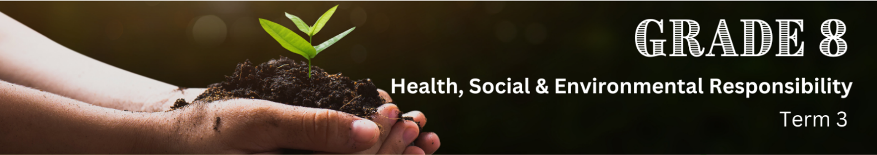

Lesson 2 – Worksheet
 | Activity 1: Informal Assessment  Complete the following activity individually.

Question 1.1
Choose the correct answer and write only the letter (A-D) next to the question numbers (1.1.1 to 1.1.4), for example, 1.1.5. D.

1.1.1 Smoke from factories, cars and wildfires are examples of ___________ pollution.
A. Water
B. Air
C. Soil
D. Light

1.1.2 The abbreviation NEMA stands for:
A. National Energy Management Association
B. National Emergency Monitoring Agency
C. National Environmental Management Act
D. Natural Ecosystem Monitoring Authority

1.1.3 This act ensures sustainable fishing practices:
A. The Marine Living Resources Act (Act No. 18 of 1998)
B. The Coastal Management Act (Act No. 24 of 2008)
C. The Environmental Conservation Act (Act No. 73 of 1989)
D. The Protected Areas Act (Act No. 57 of 2003)

1.1.4 Examples of hazardous waste include:
A. Computers, smartphones, televisions, and appliances.
B. Scrap material, concrete, wood, metal and bricks.
C. Food scraps, paper, plastic, glass, metal, and clothing.
D. Syringes, bandages, and expired pharmaceuticals.
(4 x 1) (4)
(Lower Order)

Question 1.2
Give ONE word/term for EACH of the following descriptions. Write only the word/term next to the question numbers (1.2.1 to 1.2.4).

1.2.1. An approach to growth that aims to meet the needs of the current generation without compromising the needs of future generations.

1.2.2. Cutting down trees to make way for agricultural activities or urban development.

1.2.3. Protecting natural resources and ecosystems from degradation or destruction.

1.2.4. An annual event celebrated on April 22 to demonstrate support for environmental protection.
(4 x 1) (4)
(Lower Order)
Question 1.3
Study the social media post on waste management below and answer the questions that follow.
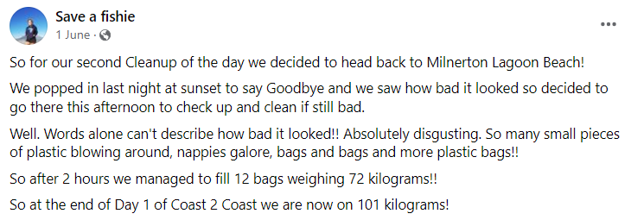

[Adapted from https://www.facebook.com/saveafishie/posts/856223406534819?ref=embed_post
Accessed: 16 July 2024]

1.3.1. Define the term 'waste'. (1 x 1) (1)
(Lower Order)

1.3.2. State TWO ways in which waste management can protect the environment. (2 x 1) (2)
(Lower Order)

1.3.3. Explain how the Waste Act (NEMWA) of 2008 encourages organisations to adopt environmentally sustainable practices. (2 x 2) (4)
(Middle Order)

1.3.4. Suggest TWO practical ways in which a learner can manage waste in their home. In your answer, also indicate how this action could lead to a healthier overall environment. (2 x 3) (6)
(Higher Order)
[13]
[Grand Total: 21]
Activity 2: Homework Reflection
Complete the following activity individually.

2.1. List NINE items you frequently dispose of and indicate with a checkmark () whether each item can be recycled, repurposed or is considered non-reusable.
Item | Recyclable | Reusable | Non-reusable

2.2. List ways in which you can personally reduce your contribution to household waste.
___________________________________________________________________________________________________________________________________________________________________________________________________________________________________________________________________________________________________________________________________________________________________________________________________________________________________________________

2.3. Describe ways in which you can encourage family members to adopt environmentally friendly practices.
___________________________________________________________________________________________________________________________________________________________________________________________________________________________________________________________________________________________________________________________________________________________________________________________________________________________________________________

