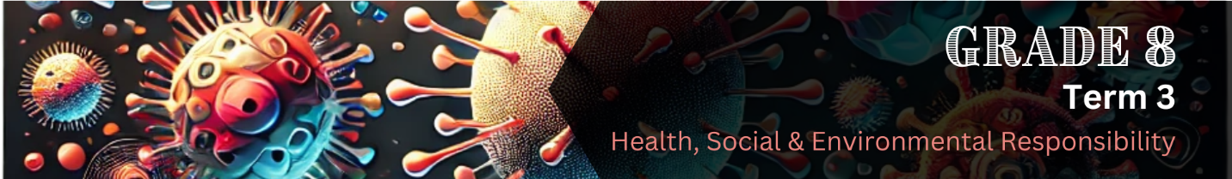

Lesson 2 – Worksheet MEMO
 | Activity 1: Informal Assessment  Complete the following activity individually.

Read the extract below and answer the questions that follow.
Living with HIV during the COVID-19 pandemic
When the COVID-19 pandemic began, it created new challenges for people all over the world, including those already living with HIV. Many people struggled to get the healthcare and support they needed. The pandemic also reminded us how important it is to treat all people fairly and make sure that everyone can get the care and information they need.

Although HIV and COVID-19 are different illnesses, both have had a big impact on communities, healthcare systems, and how people treat one another. This has led many people to think about how we respond to disease, how we protect others, and how we can help stop the spread of illness in our communities.

[Adapted from: https://www.who.int/teams/global-hiv-hepatitis-and-stis-programmes/covid-19 Accessed: 28 March 2025]

1.1 Describe ONE social similarity between how HIV and COVID-19 affect communities. (1 x 1) (1)
Both can...
- lead to stigma/people judging/avoiding those who are sick. ()
- cause fear/misinformation to spread/make people believe/share false information. ()
- cause isolation/loneliness/exclusion for those who are infected. ()
- highlight the importance of community support/people coming together to help/care for each other. ()
Any ONE of the above for ONE mark

1.2 How does 'HIV' differ from 'COVID-19'? (1 x 2) (2)

Possible answers may include the following:
- HIV is a long-term, chronic illness, () while COVID-19 is usually short-term. ()
- HIV must be managed with daily medication, () while most people recover from COVID-19 within a few weeks. ()
- HIV is spread through blood/semen/vaginal fluids/breast milk, () while COVID-19 spreads through respiratory droplets from coughing/sneezing/talking. ()
- HIV attacks the body’s ability to fight infections, () while COVID-19 mostly causes problems with breathing/the lungs. ()

- HIV is managed with antiretroviral therapy (ART), () while COVID-19 can often be treated with rest/medication/oxygen support. ()
Any ONE of the above for TWO marks
(i.e. ONE mark for the first statement and ONE mark for the second statement)

1.3 Discuss why it is important to provide support to someone living with HIV or recovering
from COVID-19. (1 x 2) (2)

It can…
- help people feel less alone, () which can make a big difference in their recovery. ()
- Improve their mental health, () which can make them feel less anxious/scared/depressed. ()
- encourage treatment/recovery () if friends/family remind them to take their medication/attend check-ups. ()
- help reduce stigma/judgement, () which can show the individual that it is okay to be sick/everyone deserves kindness/respect. ()
- create a safe space/caring environment, () which can help them recover faster/feel motivated to take care of themselves. ()
Any ONE of the above for TWO marks
(i.e. ONE mark for the first statement and ONE mark for the second statement)
[Total: 5]

Activity 2: Reflection
Complete the following activity individually.

In the space provided below, write a short paragraph (5-7 sentences) about how this lesson made you feel.

Include the following in your reflection:
- What emotions came up during the lesson?
- Did it remind you of a time during the COVID-19 pandemic that was challenging or meaningful for you or someone you know?
- How did that experience shape how you think about health, safety, or caring for others?

_____________________________________________________________________________________________________________________________________________________________________________________________________________________________________________________________________________________________________________________________________________________________________________________________________________________________________________________________________________________________________________________________________________________________________________________________________________________________________________________________________________________________________________________________________________________________________________________________________________________________________________________________________________________________________________________________________________________________________________________________________________________________________________________________________________________________________________________________________________________________________________________________________________________________________________________________________________________________________________________________________________________________________________________________________________________________________________________________________________________________________

Learners will have personal responses to this activity.

