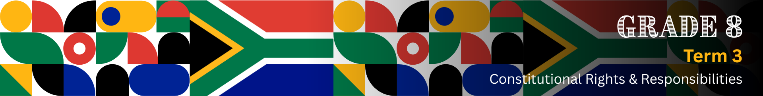

Content Summary

Definition of nation-building
Shared identity means that people in a country feel connected because they have things in common, like values, goals or experiences. Even though they may have different cultures or backgrounds, they see themselves as part of the same team.
Nation-building is the process of helping a country become stronger and more united. It includes creating a shared identity, building trust between people, and making sure everyone feels like they belong. Nation-building also means working together to grow the country’s government, economy, and culture.

Key ideas that support nation-building
The Rainbow Nation
The term "Rainbow Nation" was used by Archbishop Desmond Tutu to describe South Africa after 1994. It refers to the diverse range of people, cultures, languages, traditions, and beliefs found in our country. Just like a rainbow is made up of different colours, our unity as a nation is made up of our beautiful diversity. Respecting diversity means accepting and valuing everyone’s differences and understanding that each person is unique
Ubuntu
Ubuntu is a South African term that means "I am because you are". It speaks about our shared humanity, the importance of community, and the way we rely on each other. Ubuntu encourages kindness, care, and responsibility towards others.

Different ways to promote nation-building
Nation-building doesn’t happen in just one place or on a particular day, like Heritage Day/Braai Day – it happens in many parts of our lives, and these parts are all connected.

Home, school, and the community are like building blocks of our society. What we learn and practise in one area affects the others. For example, when we learn values like love, responsibility and respect at home, we carry them into school and into our community. If our schools teach us to celebrate diversity, we take that attitude back home and into the community. When communities work together and support one another, they create safer, kinder environments for schools and families.

This shows that each space supports and strengthens the others, and when all three work together, they help to build a united, strong nation. Look at the diagram below that illustrates this interconnection.

How home, school, and community work together to build the nation
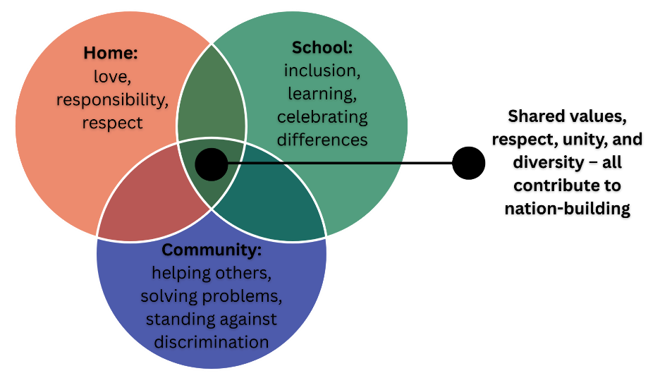

Practical ways to promote nation-building in different areas
Nation-building starts with the small actions we take every day. Here are some practical ways you can make a difference:
At home (family)

At school

In the community

Sport as a nation-building tool
Sport brings people together, no matter their background, language, culture, or belief system. Supporting and celebrating our national teams (Springboks, Bafana-Bafana, Banyana Banyana, Proteas) helps build pride, unity, and a shared identity as South Africans.

A powerful example are the Springboks’ Rugby World Cup victories, especially in 1995, 2007, 2019, and 2023. These moments united the country, bringing people of all races and backgrounds together to celebrate a shared victory.

Contributions of women and men towards nation-building: individuals and groups
South Africa has many individuals and groups who have made major contributions to building a better South Africa. Here are a few examples:

 | POLITICS & HUMAN RIGHTS
 | Nelson Mandela  (1918–2013)  South Africa’s first democratic president and anti-apartheid hero. He spent 27 years in prison and, upon release, led the country towards peace, unity, and democracy. | Helen Suzman  (1917-2009)  Member of Parliament who courageously opposed apartheid. She visited political prisoners, including Mandela, and defended human rights, fairness, and justice for all. | Thuli Madonsela  (1962-)  Former Public Protector who exposed high-level corruption. Her State of Capture report was a turning point for accountability in government. | Zackie Achmat  (1962-)  HIV/AIDS activist and co-founder of the Treatment Action Campaign. He led the fight for accessible treatment and health rights for all.
 | ECONOMY & BUSINESS
 | Patrice Motsepe  (1962-)  Businessman and philanthropist. He became one of South Africa’s first Black billionaires and promotes economic empowerment through jobs and giving back. | Wendy Luhabe  (1957-)  Business leader and social entrepreneur. She created opportunities for women in business and helped grow South Africa’s economy inclusively. | Imtiaz Sooliman  (1962–)  Humanitarian and founder of Gift of the Givers, Africa’s largest disaster relief organisation. He has helped millions through food, water, and medical support, guided by compassion and service to all people. | Adrian Gore  (1964-)  Founder and CEO of Discovery Health. He introduced new ways to support people’s health and access to medical care, while also backing education and entrepreneurship in South Africa.
ARTS, CULTURE & SPORT
Miriam Makeba  (1932-2008)  Famous singer and global activist known as “Mama Africa.” She used music to fight apartheid and share South African culture with the world. |  | Johnny Clegg  (1953-2019)  Musician who blended Zulu and Western music. His work challenged racial barriers and brought people together through song. | Caster Semenya  (1991-)  Olympic gold medallist and advocate for gender rights. She also supports rural sports development through her foundation. | Siya Kolisi  (1991-)  First Black captain of the Springboks who inspires national pride and unity through sport and leads the Kolisi Foundation, which provides support in underprivileged communities.
EDUCATION & SOCIAL DEVELOPMENT
Albertina Sisulu  (1918-2011)  Nurse and activist who supported health and education during apartheid. She helped build a better society through care and community service. |  | Steve Biko  (1946-1977)  Leader of the Black Consciousness Movement. He encouraged pride, confidence, and independence among Black South Africans. | Graça Machel  (1945-)  Advocate for education and women’s rights. She worked across Africa to improve children’s lives and promote gender equality. | Neville Alexander  (1936-2012)  Educator and activist whose work laid the foundation for language policies that support learning in home languages and literacy for all.
GROUPS THAT HELP BUILD SOUTH AFRICA
Ndlovu Youth Choir  A choir from rural Limpopo that uses music to inspire, uplift, and unite. They promote African pride and global recognition while providing opportunities for young people through performance, education, and personal growth. |  | Equal Education Movement  A learner-led movement that fights for equal, quality education in South Africa. They campaign for better school infrastructure, safer environments, and justice in the education system. | Soul City Institute  Uses television, radio, and community programmes to raise awareness on health, gender equality, and human rights. Their work empowers communities through knowledge. | Good Things Guy (Online platform by Brent Lindeque)  A feel-good media brand that shares positive South African news, inspiring stories, and community efforts. It uplifts national morale and reminds South Africans of their shared humanity.

Learning from role models
Inspiration plays a big part in nation-building. When we hear stories of South Africans who made a difference, we feel proud and motivated to do the same. These heroes show us how ordinary people can make an extraordinary impact.

You can be a nation-builder too! Nation-building is not only for leaders or adults. Everyone has a role to play, even learners. Whether it’s by helping someone in need, standing up for a friend, or respecting people who are different, you are already helping to build a better South Africa.

