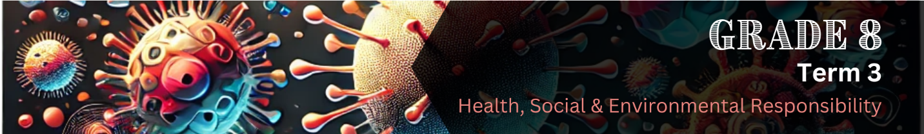

Lesson 1 – Worksheet MEMO
 | Activity 1: Brainstorm  Complete the following activity in pairs.

Use the brainstorm template below to come up with different ways you could support a friend or family member who is living with HIV.

Possible responses may include the following:
- Listen without judgment when they want to talk.
- Remind them they are not alone.
- Offer encouragement and kindness.
- Respect their privacy about their HIV status.
- Help them remember to take their medication on time.
- Go with them to doctor appointments if they want company.
- Help with tasks if they’re feeling unwell (e.g. cooking or cleaning).
- Encourage them to eat healthy food and stay active.
- Remind them to take care of their mental health.
- Share reliable health information with them.
- Defend them if others spread myths or gossip.
- Educate friends and family about the truth of HIV.
- Speak out against discrimination.
Activity 2: Informal Assessment
Complete the following activity individually.

Read the extract below and answer the questions that follow.
The consequences of the US HIV/AIDS funding withdrawal will be dire
For many years, the United States has helped countries in southern Africa, like South Africa and Botswana, fight HIV/AIDS. This support included medicine, education, and programmes to stop the virus from spreading. But recently, the U.S. government has started cutting back on this funding.

South Africa has over 7 million people living with HIV, and many rely on treatment supported by U.S. funding. Without this help, important prevention programmes may stop.

Even if funding returns later, the damage could last a long time. Other countries may try to step in and offer help, but it may not be enough. It’s important for African governments, businesses, and global organisations to work together and find new ways to continue HIV support programmes.

[Adapted from: https://bit.ly/4j23qy5 Accessed: 26 March 2025]

2.1 List TWO ways in which HIV is transmitted. (2 x 1) (2)
It is transmitted...
- via unprotected sex with an infected person. ()
- through sharing needles/syringes that have been used by someone with HIV. ()
- from mother to baby during pregnancy/childbirth/breastfeeding. ()

Any TWO of the above for ONE mark each

2.2 Mention TWO reasons why continued education about HIV prevention is important,
especially when funding is cut. (2 x 1) (2)
It...
- helps people make informed/safe choices. ()
- prevents the spread of HIV through awareness. ()
- reduces fear/stigma/misinformation around HIV. ()
- encourages regular testing/early treatment. ()
- reminds people to practise safe sex. ()
- teaches how HIV is/isn’t spread. ()
- keeps prevention efforts strong, even without money. ()
- empowers communities to support one another. ()
Any TWO of the above for ONE mark each

2.3 Suggest TWO ways in which young people can help continue HIV prevention efforts when
support programmes are no longer available due to funding cuts. (2 x 2) (4)

They can…
- create awareness groups at school/in their community, () which can help them educate others about HIV. ()
- speak openly/normalise conversations about HIV, () which can help reduce stigma/encourage people to seek help/support each other. ()
- challenge misinformation/myths/correct false beliefs about HIV, () which can help others understand how HIV is spread/how to protect themselves. ()
- encourage compassion/support for people living with HIV, () which can help people feel less afraid to speak out/ask for help. ()
- participate in youth-led initiatives/volunteer efforts like making posters/holding talks, () which can raise awareness in communities that no longer have formal programmes. ()
- use social media responsibly to share facts, () which can spread HIV prevention messages. ()
- promote healthy lifestyle choices/encourage peers to avoid substance abuse/risky behaviour, () which can help reduce chances of HIV transmission. ()
- connect with NGOs/community leaders/organisations/businesses in their area, () which may help bring HIV prevention attention/resources to their communities. ()
Any TWO of the above for TWO marks each
(i.e. ONE mark for statement and ONE mark for qualifier/explanation)
[8]

Activity 3: Reflection
Complete the following activity individually.

You’ve learned how important it is to prevent the spread of HIV and support people who are living with the virus. Now it’s your turn to help spread awareness in a creative way!

Your task:
Design a sticker that could be handed out at schools/clinics to encourage people to:
- Prevent the spread of HIV,
OR
- Get tested for HIV,
OR
- Start treatment if they have HIV.

Your sticker must include:
- A short, powerful message or slogan.
- A simple and bold design or drawing that grabs attention.
- A message that promotes hope, support, and health.
You may use colour and symbols, but keep it simple so it’s easy to understand at a glance.

Sticker Design

Learners will have personal responses to this activity.

