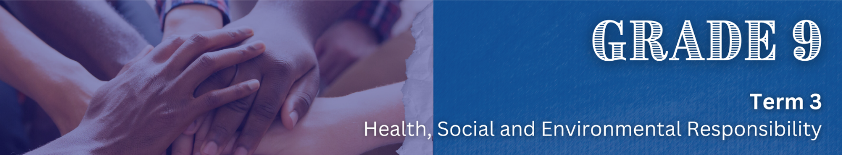
Lesson 1 – Worksheet MEMO
5. Why is VOLUNTEERISM important?

- Volunteers offer crucial support during both times of crisis and times of peace. Many nonprofits wouldn’t be able to operate without the help of volunteers.
- Volunteerism doesn’t just offer benefits to nonprofits and other community organisations but also benefits the volunteers themselves.
- Rather than receiving a financial reward, volunteers change the lives of their community members out of feelings of social responsibility and a desire to give back.
- Nonprofit organisations can provide direction for these passionate individuals with structured programmes designed to maximise impact for a specific cause.

2. Where could VOLUNTEERISM happen?
Volunteerism can happen anywhere, and volunteers can get involved in many different ways – formal or informal.

3. INFORMAL VOLUNTEERING examples…

- Helping a neighbour with household chores or errands.
- Providing childcare for a friend in need.
- Assisting an elderly person with grocery shopping.
- Picking up trash in your local park without being part of an organised group.
4. FORMAL VOLUNTEERING examples…

- Volunteering at a food bank or soup kitchen.
- Assisting at a hospital or nursing home as a registered volunteer.
- Participating in a community clean-up organised by a nonprofit group.
- Mentoring or tutoring through an established educational programme.

1. What do you understand by the term VOLUNTEERISM?

- The act of willingly offering time, skills, and services without expecting financial compensation, typically to help individuals, support a cause, or improve a community.
- It involves individuals or groups contributing their efforts to assist nonprofit organisations, social causes, or local initiatives, aiming to create a positive impact and promote social responsibility.

 | Activity 1: Concept Map  As the lesson progresses, complete the concept map below individually.

7. GROUP DISCUSSION: How could VOLUNTEERISM benefit YOU as an individual?

- Social benefits: It fosters a sense of connection to the community, helps build new friendships and networks, and enhances social and relationship skills.
- Emotional well-being: Engaging in volunteer work can help reduce stress, anger, and anxiety, leading to improved mental health.
- Personal growth: It boosts confidence, provides a sense of purpose, and allows individuals to give back to society.
- Health benefits: Volunteerism can contribute to better physical and mental well-being.
- Skill development: It offers opportunities to learn new skills and gain valuable experience that can be useful in both personal and professional life.

6. Social Benefits of VOLUNTEERISM are:

- Strengthening communities
- Community engagement
- Improves quality of life
- Raise awareness of the issues underlying the need for change
- Raise diversity, equity, and inclusion efforts in your community

Learners may have varying responses to this activity.

