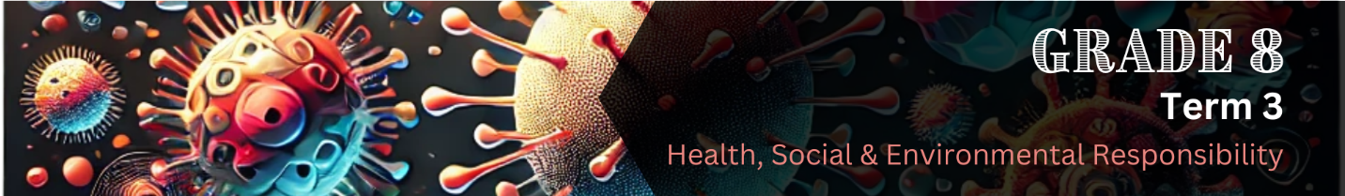

Content Summary
Lesson 1
Introduction to health and safety
What does it mean to make responsible decisions about health and safety?
Making responsible decisions about health and safety means choosing actions that protect your well-being and the well-being of others. It involves:
Precautions are actions taken to prevent harm or danger.
Empathy is the ability to understand and share someone else's feelings.
Stigma is negative judgment of someone because of a particular trait, condition, or situation.
Misinformation is false or incorrect information that is spread

- Learning accurate facts about health risks and safety measures from reliable sources.
- Thinking about how your choices affect your health, your family, and your community.
- Following safe practices to prevent illness or injury.
- Avoiding risky behaviours by saying "no" to harmful activities.
- Educating others and supporting responsible health choices in your community.
Why is it important to be informed about diseases like HIV/AIDS and COVID-19?
Being informed allows individuals to:
- Understand how diseases spread helps people take the right precautions.
- Treat those affected with empathy, reduce stigma and stop the spreading of misinformation.
- Seek medical help quickly, preventing severe illness or complications.
Understanding HIV/AIDS
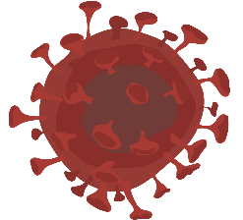
HIV (Human Immunodeficiency Virus) attacks the immune system and, if untreated, can lead to AIDS (Acquired Immunodeficiency Syndrome), a condition that severely weakens the body's ability to fight infections.
The immune system is the body's defence system that protects against infections, diseases, and harmful substances.

Prevention and safety issues related to HIV/AIDS
How HIV is transmitted
Unlike common illnesses, HIV does NOT spread through casual contact like hugging, shaking hands, or sharing food. It can not be transmitted through coughing, sneezing or mosquito bites. The virus is transmitted when certain body fluids – such as blood, semen, vaginal fluids, or breast milk – enter another person’s body.
Transmitted means passed or spread from one person to another.

HIV can be transmitted in the following ways:
- Unprotected sex with an infected person.
- Sharing needles or syringes that have been used by someone with HIV.
- From mother to baby during pregnancy, childbirth, or breastfeeding.
- Through blood transfusions, although donated blood is now carefully tested and considered very safe.

How to prevent HIV
There are several effective ways to prevent HIV infection:
Practising safe sexual choices
The only way to completely eliminate the risk of sexual transmission is through abstinence – choosing not to have sex.
For those who are sexually active, using condoms correctly every time during sexual activity is one of the best ways to reduce the risk. Condoms act as a barrier, preventing the virus from passing between partners.
It’s also important to get tested and know your HIV status before starting a new sexual relationship. Making informed and responsible choices helps protect both you and your partner.
Avoiding needle sharing
Injecting drugs is extremely dangerous – not only for your physical and mental health, but also because sharing needles can spread HIV and other serious infections like hepatitis. The safest choice is to avoid illegal drugs entirely, as they can lead to addiction, poor decision-making, and serious health risks. If you or someone you know is struggling with substance abuse, seek help from a trusted adult, counsellor, or healthcare professional.

Blood donations and hospital drips are usually very safe. Nurses and doctors use clean, new needles each time and follow strict safety rules to protect patients. This means the chance of getting HIV through a drip or blood transfusion is very low. In the past, there have been a few cases where safety rules weren’t followed, which led to infection. That’s why it’s important for health workers to always follow proper procedures.

PrEP
Pre-Exposure Prophylaxis (PrEP) is a medication for people who are HIV-negative but at high risk of infection. When taken consistently, it greatly reduces the risk of contracting HIV. This is an important preventive option, but it should always be used alongside other safe practices.
Prevention for pregnant women
Pregnant women who have HIV can receive medical treatment to prevent passing the virus to their babies. If they follow proper treatment, the risk of transmission is very low. Doctors provide medication, advice on safe delivery methods, and feeding options to ensure the baby stays HIV-free.

Managing HIV with medication
A few rare cases of people being cured have been reported, but these involved complex treatments that are not widely available. Scientists are still working on finding a universal cure. Until then, antiretroviral therapy (ART) remains the best way to manage the virus and live a long, healthy life. ART involves taking medication as prescribed by a healthcare provider to reduce the amount of HIV in the body, helping individuals stay healthy and preventing the virus from progressing to AIDS.

Antiretroviral therapy facts
- Taking HIV medication as prescribed helps keep the virus levels low and strengthens the immune system.
- Reduced virus levels after starting HIV treatment indicates that the medication is working. Continuation of treatment is essential.
- Skipping doses can allow the virus to multiply, weakening the immune system and increasing the risk of illness.
- Achieving and maintaining an undetectable viral load (viral suppression) is the best way to stay healthy and prevent transmission.
- HIV treatment prevents sexual transmission of the virus if the viral load remains undetectable (Undetectable = Untransmittable, U=U).
- Most people can achieve viral suppression within six months of starting treatment.

Caring for people living with HIV/AIDS
How to support someone living with HIV
Being diagnosed with HIV can be emotionally overwhelming. Support from friends and family can make a big difference in helping them adjust and manage their health.
 | 
Listen and offer support | Educate yourself about HIV
Let them share their feelings without judgment. Some people may need time before they are ready to talk about their diagnosis. | Learn how HIV is transmitted, treated, and managed. HIV is now a treatable, long-term condition with the right medication and care.
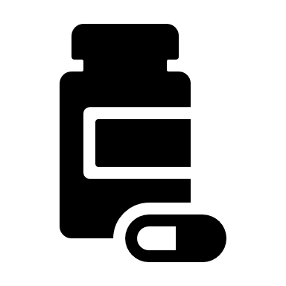 | 
Encourage treatment and adherence | Help them access healthcare
Early treatment helps people with HIV live long and healthy lives. HIV medication reduces the virus to undetectable levels, preventing transmission. | Encourage them to find a healthcare provider and start treatment as soon as possible.
 | 
Respect their privacy | Seek support for yourself
Do not share their HIV status without their consent. | Supporting someone with HIV can be emotionally challenging. Talk to a counsellor or support group if you need help processing your feelings.
Lesson 2
Understanding COVID-19
The respiratory system is the group of organs that help the body breathe.

Vulnerable individuals refer to elderly individuals, people with chronic illnesses, and those with weakened immune systems, including some people living with HIV/AIDS.

Variants are different versions of a virus that change over time.

Contagious refers to the ability of a disease to spread from one person to another through direct or indirect contact.

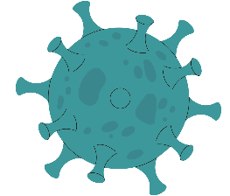
COVID-19, caused by the coronavirus, primarily affects the respiratory system and can lead to severe complications, particularly in vulnerable individuals.

While COVID-19 is no longer a global emergency, it remains a public health issue due to ongoing variants and its potential long-term effects. While vaccines, treatments, and preventive measures have helped manage its impact, responsible decision-making remains crucial in reducing the spread and protecting vulnerable populations.

Prevention and safety issues related to COVID-19
How COVID-19 is transmitted
COVID-19 is a highly contagious respiratory disease. It spreads mainly through respiratory droplets released when an infected person coughs, sneezes, talks, or breathes. These droplets can land in another person’s mouth, nose, or eyes, or on surfaces, where the virus may survive for some time. If a person touches these contaminated surfaces and then touches their face, they may become infected.

How to prevent COVID-19
Good hygiene and healthy habits are the best ways to prevent COVID-19 and many other infectious diseases. Washing hands regularly with soap and water for at least 20 seconds is one of the most effective ways to remove germs. When soap and water are unavailable, using a hand sanitiser with at least 60% alcohol can also help kill viruses.
It is also important to avoid touching the face, especially the eyes, nose, and mouth, as this is how viruses enter the body. People should also maintain a safe distance from others in crowded spaces and avoid close contact with anyone who is coughing, sneezing, or showing symptoms of illness.
Wearing a mask in public places, particularly in areas where social distancing is difficult, can reduce the risk of infection. Masks help prevent respiratory droplets from spreading and protect both the wearer and those around them.
If a person starts to feel unwell, it is important to get tested and self-isolate to avoid spreading the virus.

Managing COVID-19 with medication
A vaccine contains a tiny, harmless part of the germ or a weakened version of it. When you get a vaccine, your immune system recognises this part and remembers how to fight it. Then, if the real germ ever tries to make you sick, your immune system is ready to stop it.

An antibody is a protein produced by the immune system to recognise and neutralise viruses and bacteria.
COVID-19 remains an ongoing concern, but the situation has evolved significantly with the widespread availability of vaccines and improved public health measures. Most individuals who become ill with COVID-19 experience mild to moderate symptoms and can recover at home. These individuals are advised to rest, stay hydrated, and use over-the-counter medications to manage fever and pain.


Current treatments for COVID-19
- Antiviral medications can reduce the severity of illness, especially when administered early in the infection.
- Antibody treatments can help prevent the progression of COVID-19 in high-risk individuals.
- Anti-inflammatory drugs can reduce inflammation in severe cases, especially for patients requiring oxygen support.
- COVID-19 vaccines remain the primary tool for preventing severe illness, hospitalisation, and death. Vaccines continue to be effective against severe outcomes, especially with updated formulations targeting newer variants.

Caring for people living with COVID-19
People infected with COVID-19 may experience mild to severe symptoms. While most cases can be managed at home, some individuals, especially the elderly or those with underlying conditions, may require medical attention.

Providing Care at Home
If a family member or friend has COVID-19 but does not need to go to hospital, home care is important. It helps them rest and recover while also preventing the virus from spreading to others in the household.

Important guidelines to follow when caring for someone with COVID-19 at home
- Keep the sick person in a separate, well-ventilated room if possible.
- Ensure they rest and stay hydrated.
- Provide healthy meals and check their temperature regularly.
- Wear masks when near the sick person.
- Wash hands frequently.
- Disinfect surfaces often.
- Avoid close contact unless necessary.
- Monitor symptoms and seek medical help if they worsen.

Lesson 3: Managing HIV & COVID-19 with diet and healthy living
The importance of good nutrition
A healthy diet helps people living with HIV and protects against COVID-19 by:
- Strengthening the immune system.
- Helping the body tolerate medication.
- Maintaining a healthy weight and energy levels.
Doctors use the term "nutritional status" to describe whether someone is getting the right nutrients from their diet. For example, a person with good nutritional status may have a strong immune system, maintain a healthy weight, and have enough energy for daily activities. In contrast, someone with poor nutritional status may be underweight, frequently tired, or more vulnerable to infections.

What Are Nutrients?
Nutrients are substances that help the body function properly. They include:
 | 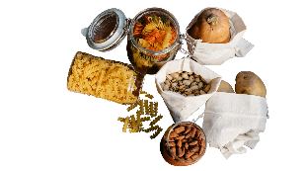 |  | 
Proteins  Builds and repairs tissues | Carbohydrates  Provides energy | Fats  Supports cell growth and hormones | Vitamins & Minerals  Boosts immunity and keeps blood healthy
Since our bodies cannot produce most nutrients, we must get them from food or supplements.
Immunity is the body's ability to resist and fight infections and diseases.
Following a healthy diet as part of treatment
A balanced diet is a key part of any treatment plan. Your diet should provide the nutrients needed to:
- Prevent weight and muscle loss
- Maintain high energy levels
- Improve the effectiveness of medications
- Minimise the side effects of drugs

The best diet for you depends on your weight, nutritional status, and health condition.

Foods to include for a strong immune system
A diet rich in vitamins and minerals supports immunity, healthy blood cells, and overall wellness. Include the following:
- Fruits: Eat a variety of colourful fruits, such as blueberries, peaches, and grapes.
- Vegetables: Vary vegetable intake, including options like cabbage, spinach, and beetroot.
- Whole Grains: Rich in fibre, examples include oats, brown rice, and whole grain bread.
- Proteins: Sources include beans, eggs, low-fat dairy, fish, poultry, and lean meat.
- Low-Fat Dairy: Choose options like low-fat cottage cheese, milk, and yoghurt.
- Fluids: Drink 8–10 glasses of water or other hydrating fluids daily.

Healthy living when managing HIV and Covid 19
In addition to eating well and taking your medication, other healthy habits can help you stay strong and manage both HIV and COVID-19 better.

Physical activity
Regular physical activity helps to keep your body strong and your mind healthy. It also helps your immune system to fight off illness. Exercise can make you feel less stressed and help you sleep better at night.
- Try to be active for at least 30 minutes most days of the week.
- Activities can include walking, dancing, skipping, or playing sports.
Good sleep habits
Getting enough sleep gives your body time to heal and recharge. People who sleep well are more likely to fight off infections.
- Try to get 7-9 hours of sleep each night.
- Go to bed and wake up at the same time each day.
- Avoid screens (like phones or TVs) just before bed to help you sleep better.
Managing stress
Too much stress can weaken your immune system and make it harder to stay healthy. It’s important to find ways to manage stress. Some healthy ways to reduce stress include:
- Talking to someone you trust.
- Deep breathing or meditation.
- Doing things you enjoy, such as reading or listening to music.

Managing HIV & COVID-19 with a positive attitude
Living with HIV, AIDS, or COVID-19 can be challenging, but having a positive attitude plays an important role in coping with these health conditions and living a full, healthy life.

What does it mean to have a positive attitude?
A positive attitude means:
- Believing that you can manage your health and live a good life.
- Staying hopeful about the future.
- Focusing on what you can do, not what you can’t.
- Reaching out for support when you need it.

This mindset does not mean ignoring challenges, it means facing them with strength and confidence.

The importance of a positive attitude in managing HIV and COVID-19

Tips for staying positive
Learn about your condition | Talk to someone you trust | Set small, achievable goals | Speak kindly to yourself | Celebrate progress
Knowledge gives you power. Understand how HIV and COVID-19 work and how they are treated. | Share your feelings with a friend, teacher, or counsellor. You don’t have to face things alone. | Focus on small steps each day, like taking your medicine, eating healthily, or exercising. | Avoid negative self-talk. Remind yourself of your strengths and progress. | Be proud of how far you’ve come, even if it’s just getting through a tough day.

Lesson 4: Coping with grief, trauma, loss and crises
The COVID-19 pandemic was a global crisis that profoundly impacted individuals and communities. It took millions of lives, disrupted daily routines, and created a sense of fear, uncertainty, and isolation. Many people experienced the loss of loved ones, economic hardship, and emotional distress, making grief and trauma widespread consequences of the pandemic. However, amidst the devastation, humanity demonstrated remarkable resilience. People adapted, supported one another, and found ways to rebuild their lives.
A pandemic is a widespread outbreak of a disease that affects multiple countries or continents.

Resilience is the ability to adapt, recover, and grow stronger after facing challenges.

Understanding grief, trauma, and crises – and learning how to cope with them – can help individuals heal and move forward after difficult experiences.

Loss and grief: how to cope
Grief is a natural response to losing someone or something important in your life. It could be the loss of a loved one, a pet, a friendship, or even a big life change. Everyone experiences grief differently, and there is no "right" way to deal with it. What’s important to remember is that you are not alone and that healing takes time.

Grief is a process, not a task
Grief isn’t something you can tick off a checklist. It’s a process that unfolds differently for everyone. Some people might go through what’s known as the five stages of grief: denial, anger, bargaining, depression, and acceptance. However, these stages don’t always happen in order, and you might not experience all of them. Grieving is more like a rollercoaster than a staircase, there are ups and downs, and that’s completely normal.

  Allow yourself to feel | It's okay to feel sad, confused, or even angry. Avoiding your emotions or pretending you're fine won't make the feelings go away. Instead, it helps to acknowledge your pain. You can do this by spending time alone, writing in a journal, or talking to someone you trust.
  Remember what brings you joy | When you’re grieving, it’s easy to forget the things that used to make you happy. But doing activities you enjoy, like listening to music, playing a sport, or spending time with friends, can help you reconnect with yourself. It’s okay to feel joy during a difficult time. Taking care of your emotional well-being is just as important as honouring your loss.
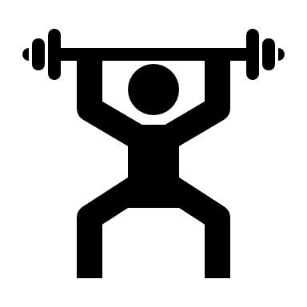  Take care of your body | Grief can affect your body as well as your mind. You might forget to eat properly, sleep enough, or take care of your hygiene. These things may seem small, but they have a big impact on how you feel. Looking after your physical health supports your emotional recovery. Try to keep up with daily routines as best you can.
  Reach out for support | You don’t have to go through grief alone. Talking to someone can make a big difference. This could be a friend, parent, teacher, or counsellor. If your feelings become overwhelming, it's okay to ask for professional help. Talking about your emotions can help you understand them better and begin to heal.

Crises and trauma: how to cope
A crisis is a sudden and often unexpected event that causes great stress and disrupts your normal life. Trauma is the emotional and mental response to experiencing a deeply upsetting or frightening event, such as a serious accident, loss, violence, or disaster. Sometimes, people who have lived through trauma may develop something called post-traumatic stress disorder (PTSD), which includes ongoing symptoms like flashbacks, nightmares, or strong emotional reactions triggered by reminders of the traumatic event.

These memories can be very vivid and may feel as if the event is happening all over again. Triggers such as certain sounds, smells, places, or even people can bring these memories back. It’s important to understand that this is a normal reaction to what you’ve been through – it doesn’t mean you are weak or broken. It means you are human.

When memories feel too painful or scary, people often try to avoid them. Some might distract themselves or use harmful substances like drugs or alcohol. Others avoid specific people or places that remind them of the trauma. While these things may feel helpful in the short term, they do not help in the long run. In fact, avoiding the memories can make them even more powerful.

Memories will come and go | Instead of pushing the memories away, it's better to learn healthy ways to cope. One useful idea is to remind yourself that the memory, like a train, will come and go. You can also carry an object or item with a comforting scent that helps you feel safe and present in the moment. These small tools can help you stay grounded and remind you that you are no longer in danger.
Take care of your body and mind | Taking care of your mental and physical health is also very important when dealing with trauma. Try to get regular sleep, eat well, exercise, and stay connected to people who care about you. Doing things you enjoy, even small things like drawing, listening to music, or being in nature, can help you feel more like yourself again.
Reach out for support | Most importantly, ask for help if you are finding things too hard to manage on your own. Reaching out is not a sign of weakness – it is a sign of strength and bravery. Talk to a trusted adult, a teacher, a doctor, or a counsellor. Help is available, and you don’t have to face trauma alone.

