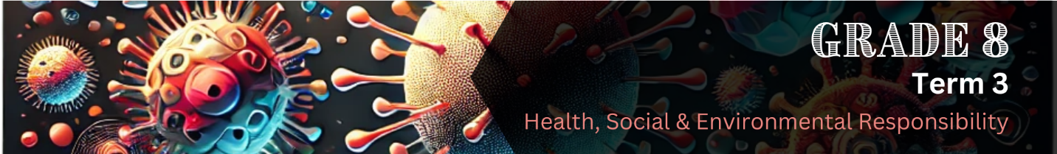

Lesson 3 – Worksheet MEMO
 | Activity 1: Essential Nutrients  Complete the following activity individually.

Watch the video (Essential Nutrients: https://bit.ly/4inyqYO) carefully. As you watch, write down keywords related to each of the six essential nutrients. These could include:
- Examples of food sources
- Functions of the nutrients
- Warnings or health tips mentioned

Don’t try to write full sentences. Focus on important words or short phrases.

Nutrient |  | Keywords/Notes
Carbohydrates |  | Energy, fruits, starchy vegetables, whole grains, avoid refined grains, added sugars, diabetes risk
Protein |  | Muscle, immune system, chemical reactions, fish, poultry, dairy, eggs, beans, legumes, nuts, soy
Fats |  | Insulate body, absorb vitamins, cell structure, hormones, unsaturated fats, nuts, seeds, olive oil, fatty fish, avocados, avoid trans fats, be mindful of saturated fats
Vitamins |  | Part of micronutrients, needed for growth, repair, immunity, metabolism, found in fruits, vegetables, e.g. vitamin C, B6
Minerals |  | Part of micronutrients, found in fruits, vegetables, fish, poultry, e.g. magnesium, potassium, iron, zinc
Water |  | Most important, hydration, body is mostly water, fluids, juice, milk, tea, coffee (caffeine may dehydrate), watery foods (melons, grapes), thirst = first sign of dehydration
Activity 2: Tips for Staying Positive
Complete the following activity in pairs.

Brainstorm practical tips for staying positive when living with or recovering from HIV or COVID-19. Think about what helps people cope emotionally, stay hopeful, and take care of themselves. Write down your ideas in the space provided below.

- Learn about your condition
- Understand how HIV and COVID-19 work and how they are treated.
- Talk to someone you trust
- Share your feelings with a friend, teacher, or counsellor.
- Set small, achievable goals
- Focus on small steps each day, like taking your medicine, eating healthily, or exercising.
- Speak kindly to yourself
- Avoid negative self-talk.
- Remind yourself of your strengths and progress.
- Celebrate progress
- Be proud of how far you’ve come, even if it’s just getting through a tough day.

Activity 3: Reflection
Complete the following activity individually.

Take a few minutes to answer the following questions.

3.1 One thing I learnt today about staying healthy while living with HIV or COVID-19 is:
__________________________________________________________________________________________________________________________________________________________________

3.2 One healthy habit I already practise is:
_________________________________________________________________________________

3.3 One new habit I want to try is:
_________________________________________________________________________________

3.4 What does a positive attitude mean to me?
__________________________________________________________________________________________________________________________________________________________________

Learners will have personal responses to this activity.

