

Lesson 3 – Group Activity
 | Activity 1: Our Environmental Health Programme  Complete the following activity in groups.

You are required to develop and implement an environmental health programme in your school. Your programme will focus on waste management.

Based on your findings from the waste audit you conducted over the last two weeks, complete the questions below.

Step 1: Define objectives and goals

1.1 List TWO objectives for your environmental health programme.
- ________________________________________________________________________________________________________________________________________________________________________________
- ________________________________________________________________________________________________________________________________________________________________________________
1.2 State TWO specific and measurable goals for your environmental health programme.
- ________________________________________________________________________________________________________________________________________________________________________________
- ________________________________________________________________________________________________________________________________________________________________________________
Step 2: Create an action plan

1.3 Write down the actions that are required to achieve your goals and objectives.
- _______________________________________________________________________________________
- _______________________________________________________________________________________
- _______________________________________________________________________________________
- _______________________________________________________________________________________
Step 3: Educate and engage

1.4 Brainstorm different ways in which you could create awareness amongst learners and staff about
your environmental health programme.

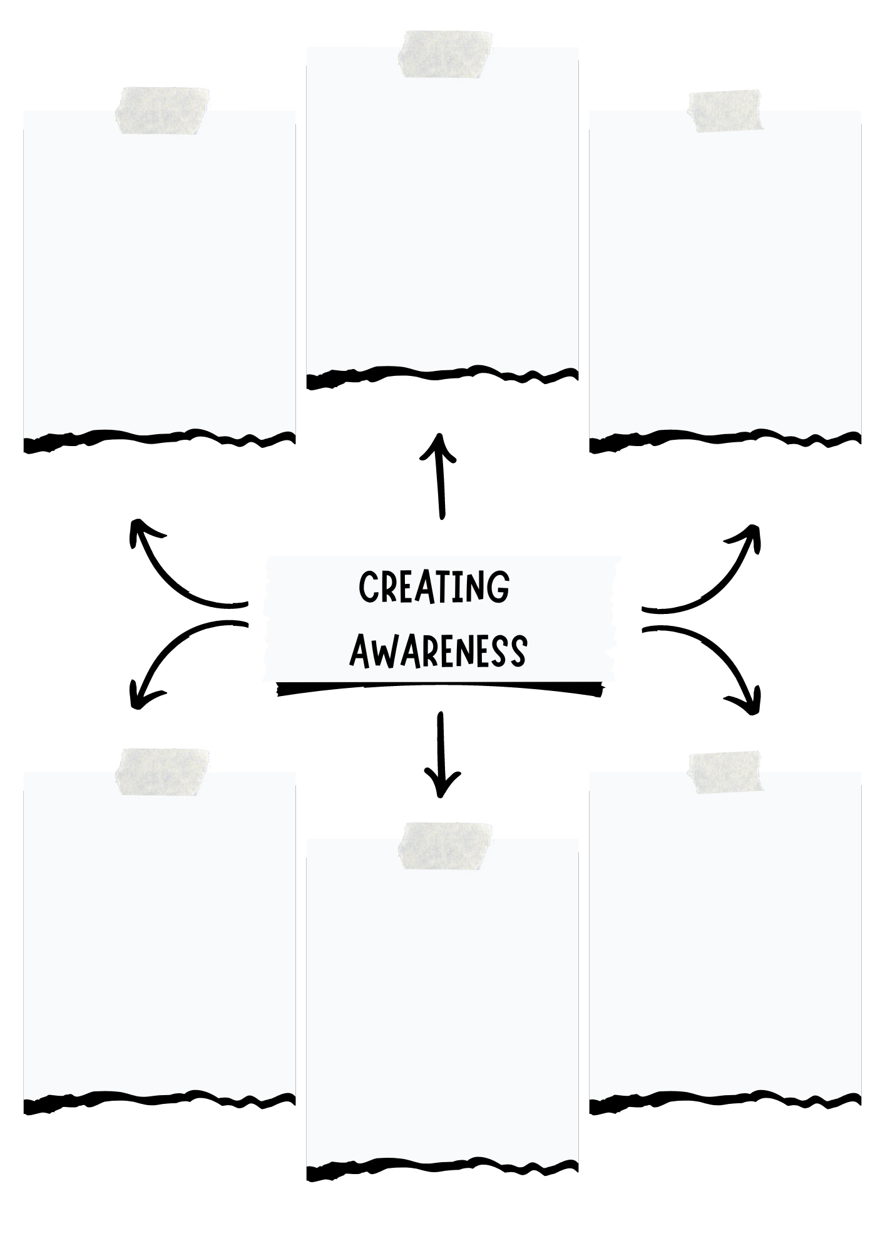
Step 4: Implement the programme (Put your action plan into practice.)

1.5. List FOUR of the tasks needed to implement the programme. Set specific dates for each task and include the resources and assistance required.

Task | Due Date | Resources Needed | Help Needed
Example:
Make posters for hallways | 12 August | Markers, paper, printer | Environmental Club members  Art Teacher for design assistance

