CAT A (2025) Extra Resources
IEB LIFE ORIENTATION COMMON ASSESSMENT TASK PART A: UBUNTU
AIMS OF THE 2025 CAT
The 2025 Common Assessment Task will explore the concept of Ubuntu. It will unpack the different aspects of the philosophy and examine how Ubuntu is a concept understood worldwide. It will also examine the positive impact of living according to the principles of Ubuntu.

The 2025 CAT will explore the following:
- An understanding of the philosophy of Ubuntu.
- An exploration of how this philosophy is expressed in different countries and across various cultures.
- How we can use the philosophy of Ubuntu to better our lives and the lives of those around us.

ADDITIONAL VIDEO LINKS
Link | Content
https://www.youtube.com/watch?v=44xbZ8MN1uk | Desmond Tutu short video
https://www.youtube.com/watch?v=SMSqZckROfA | Reverend Mpho Tutu
https://www.youtube.com/watch?v=GjVwsgL2i98 | Example of Ubuntu
https://www.youtube.com/watch?v=uo2LGGqtjqM | Desmond Tutu (forgiveness)
https://www.youtube.com/watch?v=7UojwMiRpNM | BBC short documentary

ADDITIONAL IMAGES
Image 1
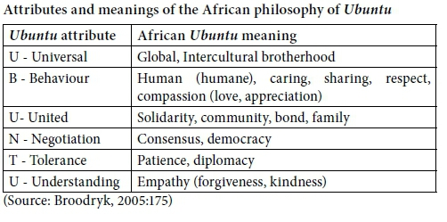

[Taken from: https://www.scielo.org.za/scielo.php?script=sci_arttext&pid=S2413-94672021000100042
Accessed: 7 March 2025]

Image 2
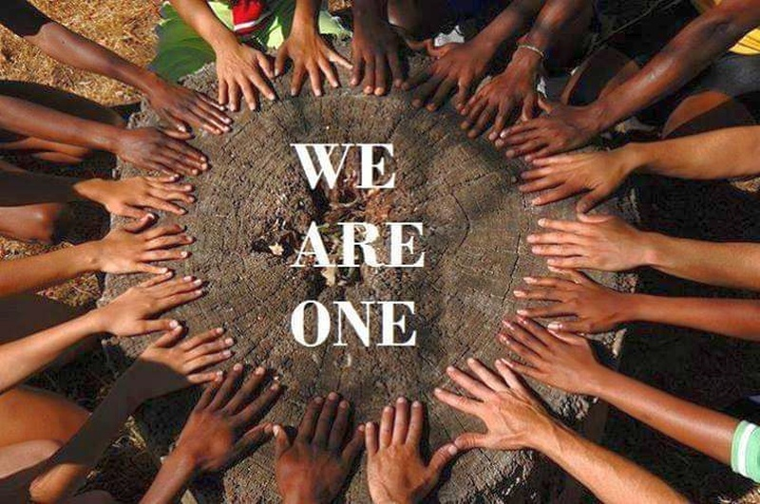

[Taken from: https://northafricapost.com/61597-googles-1bn-africa-investment-plan-is-centered-on-the-spirit-of-ubuntu.html#google_vignette
Accessed: 7 March 2025]

Image 3


[Taken from: https://www.listeningpartnership.com/insight/the-beautiful-african-philosophy-of-ubuntu-an-antidote-to-individualism/
Accessed: 7 March 2025]

Image 4


[Taken from: https://za.pinterest.com/pin/334110866083005461/
Accessed: 7 March 2025]

ADDITIONAL QUOTES
- Ubuntu really says if you want to be nice to yourself, start in a way by being nice to the other. (Desmond Tutu)
- I don't do great things. I do small things with great love. (Mother Teresa)
- Ubuntu is not a biblical concept but an ancient African one. Nevertheless, it falls back on one simple thing: that humans have been created for togetherness, and what drives us apart is greed, lust for power, and a sense of exclusion, but those are aberrations. (Allan Boesak)
- The common bond of humanity and decency that we share is stronger than any conflict, any adversity. Fighting for your convictions is important. But finding peace is paramount. Knowing when to fight and when to seek peace is wisdom. Ubuntu was right. (Wes Moore)
- Nelson Mandela explained Ubuntu as follows: A traveller through a country would stop at a village and he didn't have to ask for food or for water. Once he stops, the people give him food and entertain him. That is one aspect of Ubuntu, but it will have various aspects. Ubuntu does not mean that people should not enrich themselves. The question therefore is: Are you going to do so to enable the community around you to be able to improve? (Nelson Mandela)

ADDITIONAL ARTICLES
Link | Title | Author
https://www.learnmindpower.com/ubuntu/ | What Is Ubuntu? African Wisdom for Your Daily Life | John Kehoe
https://www.linkedin.com/pulse/ubuntu-philosophy-action-four-inspiring-examples-niam-sinno-0gggf/ | The UBUNTU Philosophy In Action: Four Inspiring Examples | Niam Sinno
https://www.listeningpartnership.com/insight/the-beautiful-african-philosophy-of-ubuntu-an-antidote-to-individualism/ | Umuntu Ngumuntu Ngabantu – I am, because you are | Unknown
https://www.globalcitizen.org/en/content/ubuntu-south-africa-together-nelson-mandela/ | What Is the Spirit of Ubuntu? How Can We Have It in Our Lives? | Hlumelo Siphe Williams

ADDITIONAL SOURCES
Source A
Ubuntu: The Philosophy of Shared Humanity

Ubuntu is a deeply rooted African philosophy that embodies the interconnectedness of humanity. Originating from Southern Africa, the term comes from the Bantu languages, often expressed as “Umuntu ngumuntu ngabantu”—meaning “a person is a person through other people.” This guiding principle emphasises community over individuality, recognising that our identities and actions are shaped by our relationships and interactions.

The Roots and Reach of Ubuntu
In contrast to Western individualism, epitomised by Descartes’ “I think, therefore I am,” Ubuntu holds that one’s humanity is defined through others. It was popularised globally by figures like Nelson Mandela and Archbishop Desmond Tutu, particularly in the context of South Africa’s Truth and Reconciliation Commission, where it played a critical role in restorative justice.

Ubuntu values compassion, mutual support, and the well-being of the collective. This moral obligation transcends superficial kindness—it’s about genuine empathy and the recognition that your humanity is tied to the humanity of others. By fostering communal harmony, Ubuntu encourages consensus-building and peaceful conflict resolution.

Ubuntu in Daily Life and Leadership
In practice, Ubuntu manifests in everyday acts of compassion and respect. Whether through sharing resources or resolving conflicts for the greater good, Ubuntu’s influence permeates all aspects of life. It extends beyond human relationships to embrace our connection with nature, urging a harmonious coexistence with the environment.

In leadership and education, Ubuntu fosters a sense of collective responsibility. Ubuntu-based education prioritises collaboration and respect, shifting the focus from individual achievement to community engagement. Leaders who embrace Ubuntu are seen as facilitators of communal success rather than individual glory.

Challenges and Global Impact
Despite its ideals, Ubuntu faces challenges in modern society. Urbanisation, globalisation, and digitisation often erode the communal bonds Ubuntu cherishes. The philosophy also faces criticism for being overly idealistic in complex human interactions, where both harmony and discord coexist. Still, Ubuntu’s influence is growing globally, particularly in discussions around social justice, ethics, and environmental stewardship.

Ubuntu offers an alternative to Western individualism by emphasising collective well-being and mutual responsibility. As climate change, inequality, and conflict continue to challenge the world, Ubuntu presents a hopeful paradigm for addressing these issues through shared responsibility and empathy.

Embracing Ubuntu for a Better Future
By embracing Ubuntu, we can cultivate a more inclusive and empathetic society. This involves building deeper connections, approaching conflicts with understanding, and recognising our roles within the larger community. From small acts of kindness to global peacebuilding efforts, Ubuntu’s call to shared humanity reminds us that “I am because we are.”

As the world faces increasing division and isolation, the principles of Ubuntu—interdependence, empathy, and communal responsibility—offer a path to a more harmonious and sustainable future.

Ubuntu is more than an African concept; it’s a universal philosophy that encourages us to view ourselves not in isolation but as part of a greater collective. As we seek to address the world’s challenges, Ubuntu serves as a timeless reminder that our strength lies in our interconnectedness. Together, we can build a future based on shared humanity and collective well-being.

[Adapted from https://thepanafrica.com/ubuntu-the-philosophy-of-shared-humanity/
Accessed: 16 March 2025]

Source B
Ethics of Artificial Intelligence

UNESCO has led the international effort to ensure that science and technology develop with strong ethical guardrails for decades.

Be it on genetic research, climate change, or scientific research, UNESCO has delivered global standards to maximise the benefits of scientific discoveries, while minimising the downside risks, ensuring they contribute to a more inclusive, sustainable, and peaceful world. It has also identified frontier challenges in areas such as the ethics of neurotechnology, on climate engineering, and the internet of things.

The rapid rise in artificial intelligence (AI) has created many opportunities globally, from facilitating healthcare diagnoses to enabling human connections through social media and creating labour efficiencies through automated tasks.

However, these rapid changes also raise profound ethical concerns. These arise from the potential that AI systems have to embed biases, contribute to climate degradation, threaten human rights and more. Such risks associated with AI have already begun to compound on top of existing inequalities, resulting in further harm to already marginalised groups.

In no other field is the ethical compass more relevant than in artificial intelligence. These general-purpose technologies are reshaping the way we work, interact, and live. The world is set to change at a pace not seen since the deployment of the printing press six centuries ago. AI technology brings major benefits in many areas, but without the ethical guardrails, it risks reproducing real-world biases and discrimination, fuelling divisions and threatening fundamental human rights and freedoms.

Recommendation on the Ethics of Artificial Intelligence
UNESCO produced the first-ever global standard on AI ethics – the ‘Recommendation on the Ethics of Artificial Intelligence’ in November 2021. This framework was adopted by all 193 Member States.
The protection of human rights and dignity is the cornerstone of the Recommendation, based on the advancement of fundamental principles such as transparency and fairness, always remembering the importance of human oversight of AI systems.

Four core values
Central to the Recommendation are four core values which lay the foundations for AI systems that work for the good of humanity, individuals, societies and the environment:

- Respect, protection and promotion of human rights, fundamental freedoms, and human dignity.
- Living in peaceful just and interconnected societies.
- Ensuring diversity and inclusiveness.
- Environment and ecosystem flourishing.

A human rights approach to AI
Ten core principles lay out a human-rights-centred approach to the ethics of AI.

- Proportionality and do no harm: The use of AI systems must not go beyond what is necessary to achieve a legitimate aim. Risk assessment should be used to prevent harm which may result from such uses.
- Safety and security: Unwanted harms (safety risks) as well as vulnerabilities to attack (security risks) should be avoided and addressed by AI actors.
- Right to privacy and data protection: Privacy must be protected and promoted throughout the AI lifecycle. Adequate data protection frameworks should also be established.
- Multi-stakeholder & adaptive governance and collaboration: International law & national sovereignty must be respected in the use of data. Additionally, the participation of diverse stakeholders is necessary for inclusive approaches to AI governance.
- Responsibility and accountability: AI systems should be auditable and traceable. There should be oversight, impact assessment, audit and due diligence mechanisms in place to avoid conflicts with human rights norms and threats to environmental well-being.
- Transparency and explainability: The ethical deployment of AI systems depends on their transparency & explainability (T&E). The level of T&E should be appropriate to the context, as there may be tensions between T&E and other principles such as privacy, safety and security.
- Human oversight and determination: Member States should ensure that AI systems do not displace ultimate human responsibility and accountability.
- Sustainability: AI technologies should be assessed against their impacts on ‘sustainability’, understood as a set of constantly evolving goals including those set out in the UN’s Sustainable Development Goals.
- Awareness and literacy: Public understanding of AI and data should be promoted through open & accessible education, civic engagement, digital skills & AI ethics training, and media and information literacy.
- Fairness and non-discrimination: AI actors should promote social justice, fairness, and non-discrimination while taking an inclusive approach to ensure AI’s benefits are accessible to all.

Actionable policies
Key policy areas make clear arenas where Member States can make strides towards responsible developments in AI. While values and principles are crucial to establishing a basis for any ethical AI framework, recent movements in AI ethics have emphasised the need to move beyond high-level principles and toward practical strategies. The Recommendation does just this by setting out eleven key areas for policy actions.

[Adapted from: https://www.unesco.org/en/artificial-intelligence/recommendation-ethics
Accessed: 16 March 2025]

