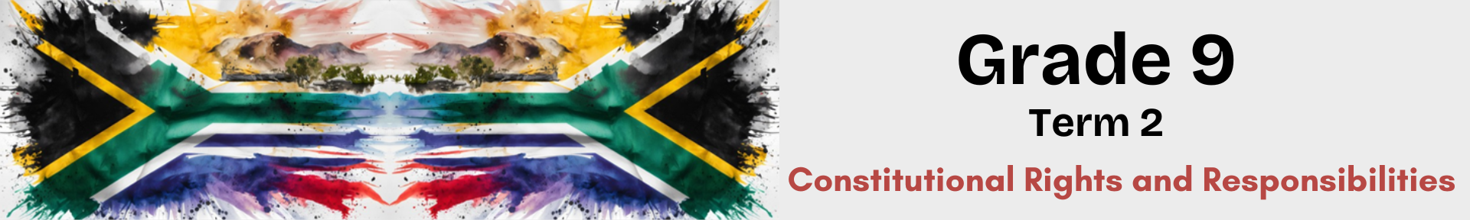
Lesson 3 – Worksheet
 | Activity 1: Matching Columns  Complete the following activity individually.

Choose a description from COLUMN B that matches an item in COLUMN A. Write only the letter (A–G) next to the question numbers (1.1 to 1.7).

Column A |  | Column B
1.1 | Human Rights Day | A. | A newly created public holiday that recognises aspects of South African culture, such as creative expression, our historical inheritance, language, the food we eat and the country we live in.
1.2 | Freedom Day | B. | The anniversary of the Soweto Uprising in 1976.
1.3 | Worker’s Day | C. | The anniversary of the Sharpeville Riots in 1961.
1.4 | Youth Day | D. | A day that marks the end of apartheid and promotes unity and healing across South Africa.
1.5 | National Women’s Day | E. | The anniversary of the first democratic elections in 1994.
1.6 | Heritage Day | F. | The anniversary of the march to Pretoria in 1952 by thousands of women who were protesting the Pass laws.
1.7 | Day of Reconciliation | G. | A national day throughout the world that celebrates workers everywhere. In America, it is known as Labour Day.

1.1 | ____ | 1.2 | ____ | 1.3 | ____ | 1.4 | ____ | 1.5 | ____ | 1.6 | ____ | 1.7 | ____

Activity 2: Categorisation of Holidays
Complete the following activity individually.

Review the list of holidays below and tick the appropriate column in the table. Categorise each holiday as either a National Day, an International Day, or a Health Day by placing a tick (✓) in the correct column.

Holiday | National Day | International Day | Health Day
African Traditional Medicine Day (31 Aug)
Christmas Day (25 Dec)
Day of Goodwill (26 Dec)
Day of Reconciliation (16 Dec)
Family Day (13 Apr)
Freedom Day (27 Apr)
Good Friday (10 Apr)
Health Lifestyle Awareness Day (17 Feb)
Heritage Day (24 Sep)
Human Rights Day (21 Mar)
Women's Day (9 Aug)
New Year's Day (1 Jan)
Worker's Day (1 May)
World Alzheimer’s Day (21 Sep)
World Braille Day (4 Jan)
World Refugee Day (20 Jun)
World Stroke Day (29 Oct)
Youth Day (16 Jun)

Activity 3: Informal Assessment
Complete the following activity individually.

Study the image below and answer the questions that follow.
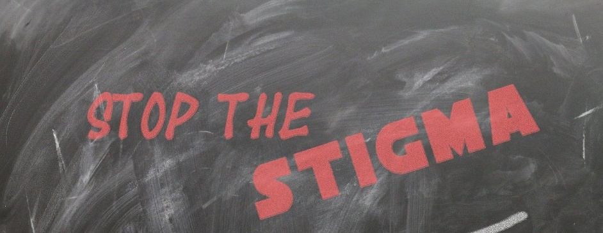

[Taken from: https://blogs.bmj.com/bmjgh/2021/08/29/stigma-related-to-covid-19/ Accessed: 6 March 2025]

Write paragraphs on HIV discrimination.

Use the following as a guideline:

- Define the term 'stigma' and provide ONE example of a stigma related to HIV. (1 + 1) (2)
____________________________________________________________________________________________________________________________________________________________________________________________________________________________________________________________________________________________________________________________________

- Explain TWO reasons why HIV discrimination can have dangerous health impacts. (2 x 2) (4)
____________________________________________________________________________________________________________________________________________________________________________________________________________________________________________________________________________________________________________________________________
_________________________________________________________________________________
_________________________________________________________________________________

- Recommend TWO ways in which learners can challenge stigmas that relate to HIV
discrimination. (2 x 2) (4)
____________________________________________________________________________________________________________________________________________________________________________________________________________________________________________________________________________________________________________________________________
_________________________________________________________________________________
_________________________________________________________________________________

[10]
Activity 4: Reflection
Complete the following activity individually.

4.1 Read the extract below from an article about the very first Nelson Mandela Day and answer the questions that follow. This article by Sashni Pather, Dominic Mahlangu and Gabisili Ndebele appeared in The Times on Friday 17 July 2009.

Madiba rests while the world works
While the world marks the first Nelson Mandela Day, the former president will be resting at home. Tomorrow, July 18, marks Mandela’s 91st birthday.
People around the globe are encouraged – and many have already pledged – to spend 67 minutes of their time doing community work. The initiative was created by the 46664 campaign and the Nelson Mandela Foundation.
Ruth Rensburg, Resource Development Manager of the Nelson Mandela Foundation, said that Mandela was ‘honoured’ by the worldwide initiatives. “But he will be spending the day, as he has in recent years, at home surrounded by friends, family and comrades,” she said.
In a recorded interview, Madiba said: “It is in your hands to create a better world for all who live in it. Mandela Day will not be a holiday, but a day created to service.”

4.1.1 What is your opinion of how Mandela Day is to be celebrated?

4.1.2 How would you spend your 67 minutes celebrating Mandela Day?

4.2 Answer these reflections as best you can.
What I learnt about in these lessons:

The most important thing I learnt about my country was…

How I feel I have performed in these lessons:

What can I do better next time?
Questions I still have:

