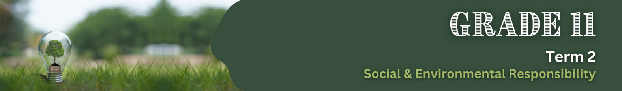

Lesson 2 – Worksheet MEMO
 | Activity 1: Brainstorming  Complete the following activity in groups.

In this activity, you will work in groups to brainstorm and identify preventive actions that can help reduce the negative impacts of environmental factors on health. Consider the following issues:
- Harmful substances in food production
- Inhumane farming practices
- Pollution
- Fires and floods

For each of the environmental factors listed above, come up with at least two actions we can take to prevent or reduce the negative effects on health and the environment. Think about practical steps we can adopt in our daily lives or encourage others to take.

Write down your group’s ideas in the table below.

Model Answers

Environmental Factor | Preventive Actions
Harmful Substances in Food Production | - Supporting organic or locally grown produce that uses fewer harmful chemicals.  - Washing fruits and vegetables thoroughly to reduce pesticide residues.  - Reading food labels to avoid products with artificial additives.  - Advocating for reduced use of pesticides and sustainable farming practices in the community.
Inhumane Farming Practices | - Choosing products from sustainable and humane farming practices.  - Reducing overconsumption of meat to lower demand for factory farming.  - Supporting reforestation projects and sustainable land management.  - Educating others about the environmental and societal impacts of inhumane farming methods.
Pollution | - Avoiding littering and properly disposing of waste.  - Reducing single-use plastics and promoting recycling.  - Using environmentally friendly products, like biodegradable cleaning supplies.  - Supporting laws and policies that regulate industrial pollution.
Fires and Floods | - Avoiding actions that can cause fires, such as careless disposal of cigarette butts or leaving open flames unattended.  - Educating communities about the importance of maintaining fire breaks and planting fire-resistant vegetation.  - Supporting conservation efforts to restore wetlands and forests, which act as natural buffers against floods.  - Developing family or community disaster response plans to reduce harm during emergencies.

Activity 2: Reflection
Complete the following activity individually.

Imagine it’s 2:00 AM, and your family is woken up by either a fire in your home or floodwaters rising outside. You have 5 minutes to get your family safe. What’s your plan?

2.1 Develop a quick, effective emergency plan tailored to your home. Include:
- The safest exit points depending on whether it’s a fire or a flood.
_________________________________________________________________________________
_________________________________________________________________________________

- A meeting spot outside where everyone will regroup (e.g., a neighbour’s house, a landmark).
_________________________________________________________________________________
_________________________________________________________________________________

- Critical items to grab, such as emergency kits, phones, or essential documents.
_________________________________________________________________________________
_________________________________________________________________________________
2.2 Every second matters in an emergency. Decide who will take on these critical roles:

2.2.1 Who will help younger or elderly family members? __________________________
2.2.2 Who will call for help? ________________________
2.2.3 Who will grab the first aid kit? ______________________

2.3 Homework: Go home and discuss the emergency plan you created in class with your family. Work together to:
  - Identify any improvements or changes needed based on your family’s needs.
  - Agree on safe exits, a meeting spot, and roles for each family member during an emergency.

Learners will have personal responses to this activity.

