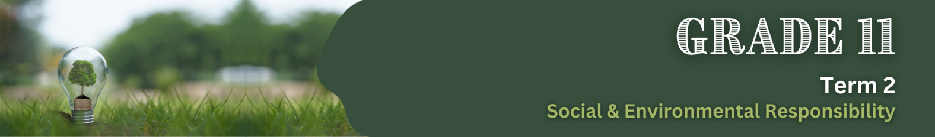

Lesson 1 – Worksheet MEMO
 | Activity 1: Reflection  Complete the following activity individually.

In the space provided below, write a short journal entry (about 4-5 sentences) in response to the following:

After today’s lesson, what thing(s) will you do differently in your life to help reduce the impact of inhumane farming practices and food production methods?

The entry should include:
- A brief reflection on what you learned.
- Specific action(s) you can take or change(s) you can make based on the lesson.


Learners will have personal responses to this activity.

