

Content Summary

Lesson 1: Environmental issues that cause ill-health

The use of harmful substances in food production
Food production processes involve the use of chemicals like pesticides, herbicides, antibiotics, and additives. While these substances help protect crops, keep livestock healthy, and extend the shelf life of processed foods, they can also negatively impact our health and the environment.
Pesticides are chemicals used to kill or control pests, such as insects, rodents, or fungi.

Herbicides are chemicals designed to kill or inhibit the growth of unwanted plants (weeds).

Biodiversity refers to the variety of life in a particular habitat, ecosystem or the entire planet.

Herbicides and Pesticides
Farmers use herbicides and pesticides to improve crop quality and provide the best produce to markets. However, when we consume fruits, vegetables, or grains exposed to these chemicals, we ingest the residues. Over time, these residues can accumulate in our bodies and potentially lead to health problems, such as cancer, hormonal disruptions, or neurological damage. That is why it is important to wash fruits and vegetables thoroughly with clean water before eating them.

These chemicals can also negatively impact the environment. As shown in the illustration below, these chemicals can seep into the soil or be washed away by rain into nearby water sources, leading to environmental contamination. This can harm wildlife and disrupt habitats, resulting in a loss of biodiversity. Species such as birds, bees, bats, and earthworms, which are crucial for pollination and maintaining healthy crop environments, can be particularly affected.
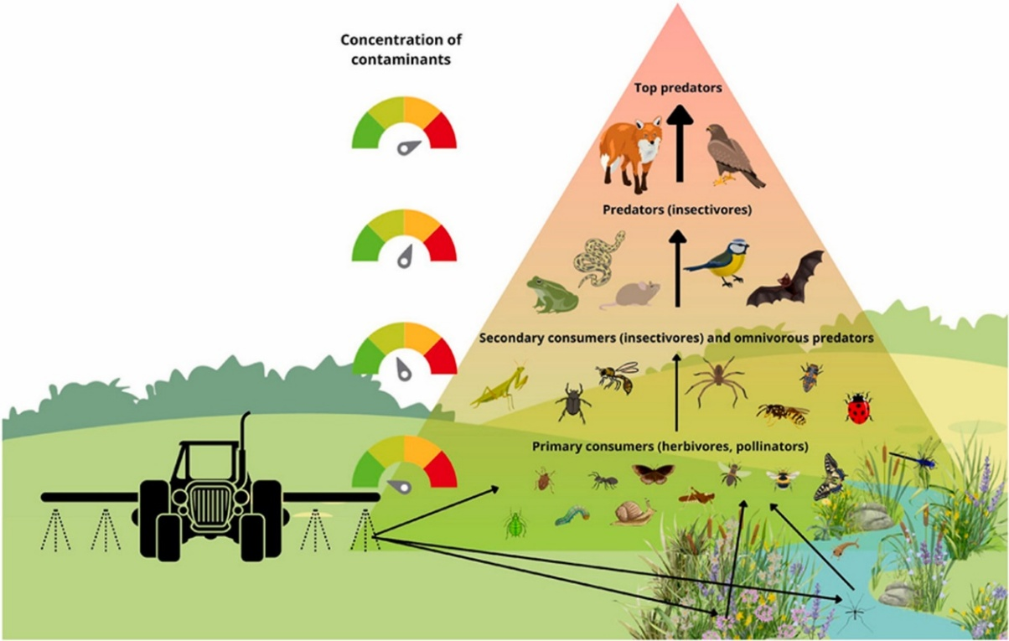
[Taken from https://www.sciencedirect.com/science/article/pii/S0045653524009299
Accessed on 23 January 2025]

Antibiotics
Antibiotics are drugs used to treat or prevent infections in animals, particularly in factory farming, where animals are often kept in overcrowded conditions. While this may seem like a good practice to ensure healthy food, antibiotics are sometimes added to livestock feed or water to prevent disease even when the animals aren’t sick.

When humans consume meat, milk, or eggs from animals treated with antibiotics, they can ingest small amounts of these drugs, which can contribute to antibiotic resistance, making it more difficult to treat infections when they occur. Some studies show that some antibiotic residues can even increase the risk of cancer.

Additives
Food production companies often use additives like preservatives and artificial colouring. additives are used to enhance taste, appearance, or shelf life. However, they can also have negative health effects, for example:
- Artificial colours have been linked to hyperactivity and allergies.
- Artificial sweeteners can contribute to weight gain and metabolic issues.
- Trans fats increase the risk of heart disease.
- Sodium nitrate, found in processed meats, has been linked to cancer.
Many of our favourite foods contain these additives, for example:
- Potato crisps contain flavour enhancers, artificial colour, artificial flavourings and preservatives.
- Frozen pizza includes preservatives and trans fats.
- Sausages and ham contain sodium nitrate and preservatives.
- Soft drinks often include artificial colours, sweeteners, and high-fructose corn syrup.
- Cookies contain artificial colours and sweeteners.
Although this might sound alarming, we don’t need to stop eating all foods that contain additives. The key is to consume them in moderation and avoid them when possible. The first step in doing this is learning to recognise these additives in food products. Make it a habit to read ingredient lists on food packaging and research any ingredients you’re unsure about.

Tips to avoid harmful additives
- Buy fresh fruits, vegetables, and unprocessed meats instead of packaged or processed foods.
- Prepare meals from scratch to control the ingredients used.
- Limit consumption of fast food.
- Drink water or natural beverages instead of sodas or artificially flavoured drinks.
- Replace chips, candy, and other processed snacks with natural alternatives like popcorn (without artificial flavouring), nuts, seeds, or dried fruit.
- Look for products with natural preservatives or sweeteners like honey or stevia.
Impact of inhumane farming methods on society and the environment
Inhumane farming methods are agricultural practices that prioritise profit over the well-being of animals, the environment, and society. These practices can harm ecosystems, degrade natural resources, and raise ethical concerns about animal welfare. Inhumane farming methods include factory farming, deforestation for agriculture and overgrazing.

Factory farming
Factory farming, also known as intensive animal farming, involves confining large numbers of animals in small spaces to maximise production. This often results in poor animal welfare, as the animals are overcrowded and have limited movement. Additionally, factory farming contributes to environmental pollution, with animal waste contaminating water sources and emitting greenhouse gases.

Deforestation for agriculture
Soil erosion is the process where the top layer of soil is removed and transported by natural forces or human activities. This leads to land degradation, making the soil less fertile and reducing its ability to support plant growth.
Deforestation for agriculture includes clearing forests to create farmland or pastures. This has significant environmental impacts, including:
- Loss of biodiversity and habitats for wildlife.
- Increased carbon emissions (through burning trees and vegetation, and machinery use) contributing to climate change.
- Soil erosion due to the loss of tree cover.

Overgrazing
Overgrazing occurs when livestock graze excessively on land without allowing vegetation time to recover. This can lead to:
- Loss of vegetation, which may contribute to desertification.
- Soil erosion and decreased soil fertility, making the land less productive.
- Reduced plant species diversity, disrupting ecosystems and food sources for wildlife.
Economic and social impact of inhumane farming methods
- Large industrial farms dominate the market, making it difficult for small farmers to compete, often forcing them out of business or into unfair contracts with big corporations.
- Land degradation, water overuse, and soil erosion reduce food production, leading to higher food prices and making it harder for low-income communities to access affordable, nutritious food.
- Workers in factory farms and industrial agriculture often face low wages, unsafe conditions, and exposure to harmful chemicals, with vulnerable groups like migrants and children being the most exploited.
- Large-scale deforestation for farming displaces indigenous communities and destroys traditional farming practices, reducing biodiversity and food self-sufficiency.

Impact of environmental hazards
Environmental hazards are natural or human-induced events that pose risks to ecosystems and human health. The table below summarises the environmental and human health impacts of soil erosion, pollution, floods, fires and radiation.
Environmental Hazard | Impact on the environment | Impact on humans
Soil erosion | - Soil erosion reduces plant growth and crop yields, leading to decreased agricultural productivity.  - Sediment buildup in rivers and dams affects water quality and aquatic life.  - Erosion can destroy habitats for plants and animals, reducing biodiversity. | - Reduced agricultural productivity can lead to food shortages and malnutrition.  - Sediment and pollutants can enter drinking water sources and cause diseases to spread.  - Increased risk of flooding can cause physical harm to individuals.
Pollution | - Harmful pollutants disrupt natural habitats and endanger wildlife.  - Harmful substances deposited on plants hinder photosynthesis and growth.  - The emission of greenhouse gases leads to extreme weather patterns. | - Inhalation of pollutants can cause asthma, bronchitis, and other respiratory issues.  - Polluted water sources can spread waterborne diseases.  - Limited access to clean air, water, and soil affects overall well-being.
Floods | - Floodwaters can destroy habitats crucial for plants and animals.  - Rapid water flow erodes soil, reducing agricultural productivity.  - Pollutants carried by floodwaters degrade water quality and contribute to disease outbreaks. | - Drowning and injuries from debris are common during floods.  - Damage to homes displaces communities, causing stress and emotional distress.  - Loss of property and livelihood can cause long-term psychological effects.
Fires | - Fires destroy habitats essential for plants and animals, reducing biodiversity.  - Loss of vegetation leads to soil instability and increased erosion.  - Large amounts of carbon dioxide released during fires intensify global warming. | - Direct contact with flames can cause severe burns and physical injuries.  - Smoke inhalation leads to breathing difficulties and other respiratory issues.  - Loss of homes and belongings causes significant emotional distress and stress.
Radiation | - Toxic substances from radiation pollute essential resources.  - Exposure to radiation harms plants and animals, disrupting ecological balance. | - Inhalation of radioactive dust causes severe breathing issues.  - Exposure increases the risk of chronic diseases, including cerebral palsy in children, cancer, birth defects and neurological damage.

Lesson 2: Environmental issues that cause ill-health
Impact of depletion of resources: Fish, Firewood and Land
Resource depletion refers to the overuse or destruction of natural resources faster than they can be replenished.

Depletion of fish stocks
Depletion of fish stocks, also known as overfishing, leads to a decline in fish populations. The consequences of overfishing are far-reaching:
- Overfishing reduces biodiversity and threatens the overall health of the ocean. Many marine species rely on each other for food and ecological balance, and when fish populations dwindle, entire ecosystems can collapse.
- Coastal communities often depend on fish as a primary source of protein. Overfishing can threaten food security, leading to malnutrition and hunger in areas where fish are a staple food.
- As fish stocks decline, fishing communities face job losses and financial instability, since fewer fish means less income from fishing.
Depletion of firewood
In South Africa, many people rely on firewood for cooking and heating. When trees are cut down faster than they can regrow, this is known as deforestation which can lead to the depletion of firewood. Deforestation has numerous negative consequences for environmental health, including:
- Loss of habitats for many animal species, leading to a decline in wildlife populations.
- Increased erosion due to the absence of tree roots to hold soil in place, which reduces soil fertility and results in poor agricultural yields.
- Release of stored carbon, as trees absorb carbon dioxide. When trees are cut down, this carbon is released into the atmosphere, contributing to increased greenhouse gas emissions and global warming.
Consequences of Firewood Shortages
Without access to firewood, people may face several challenges:
- Without firewood, people may have to turn to other, often more expensive, energy sources like gas or electricity for cooking and heating, which can strain household budgets.
- In areas where firewood is the primary cooking fuel, the lack of it could lead to the use of unsafe alternatives, such as plastic or other materials that release toxic fumes when burned, increasing the risk of respiratory diseases.
- Many communities depend on gathering and selling firewood for income. Without access to firewood, people may lose their livelihoods, affecting their financial stability.

Depletion of land
Depletion of land, also known as land degradation or desertification, is caused by the overuse of land for farming, urban expansion, and industrial activities. This can lead to:
- Reduced agricultural productivity, which threatens food security.
- Increased risk of natural disasters, as deforested and overgrazed lands are more prone to floods, landslides, and droughts.
- Water scarcity, since degraded land retains less water, reducing groundwater recharge and causing water shortages.
- Loss of livelihoods, as farmers and rural communities dependent on fertile land struggle to grow food and earn a living.
Dealing with environmental effects on health: Floods, Fires, and Pollution
While environmental hazards such as floods, fires, and pollution may seem overwhelming, adopting a proactive and positive mindset can significantly improve our ability to respond effectively. By reframing our thoughts, we can take actions that help protect both our health and the environment.

A positive attitude towards environmental issues
People often express frustration with statements like, “There’s nothing we can do about it,” or “The problem is too big for us to make a difference.” However, adopting a more positive and proactive perspective can lead to meaningful changes:

- Harmful substances in food production: Instead of feeling powerless, we can actively choose healthier, safer, and environmentally friendly food options. By supporting sustainable food production methods, we can reduce the harm caused by harmful chemicals and practices.
- Pollution: Rather than succumbing to the belief that pollution is too widespread to tackle, we can embrace the idea that reducing pollution is everyone’s responsibility. Small, individual actions, like reducing waste or conserving energy, can collectively make a significant impact on the environment.

Coping with floods: Preparedness, Safety and Recovery
The following coping techniques are specifically designed for floods. However, it's important to remember that they can also be applied to other types of disasters, such as fires, as they share similar safety and recovery considerations.

Phase 1: Preparedness and Prevention (Pre-Flood)
Before a flood occurs, there are several strategies we can adopt to stay safe and minimise harm:

Phase 2: Safety and Survival (During the Flood)
During the flood, safety is paramount. These steps can help ensure that you and your family remain safe:

First Aid Skills for Fires
In the event of a flood or fire, knowing basic first aid can save lives. First aid refers to the immediate care or treatment given to someone who is injured or ill before professional medical help arrives. The goal is to preserve life, prevent further harm, and promote recovery.

Treating Burns
- Cool the Burn: Immediately cool the affected area under cool running water for at least 10 minutes to reduce pain and prevent further skin damage.
- Cover the Burn: After cooling, loosely cover the burn with a sterile, non-stick dressing or clean cloth to protect it from infection.
- Seek Medical Attention: For severe burns, such as those that are deep, larger than the victim's palm, or located on sensitive areas like the face, hands, or genitals, seek professional medical help promptly.
Treating Smoke Inhalation
- Move to Fresh Air: Immediately relocate the individual to an area with clean air, away from the source of smoke, to prevent further inhalation of harmful substances.
- Assess Breathing: Check if the person is breathing adequately. Look for signs of respiratory distress, such as difficulty breathing, coughing, or soot around the mouth and nose.
- Call Emergency Services: If the individual shows signs of significant smoke inhalation or respiratory distress, call emergency services promptly.
- Monitor and Support: While waiting for emergency responders, monitor the person's vital signs. If they are conscious and alert, encourage them to take slow, deep breaths. If trained and necessary, be prepared to administer CPR.
First Aid Kit List
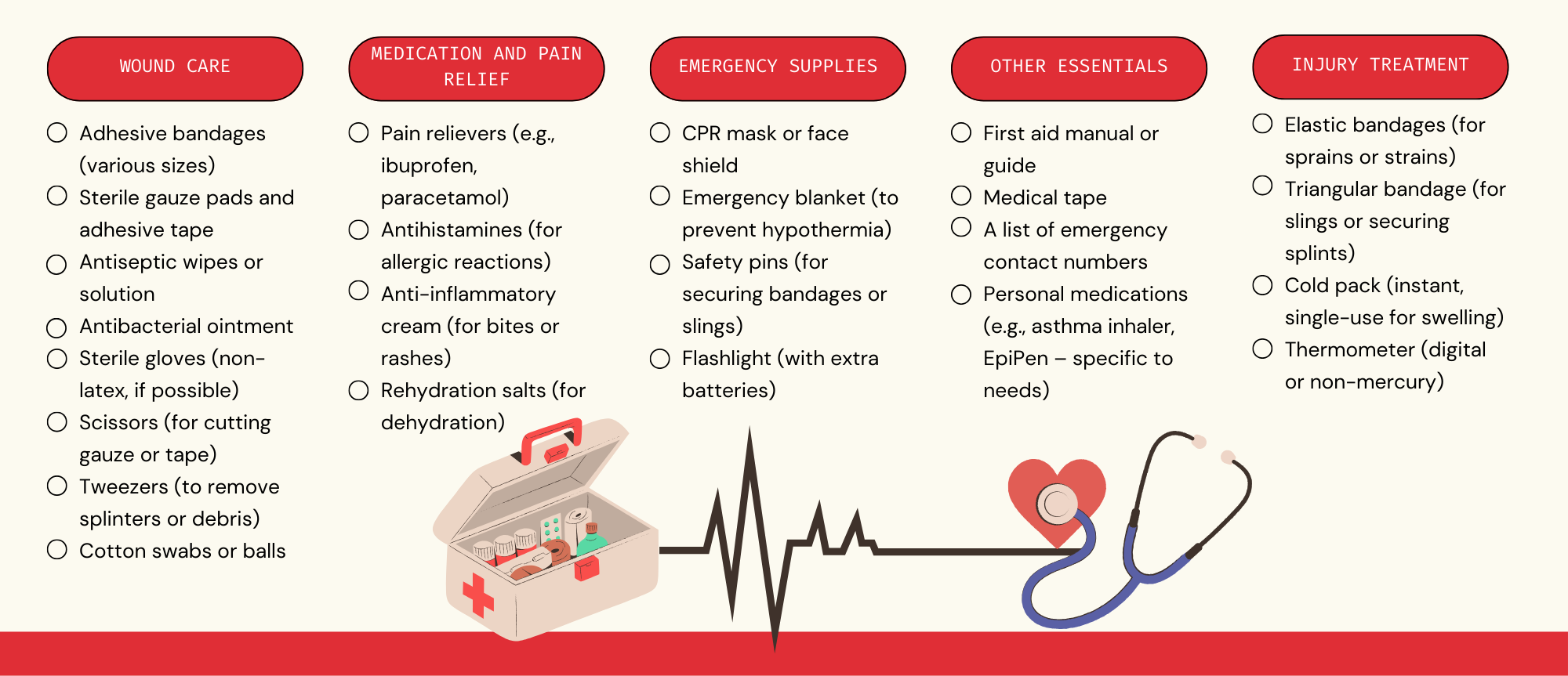

Phase 3: Recovery and Resilience (Post-Flood)
After a flood, the recovery phase involves rebuilding safely and ensuring long-term resilience:

By adopting these preparedness, safety, and recovery strategies, we can better cope with floods, fires, and other environmental hazards while minimising their impact on our health and the environment.

Lesson 3: Climate Change: Causes, Impacts, and Solutions
Climate change is one of the most pressing environmental challenges of our time. It involves long-term shifts in temperature, weather patterns, and atmospheric conditions on Earth. These changes can occur naturally, such as through volcanic eruptions or variations in solar radiation. However, in recent decades, human activities have been the primary drivers of climate change, leading to significant global impacts.

Human activities that cause Climate Change
Increased greenhouse gas emissions significantly accelerate climate change.
Greenhouse Gases and the Greenhouse Effect
Greenhouse gases are gases in the atmosphere that trap heat from the sun. Some of the most common ones are carbon dioxide (CO₂), methane (CH₄), and nitrous oxide (N₂O). Think of these gases like smoke rising from a chimney. You can’t always see it, but it builds up in the atmosphere, acting like a thick blanket around the Earth.
These gases are naturally present in the atmosphere and are important for keeping our planet warm enough to support life. Without them, Earth would be too cold for us to survive. The problem isn’t that we have greenhouse gases – it’s that human activities are adding too many of them to the atmosphere. The more greenhouse gases we add, the thicker the 'blanket' around the Earth becomes. This traps more heat and makes the planet warmer than it should be. This process is known as global warming and is a major driver of climate change.

The primary contributors include:
Burning of Fossil Fuels
Fossil fuels such as coal, oil, and natural gas are burned for energy in transportation, electricity generation, and industrial processes. This releases carbon dioxide (CO₂).Examples of daily activities contributing to CO₂ emissions:
- Using petrol or diesel-powered vehicles.
- Air travel for holidays, business, or family visits.
- Electricity consumption from coal or gas power plants.
- Using gas heaters, grills, or fireplaces.
- Manufacturing goods in factories powered by fossil fuels.
- Agricultural machinery operating on diesel or petrol.
- Transportation of goods using trucks, ships, and aeroplanes.
Deforestation
Trees naturally absorb carbon dioxide through photosynthesis, playing a crucial role in regulating atmospheric CO₂ levels. When trees are cut down, not only is this carbon-absorbing capacity lost, but the stored carbon is also released back into the atmosphere, intensifying the greenhouse effect.

Industrial Processes
Industrial activities, including cement production, chemical manufacturing, and plastic production, emit significant greenhouse gases. While these processes are essential for modern life, they contribute to global warming by releasing CO₂, methane (CH₄), and other pollutants.

Livestock Farming
Livestock farming, particularly of ruminant animals like cows, sheep, and goats, is a major source of methane emissions. These animals have a unique digestive system that produces methane as a byproduct of fermentation in their stomachs. Methane is released into the atmosphere primarily through belching, contributing significantly to global warming due to its high heat-trapping potential.

Impacts of Climate Change
Climate change has widespread effects on ecosystems, oceans, human health, and weather patterns.
Ecosystems
Global warming leads to shifts in ecosystems due to rising temperatures, which can cause species to migrate or face extinction. Warmer temperatures can also disrupt the timing of natural processes, such as flowering or migration, which affects food availability and survival. Species that are adapted to specific climates or environments, like polar bears in the Arctic, are particularly vulnerable. Global warming can melt ice habitats, leading to the loss of biodiversity.

Oceans
- Global warming contributes to the warming of ocean waters, which affects marine life. Warmer oceans can lead to coral bleaching, where corals expel the algae that live in symbiosis with them, leading to coral death. This disrupts entire marine ecosystems.
- The rise in ocean temperatures also contributes to sea level rise through thermal expansion and melting ice, threatening coastal communities and ecosystems.
Human Health
- Global warming increases the frequency of heat waves, leading to more heat-related illnesses such as heatstroke and dehydration.
- Respiratory issues are exacerbated by the increase in air pollution, which is worsened by higher temperatures. Wildfires, which are more likely to occur due to heat and drought, also contribute to poor air quality.
- The spread of diseases like malaria and dengue fever may increase as warmer temperatures expand the range of mosquitoes and other disease vectors.
Weather Patterns
- Global warming intensifies extreme weather events, including heatwaves, droughts, and wildfires.
- Hurricanes and typhoons become more severe due to warmer ocean waters.
- Altered rainfall patterns lead to heavier rainfall and flooding, while prolonged dry spells contribute to droughts.
Mitigation and Adaptation Strategies
Mitigation involves actions aimed at reducing or preventing the release of greenhouse gases to slow down climate change. Key strategies include:
- Replacing fossil fuels with renewable energy sources such as solar, wind, and hydropower.
- Using energy-efficient appliances, LED lighting, and improved insulation to reduce energy consumption.
- Planting trees to absorb carbon dioxide from the atmosphere through photosynthesis.
- Encouraging the use of public transportation, cycling, and walking to reduce emissions from personal vehicles.
- Supporting carpooling, ride-sharing, and other low-emission transportation alternatives.
- Promoting electric vehicles (EVs) and investing in EV infrastructure to minimise reliance on fossil fuels.
- Reducing waste by promoting the use of reusable products and minimising single-use plastics.
- Supporting sustainable packaging solutions and reducing food waste.

Adaptation strategies involve making adjustments to social, economic, and environmental systems to reduce vulnerability and enhance resilience to climate change impacts. These strategies include:
- Constructing climate-resilient buildings and infrastructure to withstand extreme weather events.
- Implementing flood barriers, stormwater management systems, and improved drainage networks.
- Promoting efficient water use and storage systems to cope with changing rainfall patterns.
- Developing drought-resistant and climate-resilient crops to ensure food security.
- Implementing sustainable agricultural practices to reduce environmental impact and increase resilience.
- Protecting and restoring natural habitats to maintain biodiversity and ecosystem services.
Climate change is a complex and urgent global issue that requires immediate action through both mitigation and adaptation strategies. By reducing greenhouse gas emissions and adjusting to their impacts, we can protect ecosystems, human health, and future generations. Understanding the causes and consequences of climate change is the first step toward developing effective solutions and promoting sustainable living.

Lesson 4: Responsible citizenship and community service
Environmental issues are not just about nature – they directly impact human health and well-being. Pollution, deforestation, climate change, and resource depletion affect the air we breathe, the water we drink, and the food we eat. As responsible citizens, we have the power to help solve these problems through community service and social activism.

Contemporary environmental issues
Contemporary environmental issues are current and ongoing challenges that threaten both the environment and human health. These include:
- Soil erosion: Often caused by inhumane farming practices and deforestation, leading to loss of fertile land and increased risk of landslides.
- Pollution: Poor waste management practices result in air, water, and soil pollution, which can cause respiratory problems, waterborne diseases, and food contamination.
- Radiation exposure: Mining activities can release harmful radiation, affecting nearby communities' health.
- Global Warming and Climate Change: Resulting in natural disasters such as wildfires, floods, and droughts that displace communities and impact food security.
- Depletion of resources: Overfishing, deforestation, and excessive land use threaten the availability of essential resources like food, water, and shelter.

These issues are not isolated – they are interconnected and continuously evolving, affecting both urban and rural communities.

Environmental Injustice
Environmental issues do not affect everyone equally. Certain groups suffer more due to their socio-economic status, geographical location, or health conditions. This is known as environmental injustice. It is crucial to understand these disparities to address environmental injustice effectively.

Low-Income neighbourhoods | Rural Communities | Children and the Elderly
These communities are often located near industrial zones or waste disposal sites, exposing residents to polluted air and contaminated water. They also have limited access to healthcare and resources to cope with environmental hazards. | People living in rural areas are more vulnerable to water shortages, soil degradation, and extreme weather events like floods and droughts, impacting their agricultural livelihoods. | These groups are more susceptible to the health impacts of pollution, such as respiratory issues and waterborne diseases, due to their weaker immune systems and limited mobility.

Responsible citizenship: Taking action through community service
Responsible citizenship involves recognizing societal issues and taking proactive steps to solve them. Community service is a powerful tool for positive change, allowing individuals and groups to address contemporary environmental issues while promoting social equity. It is an opportunity to engage, educate, and empower communities to create sustainable solutions.

Community service can take many forms, including:
- Organising clean-up drives: Cleaning local parks, rivers, or neighbourhoods to reduce pollution and promote public health.
- Tree planting campaigns: Reforestation projects that improve air quality, reduce soil erosion, and provide shade and shelter.
- Recycling programmes: Establishing recycling initiatives in schools or communities to minimise waste and conserve natural resources.
- Educational workshops: Teaching communities about sustainable practices like water conservation, energy efficiency, and proper waste disposal.

How to get involved: Practical steps for learners
- Research environmental challenges in your community and understand how they affect different groups.
- Decide whether you want to organise, volunteer, educate, or advocate.
- Partner with local organisations, community leaders, and schools to maximise your impact.
- Use social media to spread awareness and encourage community participation.
- Learn from your experiences and continuously seek ways to improve and expand your initiatives.

