

Lesson 4 – Worksheet
 | Activity 1: Community Issue Investigation  Complete the following activity in groups.

1.1 Brainstorm environmental issues you can think of in your community or city.

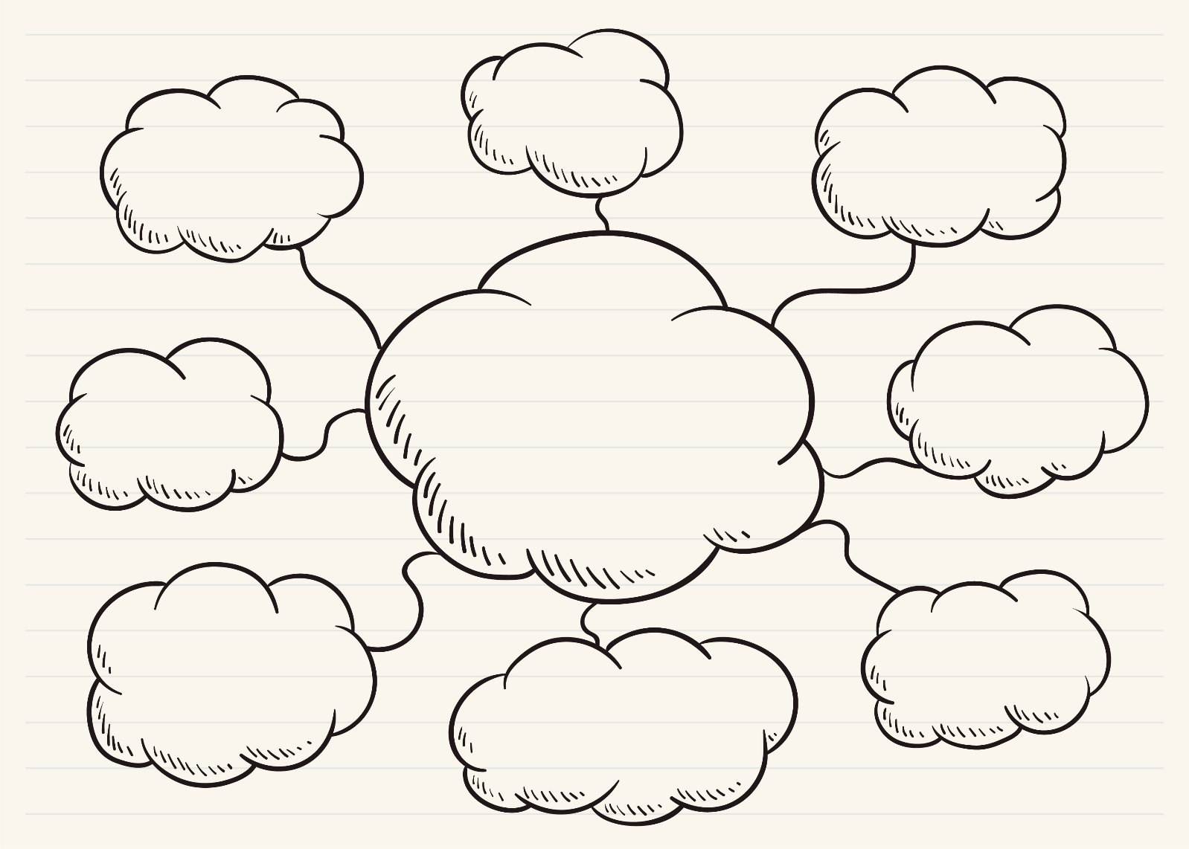

1.2 Review the list above and, as a group, choose the environmental issues you would like to focus on. Record your selection below.

________________________________________________________________________________

1.3 Discuss how your chosen environmental issues could affect different groups of people based on the following factors:
1.3.1 Income
____________________________________________________________________________________________________________________________________________________________________________________________________________________________________________________________________________________________________________________________________
1.3.2 Geographical location
____________________________________________________________________________________________________________________________________________________________________________________________________________________________________________________________________________________________________________________________________

1.4 Develop a community service plan for your selected environmental issue by answering the following questions. Your group will use these notes to present your plan to the class.
1.4.1 Clearly define the issue your group has chosen, providing specific details about the problem.
__________________________________________________________________________________________________________________________________________________________________
1.4.2 List the target group(s) most affected by this issue.
__________________________________________________________________________________________________________________________________________________________________
1.4.3 Describe your proposed action/service to address the issue.
__________________________________________________________________________________________________________________________________________________________________
1.4.4 Explain how your proposed service will help the community.
__________________________________________________________________________________________________________________________________________________________________
1.5 Design the action plan by breaking it down into actionable steps. Complete the table below.
Who will be involved?
What resources are needed?
Where will the service take place?
When will the service happen?

Activity 2: Reflection
Complete the following activity individually.
Reflect on the presentations you’ve heard from the other groups and answer the questions that follow.
2.1 Which community service plan stood out to you and why?
____________________________________________________________________________________________________________________________________________________________________________________________________________________________________________________________________________________________________________________________________________________________
2.2 How could you get involved in one of these projects in real life? List actionable steps you can take.
____________________________________________________________________________________________________________________________________________________________________________________________________________________________________________________________________________________________________________________________________________________________

