

Lesson 3 – Worksheet MEMO
 | Activity 1: Mitigation and Adaption Strategies  Complete the following activity in pairs.

Identify whether the following strategies are mitigation or adaptation efforts by placing a checkmark in the appropriate column.
Strategy | Mitigation | Adaptation
1.1 Plant a tree | 🗸
1.2 Use public transportation | 🗸
1.3 Install solar panels | 🗸
1.4 Build a flood barrier |  | 🗸
1.5 Reduce plastic waste | 🗸
1.6 Create a rainwater harvesting system |  | 🗸
1.7 Switch to energy-efficient light bulbs | 🗸
1.8 Educate others about climate change | 🗸
1.9 Grow drought-resistant crops |  | 🗸
1.10 Build a green roof |  | 🗸
1.11 Support local farmers | 🗸
1.12 Adopt sustainable fishing practices | 🗸
1.13 Reduce meat consumption | 🗸
1.14 Create a community garden |  | 🗸
1.15 Install a wind turbine | 🗸
1.16 Install water-efficient appliances |  | 🗸
1.17 Recycle | 🗸
1.18 Use a clothesline instead of a dryer | 🗸
1.19 Create flood-resistant infrastructure |  | 🗸
1.20 Use biodegradable products | 🗸
1.21 Create wildlife corridors |  | 🗸
1.22 Support renewable energy initiatives | 🗸
1.23 Reduce water usage | 🗸
1.24 Plant a coastal buffer zone |  | 🗸
1.25 Switch to a plant-based diet | 🗸

Activity 2: Individual Activity
Complete the following activity individually.

Question 1
1.1 Choose the correct answer and write only the letter (A–D) next to the question numbers (1.1.1 to 1.1.3), for example, 1.1.4. D.
1.1.1 Global warming leads to:
A. Overfishing
B. Inhumane farming methods
C. Pollution
D. Climate change

1.1.2 Depletion of land for agriculture can cause:
- Food insecurity
- Food biodiversity
- Food production
- Food fertility

1.1.3 The degradation of society due to inhumane farming methods refers to…
A. the negative impact on community well-being due to unsustainable farming practices.
B. the negative impact of technological agricultural techniques on societal growth.
C. the negative impact on public health caused by eco-friendly farming methods.
D. the negative impact on community productivity due to sustainable farming techniques.
(3 x 1) (3)

1.2 Give ONE word/term for EACH of the following descriptions. Write only the word/term next to the question numbers (1.2.1 to 1.2.5).

1.2.1 Agricultural practices that prioritise profit over the well-being of animals, the environment, and society.
Inhumane farming methods (🗸)

1.2.2 Substances added to food, beverages, or other products to preserve freshness, enhance flavour, improve texture, or add colour.
Additives (🗸)

1.2.3 The process by which the top layer of soil is worn away or removed by natural forces such as wind, water, or human activity.
Soil erosion (🗸)
(3 x 1) (3)

[6]

Question 2
Study the image below and answer the questions that follow. Write your answers in full sentences.
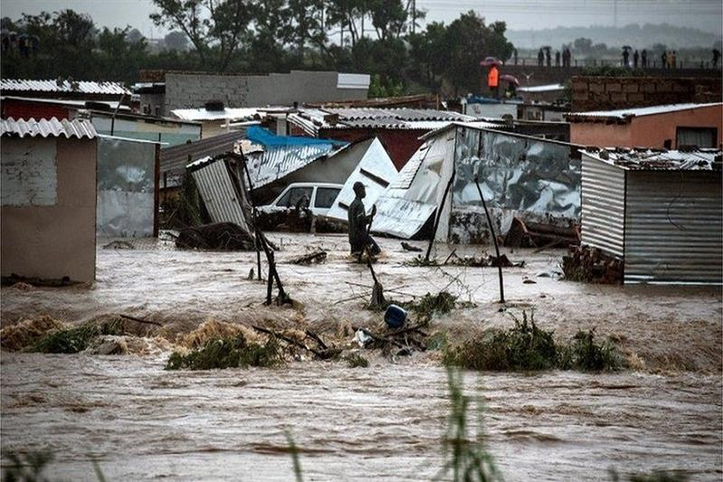

[Taken from: https://english.ahram.org.eg/News/454884.aspx Accessed on: 19 February 2025]

2.1 Define the term 'environmental disaster'. (1 x 2) (2)

It refers to…
- a catastrophic event caused by human activity/natural phenomena (🗸) that results in significant harm to the environment/ecosystems/human health. (🗸)
- an event that causes severe damage to the natural environment (🗸) that leads to long-term ecological consequences/disruption of local communities. (🗸)
- a sudden event that causes significant harm to ecosystems (🗸) that can lead to loss of biodiversity/habitat destruction/contamination of natural habitats. (🗸)
Any ONE of the above for TWO marks
(i.e. ONE mark for statement and ONE mark for qualifier/explanation)

2.2 Mention TWO ways in which communities can be negatively affected by a flood. (2 x 1) (2)

It could…
- lead to the displacement of families as homes are damaged/destroyed by floodwaters. (🗸)
- contaminate local water sources, making drinking water unsafe/increasing the risk of waterborne diseases. (🗸)
- destroy crops/farmland, leading to food shortages/loss of income for local farmers. (🗸)
- damage infrastructure such as roads/bridges/electricity lines, disrupting transportation/essential services. (🗸)
- cause economic losses, as businesses are forced to close/recovery costs rise for affected communities. (🗸)
- increase health risks by spreading diseases through stagnant water/causing injuries from debris. (🗸)
Any TWO of the above for ONE mark each

2.3 Discuss ONE important factor to include in a family emergency plan for a flood. (1 x 2) (2)

It could…
- include an evacuation plan (🗸) which ensures family members know where to go/how to safely leave the area in case of rising floodwaters. (🗸)
- include an emergency supply kit (🗸) which contains essential items like food/water/first aid supplies/flashlights to ensure survival during a flood. (🗸)
- include a communication strategy (🗸) which helps family members stay in contact with each other during an emergency, even if phone lines are down. (🗸)
- include subscribing to/following flood alerts/warnings (🗸) which provide timely information about approaching floods/allow families to take necessary precautions. (🗸)
- include a safe meeting place (🗸) which is a predetermined location where family members can regroup if they are separated during the flood. (🗸)
- include safeguarding important documents (🗸) which ensures that essential personal papers, such as identification/insurance information are protected from water damage. (🗸)

Any ONE of the above for TWO marks
(i.e. ONE mark for statement and ONE mark for qualifier/explanation)

[6]

Question 3
Study the image below and answer the questions that follow. Write your answers in full sentences.
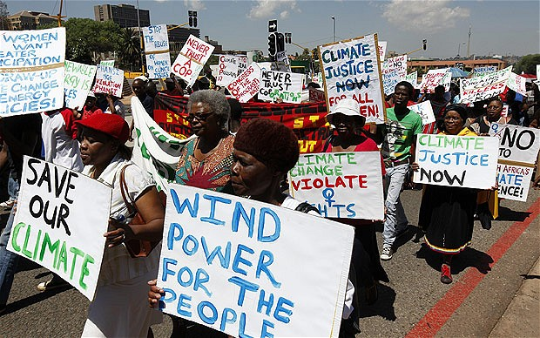

[Taken from: https://cer.org.za/news Accessed on: 19 February 2025]

Write paragraphs on climate change.

Use the following as a guideline:

- State FOUR human activities involving the burning of fossil fuels that contribute to
global warming. (4 x 1) (4)

Possible answers may include the following:
- Burning coal for electricity generation. (🗸)
- Driving petrol/diesel-powered vehicles. (🗸)
- Industrial manufacturing processes. (🗸)
- Burning oil for heating/energy production. (🗸)
- Deforestation for urban development. (🗸)
- Using natural gas for cooking/heating. (🗸)
- Air travel using fossil fuel-powered aircraft. (🗸)
- Mining/extraction of fossil fuels. (🗸)
- Transportation of goods using trucks/ships/trains. (🗸)
- The use of agricultural machinery powered by diesel/petrol. (🗸)
Any FOUR of the above for ONE mark each

- Analyse how climate change can impact individuals psychologically. (2 x 4) (8)
It could...
- increase anxiety/stress (🗸) since individuals might worry about the future/the potential impacts of climate change on their lives (🗸) which can lead to higher levels of mental health issues such as chronic stress/anxiety disorders (🗸) and that could affect their overall well-being/quality of life. (🗸)
- cause trauma from extreme weather events (🗸) since individuals may experience/witness natural disasters like floods/wildfires/hurricanes (🗸) which can result in post-traumatic stress disorder (PTSD)/other emotional scars (🗸) and that could lead to long-term mental health challenges/reduced community resilience. (🗸)
- create feelings of helplessness/despair (🗸) since people may feel powerless to stop climate change/see the worsening of their environment (🗸) which can lead to depression/a sense of futility (🗸) and that could cause a loss of hope/motivation to make positive changes. (🗸)
- disrupt social connections (🗸) since communities may face displacement/destruction of their homes due to climate-related events (🗸) which can lead to social isolation/loss of support systems (🗸) and that could further contribute to loneliness/anxiety/depression among affected individuals. (🗸)
- increase the burden of grief/loss (🗸) since individuals may lose loved ones/homes/entire communities due to climate-related disasters (🗸) which can lead to prolonged mourning/difficulty in coping with the loss (🗸) and that could affect emotional stability/mental health for extended periods. (🗸)
- trigger a sense of uncertainty/fear for the future (🗸) since climate change continues to affect the environment/disrupt lives (🗸) which can lead to ongoing worries about health/safety/livelihood (🗸) and that could contribute to chronic fear/instability in individuals’ mental/emotional states. (🗸)
Any TWO of the above for FOUR marks each
(i.e. To be awarded the full FOUR marks for the ANALYSIS candidates must: give a statement, (🗸) elaborate on the statement, (🗸) qualify the statement (🗸) and give an outcome. (🗸))

- Evaluate the effectiveness of campaigns that address climate change. (2 x 4) (8)
It could…
- raise public awareness about climate change (🗸) as campaigns can inform the public about the causes/impacts/urgent need for action; (🗸) however, despite the increased awareness, many individuals may not take the necessary steps to change their behaviour due to the complexity of the issue/lack of personal motivation (🗸) which could reduce the overall impact of these campaigns. (🗸)
- encourage individuals to adopt sustainable behaviours (🗸) by promoting eco-friendly practices such as reducing energy consumption/using public transport/recycling; (🗸) however, the effectiveness can be limited by economic/practical barriers, like the cost of sustainable products/the availability of alternatives (🗸) which could lead to low participation rates in some communities. (🗸)
- influence government policies/corporate actions (🗸) as campaigns can create pressure on policymakers/businesses to prioritise climate action; (🗸) however, these efforts can be undermined by political resistance/vested interests in industries that contribute to climate change (🗸) which could slow down the implementation of effective policies. (🗸)
- foster a sense of global solidarity/unite diverse groups towards common goals (🗸) by creating a shared sense of responsibility for tackling climate change; (🗸) however, not all communities may feel the urgency/relevance of the issue (🗸) which could limit the effectiveness of global campaigns. (🗸)
- promote sustainable technological innovations (🗸) by encouraging investment in renewable energy/green technologies; (🗸) however, the pace of technological development/the cost of transition could limit the immediate impact of such campaigns (🗸) which could delay widespread adoption of these solutions. (🗸)
- mobilise local communities to take action (🗸) by encouraging grassroots movements/local environmental initiatives; (🗸) however, local campaigns may lack the resources/support needed to reach a larger audience/make a significant impact at the national level (🗸) which could limit the long-term effectiveness of the movement. (🗸)

Any TWO of the above for FOUR marks each
(i.e. To be awarded the full FOUR marks for the EVALUATION candidates must: give the first statement, () and qualify it (). Additionally, the learner should give another statement () and qualify that statement. ())

[10]

[Grand Total: 26]

